Treasurer’s Report for AGM 17 April 2023

# Summary

As I write this in the middle of March I am still pulling together all of the Branch Annual Financial Returns, the process having been delayed by my ongoing health problems.

As soon as the full consolidated accounts are back from our Independent Examiner I’ll ask Beryl to send them out, ahead of the AGM.

The Diocesan element of the 2022 accounts is complete and our Balance Sheet continues to reflect the healthy state of the Diocesan finances, with almost £44,000 in our various bank accounts and a small amount in petty cash, an increase of nearly £5,000 on 2021.

Most of this increase is accounted for by £4,512.50 that we still owed to Mary Sumner House at the end of the year. This was caused by postal strike delays meaning that there wasn’t time for the final batch of branch cheques that I paid in to clear. I am normally able to make a final payment to MSH at the end of the year to bring their Fund balances to zero, but this just wasn’t practicable in 2022. The monies owing have been paid over to MSH, together with subs and donations collected after the 2022 year end.

# Reserves

For some years now we have been holding around £25,000 in reserves, split across 3 accounts, a sum that is quite high. After a discussion a decision was taken by the Trustees to reduce our reserves to around £10,000, which should be more than enough for any emergency purposes, giving us almost £15,000 to distribute.

As a result of this decision the account that we held with Shawbrook Bank, containing £10,000, was closed and the funds were transferred to our CAF Bank Gold Saver Account to continue earning a bit of interest, while a decision was taken about how to distribute them.

Until all of the £10,000 is spent the remaining £4,647 of our excess reserves will continue to be held in our CBF Church of England Deposit Account earning interest. For the final quarter of 2022 the average interest rate on these funds was 2.592%, which has increased the interest earned on this Deposit Account during the year from £2.39 in 2021 to £60.33 in 2022!

We will continue to retain our CBF Church of England Investment Account as our main reserves account. Although this holding has reduced by just over £1,200 in 2022, due to movement of the stock market, it is best to take a long term view on investment accounts like this. The new Treasurer will be able to review this holding and can advise the Trustees if he / she thinks it ought to be moved elsewhere.

Out of the excess reserves the Trustees have decided to send £7,500 to Mary Sumner House and a decision on exactly how to direct those funds will be taken at the next Trustees’ meeting. This leaves just under £2,500 to be distributed at the moment.

The Trustees have decided to make some of these funds available to branches to pay for items such as baptism books and the like. When I wrote to Branch Treasurers in 2022 I mentioned the availability of these funds but no-one appears to have applied for any yet.

Once the initial £10,000 has been fully distributed the new Treasurer can close the CBF Church of England Deposit Account and the Trustees can decide how to distribute those funds too.

# Balance Sheet

Turning to the 2022 Balance Sheet you will see the almost £44,000 funds distributed across our bank accounts and in petty cash.

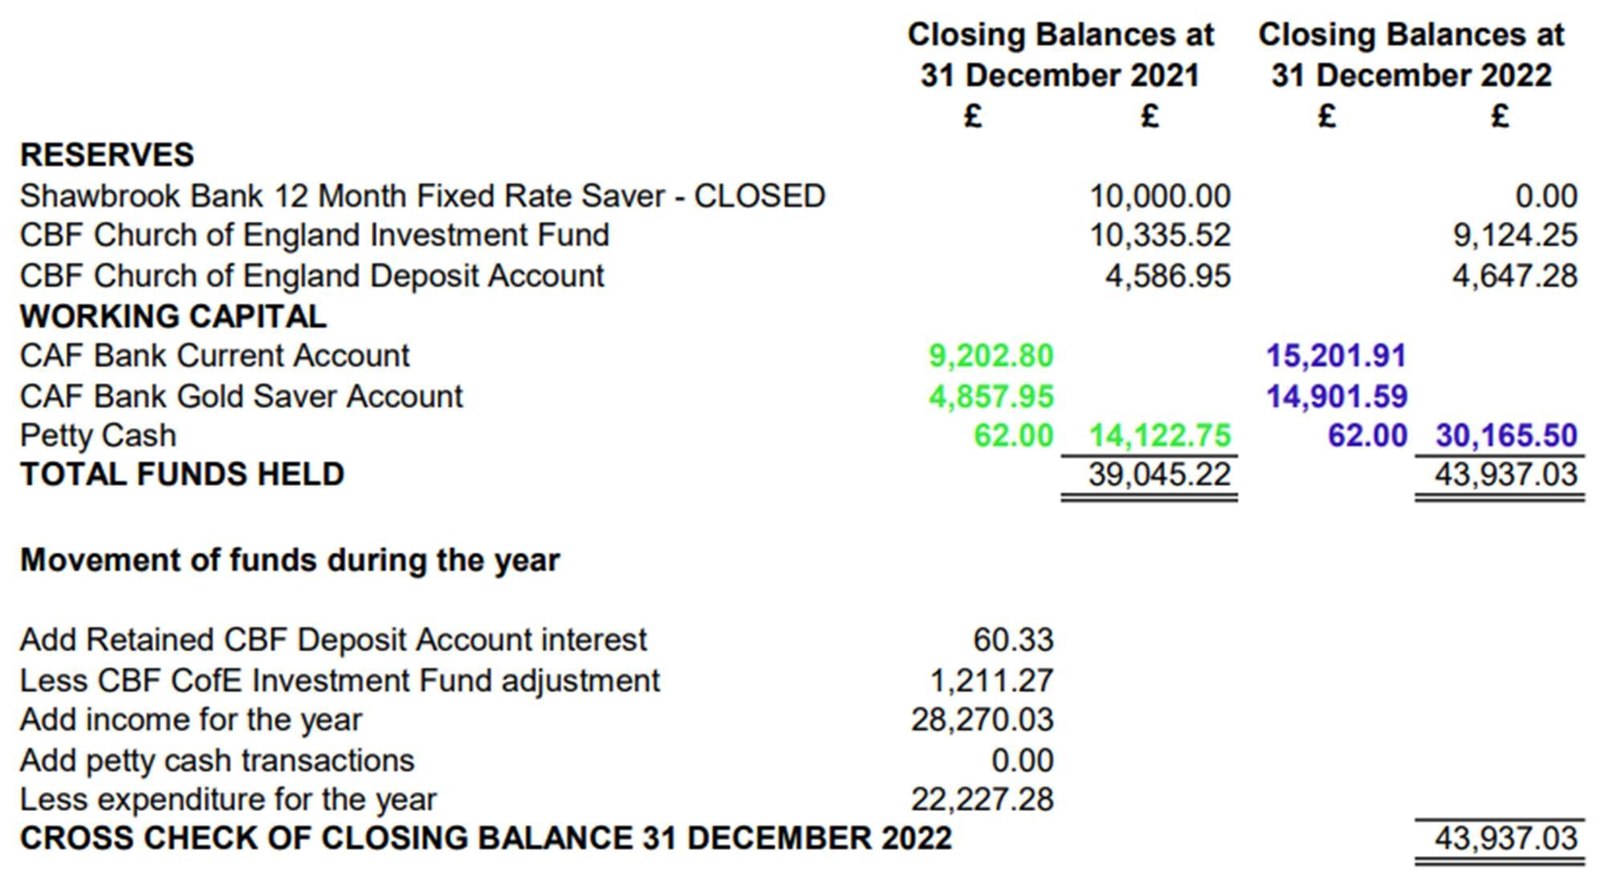

This year I have added headings for “Reserves” and “Working Capital” to better reflect the split of the monies that we retain in reserves and those that are available for us to use elsewhere, “working capital”.

In the Movement of funds section you will see the increased interest earned on our CBF

Church of England Deposit, an adjustment for the reduction in the balance in our CBF Church of England Investment Account and our Diocesan income and expenditure totals for 2022. Our Diocesan income is slightly up on 2021 and our expenditure is slightly down.

# Diocesan Fund Balances

Our Diocesan Fund balances at the year end are shown below.

As explained last year “Restricted Funds” have now become “Designated Funds” and you will see that I have established a new Unrestricted Fund called “Reserves for distribution” with a £10,000 opening balance. Having a separate Fund will allow us to detail where these monies go. A new quarterly report will be created so that the Trustees can see where this Fund is being spent.

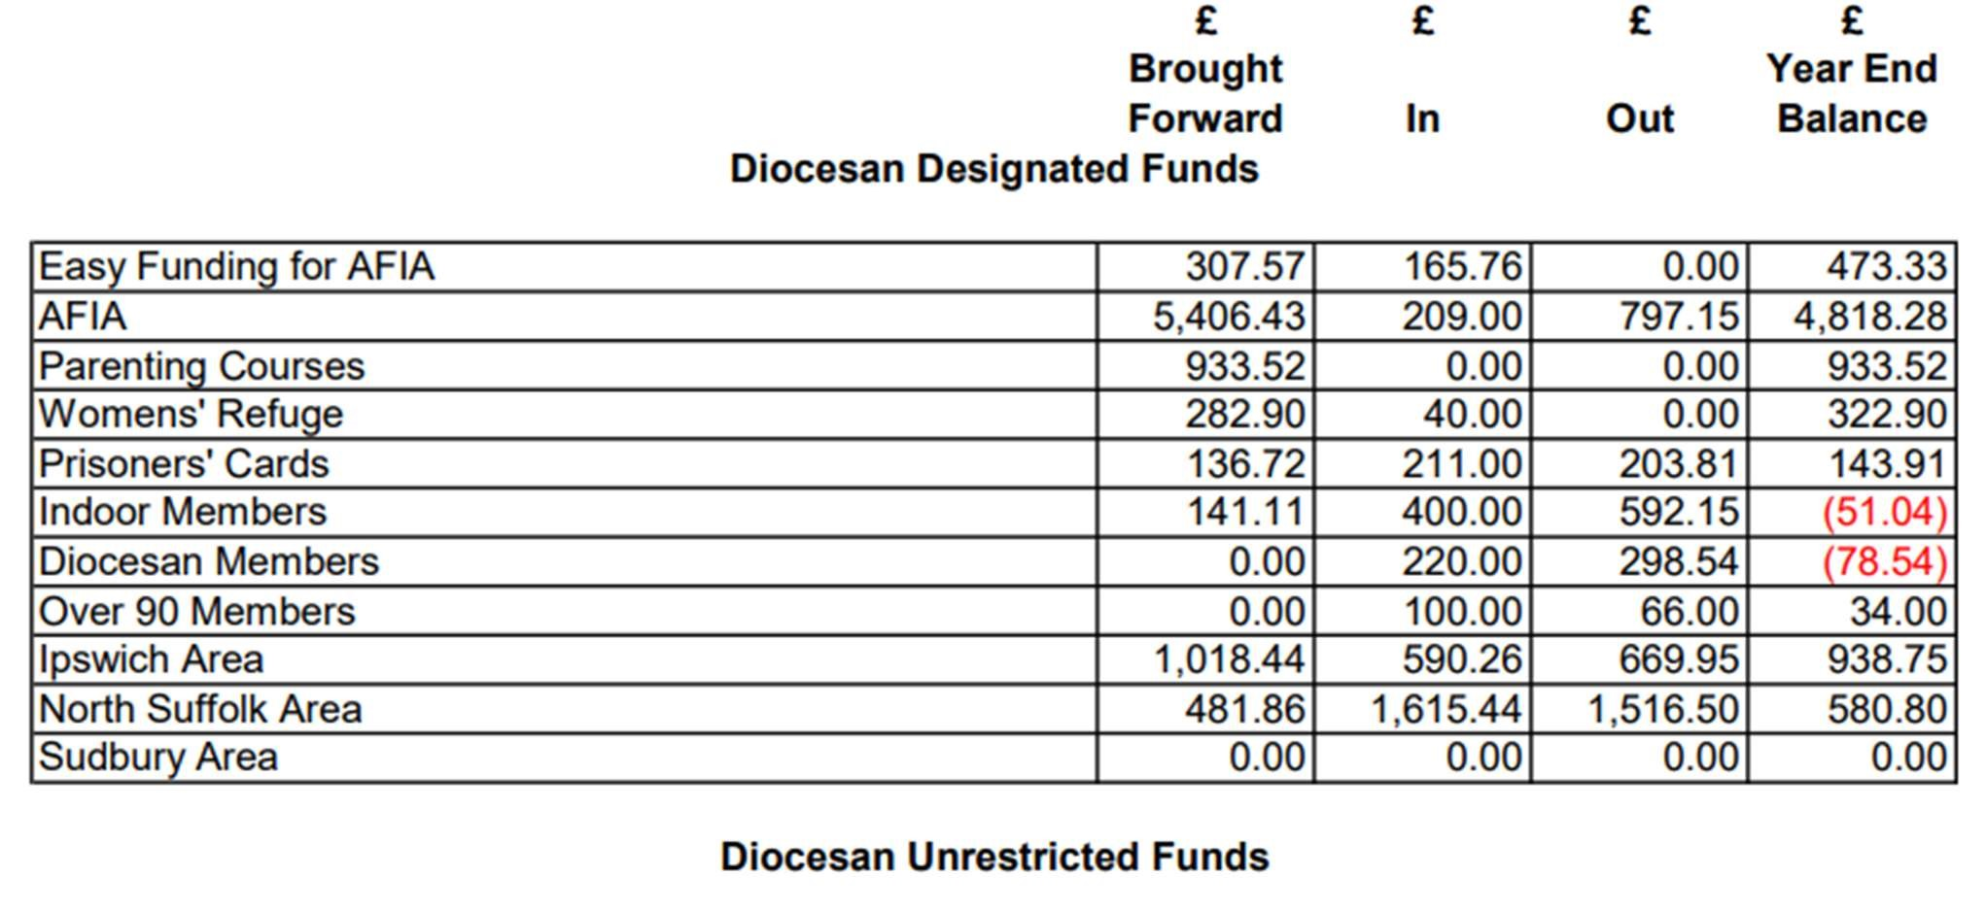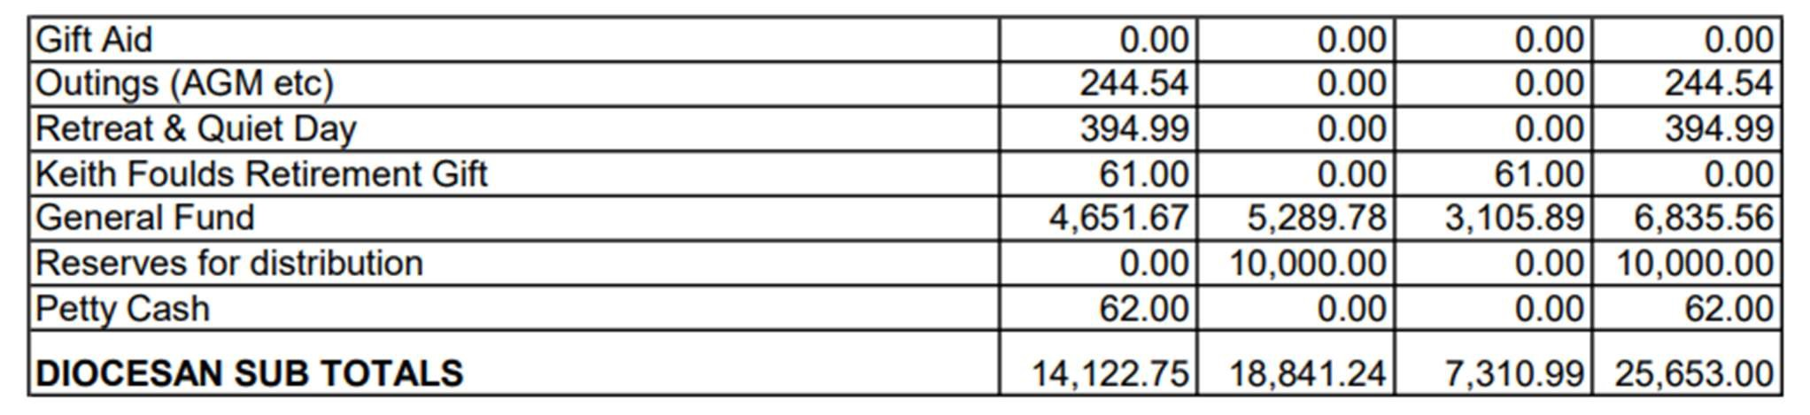

Designated Funds

As you will see our AFIA funds continue to accumulate but Val was able to make a grant to a young Air Cadet and to a family in need, who were unable to get away for a break but who benefited from a Bag of Love instead.

Although there are no outgoings from our Womens’ Refuge Fund both North Suffolk and Ipswich Areas have been supporting this important charity from their Funds, with just over £500 of vouchers, treats and craft items being provided.

Our Prisoners’ Cards work continues to be well supported and I know that members enjoyed the 2022 workshops that took place.

With the ever increasing costs of postage both the Indoor and Diocesan Members’ Funds ended up in deficit at the end of the year so the Trustees have agreed to increase the amount of support we give to both of these groups in 2023.

Unrestricted Funds

Before I stand down I will be completing the outstanding Gift Aid claims to submit to HMRC, we have 4 years within which to submit each annual claim and I have two claims to finalise.

# Mary Sumner House

We are continuing to support Mary Sumner House well with a total of £19,428.79 sent to them (£4,512.50 of which was outstanding), broken down as follows:

|  |  |
| --- | --- |
| Fund |  |
| Literacy & Financial Education | £925.00 |
| Britain & Ireland Development Work | £630.00 |
| Overseas Relief Work | £911.79 |
| Overseas Development | £1,040.00 |
| Provident Fund | £495.00 |
| Summer of Hope | £1,048.50 |
| Christmas Appeal | £90.00 |
| Subscriptions 2023 | £6,741.00 |
| Subscriptions 2022 | £7,026.00 |
| Subscriptions 2021 | £100.00 |
| Subscriptions 2020 | £14.50 |
| General Donations | £407.00 |
| Total | £19,428.79 |

You will see that the Overseas Funds have now been split into Relief Work and

Development and there is an additional Fund entitled Provident Fund. This is to support MU workers’ overseas.

Regrettably the number of branches continues to decline with Clare, Ipswich - St Augustine’s and Mildenhall closing and Hoxne becoming a Fellowship Group. At the end of 2022 there were 28 branches and one deanery.

I am sorry that I’m not in a position health wise to carry on as Diocesan Treasurer. I took the role on immediately after the end of treatment for my second episode of breast cancer. As it has turned out I haven’t bounced back as well as I’d hoped, and I need more time to rest and recover after my gruelling treatment plan. My cancer is in remission and long may that continue.

I wish the new Treasurer well and I will do what I can to ensure as smooth a transition as possible.

Amanda Langan

17 March 2023