Appendix 6 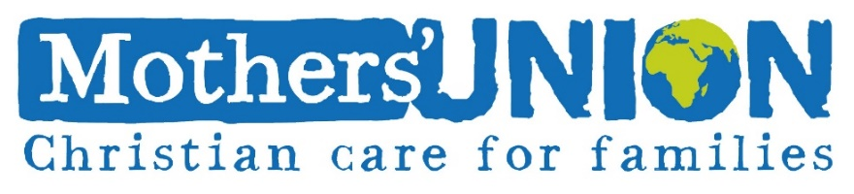
What are the hazards? | Who might be harmed and how? | What are you already doing? | Do you need to do anything else to manage this risk? | Action by whom? | Action by when? | Date Completed
Risk Management Plan Template/First Aid Requirements:
MOTHERS’ UNION ACTIVITY
RISK MANAGEMENT PLAN
Activity:
Location:
Date of First Risk Assessment:
Date to be reviewed:
Name, Designation and Contact details of Person with Overall Responsibility:

FIRST AID
It is recommended that at least one person involved in Mothers’ Union activities/projects attends a recognised First Aid course, such as one-day Emergency First Aid Training.
A first aid kit should be available in premises and on outings and trips. Kits should be easy to access.
When administering first aid, record what led up to the treatment, what treatment was administered, and who was present. Use an accident book to record this.
Similarly, if emergency services are called or a child/adult needs to seek medical attention, these incidents should be recorded as above in the accident book

