Appendix 5 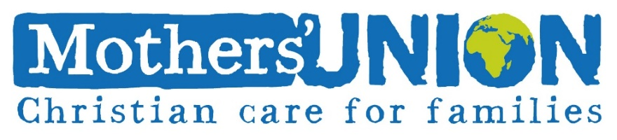
Mothers’ Union Photography and Filming Consent form
In accordance with our Safeguarding Policy, we will not permit photographs, video or other images of children/young people or adults to be taken without consent. If the child is under 18, consent must be obtained from a parent/carer.
[Insert Name of Project/Programme] will take all steps to ensure these images are used solely for the purposes for which they are intended. If you become aware that these images are being used inappropriately, please inform us immediately.

Declaration of Consent

Name of adult:

Please tick each box (or strike out what you do not consent to), then sign this form.
 | I give permission for my photograph to be used within the project/programme for display purposes.
 | I give permission for my photograph to be used within other printed publications.
 | I give permission for my photograph to be used on Mothers’ Union websites.
 | I give permission for my photograph to be used on Mothers’ Union social media pages.
 | I give permission for video of me to be used on Mothers’ Union websites.
 | I give permission for video of me to be used on Mothers’ Union social media pages.
 | I give permission for video of me to be used for training or analysis purposes.
 | I confirm that I have read, or been made aware of, how these images or videos will be stored within the organisation.
Signature |  |  | Today’s date
Declaration of Consent – parent/guardian of child under 18
Name of child/children:

Age:

Name:

Relationship to the child: parent/guardian:

Please tick each box (or strike out what you do not consent to), then sign this form.
 | I give permission for my child/children’s photograph to be used within the project/programme for display purposes.
 | I give permission for my child/children’s photograph to be used within other printed publications.
 | I give permission for my child/children’s photograph to be used on Mothers’ Union websites.
 | I give permission for my child/children’s photograph to be used on Mothers’ Union social media pages.
 | I give permission for video of my child/children to be used on Mothers’ Union websites.
 | I give permission for video of my child/children to be used on Mothers’ Union social media pages.
 | I give permission for video of my child/children to be used for training or analysis purposes.
 | I confirm that I have read, or been made aware of, how these images or videos will be stored within the organisation.
Signature |  |  | Today’s date
Print name

If a Group Activity is taking place for Mothers’ Union members (and where appropriate, accompanying friends/family members) a list of names can be appended to this form, indicating that those attending are in agreement to their photograph/image being used for MU purposes.
The form can then be signed by the activity group leader, on behalf of all those attending.

See below for suggested wording for appended list:

The following have given consent for their photograph/image to be used by Mothers’ Union, as stated on the form overleaf:

Name | Designation | Signed Date

