

Service
with Holy Communion on Mary Sumner Day

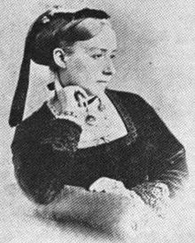

Wednesday 9th August 2023 at
St Mary Stoke, Stoke Street IP2 9DA at 2.15pm
Led by Rev Catherine Forsdike MU Diocesan Chaplain

This year we celebrate 147 years of Mothers' Union and pay tribute to Mary Sumner on the 102nd anniversary of her death giving thanks to God for all she has achieved in life, empowering women and mothers worldwide, and establishing the home as a place of religious education and growth all of which is in keeping with our Diocesan commitment Growing in God.

Light refreshments served in the church hall after the service provided by St Mary Stoke branch.

