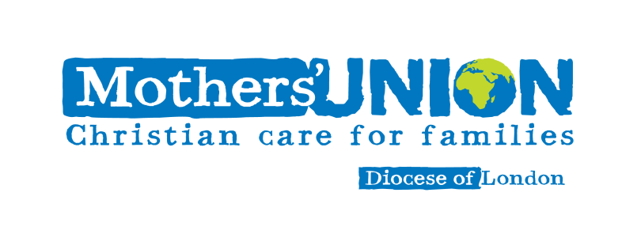

Diocesan President and Trustees

Invitation to

Mothers Union London Diocesan

Festival Eucharist

at

St Paul’s Cathedral

on

Wednesday 11th June 2025

7pm

Preacher: Bev Jullien, CEO Mothers’ Union

Plus commissioning of Trustee Board members

Guest

City of London School Chamber Choir

Priests - Please let me know if you wish to robe

email: paulinedpmulondon

Mob: 07795510908

Charity No. 249679