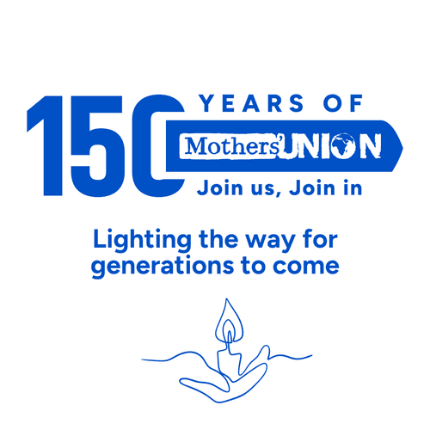

No 74 February 2026
www.musuffolk.org.uk
Charity No. 249726

Lighting the way for generations to come
Branch news: Henley MU would like to invite you to their upcoming event – a “Puzzle + Pudding evening.
Friday 20th February 7pm at The Coddenham Centre Mary Day Close, Coddenham IP6 9SR
Tickets £10. to include a selection of puddings,
The idea is that you come along and, as part of a team, attempt a jigsaw puzzle, whilst also eating from our delicious puddings. The team to complete (or most nearly complete!) their jigsaw in the evening wins a prize. Booking is essential! Email: henleymothersunion@gmail.com
The profits will be to provide items from the Brave Futures Amazon wish list. Brave Futures is an Ipswich-based group who came to speak to our branch in December as part of the 16 Days of Activism Against Gender-Based Violence – and the work they do is amazing.
Hosting a meeting along these lines is an excellent start to achieving a Silver RISE-UP award.
Mothering Sunday cards. Clare Thomas has some Mothering Sunday cards from previous years available at 20p per card which would be ideal if your group wanted to give cards out to your congregation / children's group etc. Please contact her for more details.
The new MUe catalogues are now out - if you haven't received one and would like one, please contact Clare on 01473 832808 or clare.thomas@btinternet.com.
Lady Day Service 2pm Wednesday March 25th Ipswich Minster
President and preacher: The Venerable Samantha Brazier-Gibbs
The Lady Day service starts our celebration of the150th anniversary of the founding of Mothers’ Union. Ipswich Minster is in the centre of the town and a very short walk from the bus station. There are also plenty of car parks nearby. Why not make a day of it and add some shopping, a visit to Christchurch Park, or lunch at one of the many cafes nearby. There will be a time to catch up with MU members from across the diocese after the service over a cup of tea.
Ideas for you to use to celebrate our 150th Anniversary?
- Could you wear your MU badge every day.
- Bring a friend to an MU meeting.
- Share you Connected magazine with a friend
- Suggest joining as a Friend of MU, if your friend is too busy to be a MU member
- Introduce the topic of Mothers’ Union into conversations.
- Tell them about our Grandparent Day in March.
- Host a Silent Knit with friends, sharing MU knitting patterns and see who lasts the longest in silence.
What do you say when people ask you to tell them about Mothers’ Union? One suggestion is to remind them of the Heineken beer advert from the 80’s, where the slogan was: - ‘Heineken the beer that reaches the parts that other beers cannot’. Tell them that like the Heineken beer Mothers’ Union is a charity that reaches people that other charities cannot.
Why? Because we are a grassroots charity with over 4 million members in more than 83 countries. Living in the communities that need our support, knowing personally who needs support and how best to provide that. Whether this is our literacy and finance outreach, credit and savings groups, or the projects here in our diocese such as our AFIA holidays and School Uniform grants. Tell them about the work we do to raise awareness of domestic abuse and gender-based violence.
We also provide fellowship and prayer support and if they really need one, we can make an excellent cup of tea and serve delicious home baked cakes.
150th Anniversary of Mothers’ Union.
There is still time to book your ticket or the service at St Paul’s on June 10th and for the Annual gathering on June 11th. Details are on the central MU website www.mothersunion.org/event/150/ there will be a final release of tickets on 16th February.

Book your place for our next Grandparent Day Saturday March 14th at the Thomas Clarkson Centre Bury St Edmunds. Doors open 10am.
The theme of the day is ‘What does it take to be a grandparent of faith’; the aim is to bring together grandparents of faith (from little faith to strong faith) and of any denomination. So that through a programme to include worship, key speakers and small group workshops participants will feel supported and encouraged and see ways to make a spiritual difference in their family situations.

Everyone who has attended in the past has given excellent feedback. Some people have come to both the previous Grandparents Days as they had found them so enjoyable, relevant and helpful.

The Thomas Clarkson Centre is full accessible, with all the rooms on the ground floor. Plenty of parking spaces as well plus disabled parking spaces. You can book your place on our third and last Grandparent Day. Tickets are free and can be booked from 1st January 2026 from Eventbrite:
https://www.eventbrite.co.uk/e/grandparent-day or email: jeanetteappleton91@gmail.com

Diocesan Treasurer Vacancy: There have been no enquiries for this role, so we have to redouble our prayers and please think who do you know who could take on this role or part of the role as a job share. For the past year the role has been shared as a Bookkeeper and Finance officer.
There is no need for this person or persons taking on this role(s) to be an MU member or for them even to be a member of a church. As all our trustee meetings and council meeting can be attended via the zoom link, they also do not need to have a car.
Prayer points:

- For one or two people to take on the role of Diocesan Treasurer
- For our membership to grow in this the 150th year of Mothers’ Union
- For younger people to join Mothers’ Union
- For our patron Bishop Joanne

Branch News

