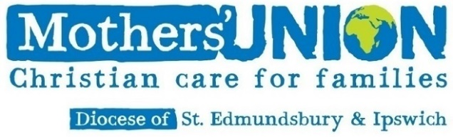

September 2021

Dear member

We hope you have enjoyed the summer and are ready for an exciting new Mothers’ Union development – a new option to pay your subscriptions by Direct Debit in addition to cash, cheque or BACS. And there is no plan to remove the existing ways of paying your subs!

**What?**

You will no doubt be aware that most organisations have for many years offered the facility to make regular or repeating payments via Direct Debit. By contrast, Mothers’ Union has been somewhat conspicuous for not doing so, much to the frustration of many members.

We’re therefore exceptionally pleased to be able to tell you that this is now changing and, following successful trials in other areas, the Diocese of St Edmundsbury and Ipswich has now opted to participate in a wider rollout, meaning this facility will be available to our members with effect for the 2022 subscription period. Our intention in writing is to detail the key practicalities of this rollout, explain the rationale behind offering the facility and set out how you can take advantage of this offer.

**Why?**

Direct Debits are a modern payment method, which, once set up, allows an individual to make repeating payments easily without the need for further instigating action on their part following the initial set up. Further details can be found on the enclosed information sheet.

As noted above, there is long held demand from our members for this facility. Offering this new method of payment (in addition to existing methods – cheque, cash, BACS) will bring us in line with other similar organisations and, if we wish to reach new and younger members, as well as retain and cherish the members we have, offering this easy and reliable way of paying can only help.

Alongside this are a range of benefits that mean we firmly believe this development will strengthen the Movement significantly. Prominent amongst these is our desire to reduce the administration burden falling on branches and members.

We know all too well that it is increasingly difficult to find members to take on the work of Leader or Treasurer in Branches and that nobody joined Mothers’ Union for joy of bureaucracy. Indeed, often the reason behind Branch closures is because we cannot find anyone to fill these demanding roles. Subscription collection is a not insignificant part of this burden, and as more banks close branches, it is increasingly difficult for MU Branches to pay cash and cheques into their accounts, further increasing the complications falling at local level.

The introduction of Direct Debits has the ability to be transformative in this space, potentially freeing up hundreds of hours of administrative input across the Diocese each year. It will also make life significantly simpler for us in the diocesan and central offices and receiving funds in predictable timeframes means we can all budget and plan more effectively.

As an additional benefit, for this year only, all costs associated with member participation in the scheme will be covered by the central charity, offering a significant potential financial boost to the diocese compared with participation commencing in future years.

**How?**

The process is being operated by Mary Sumner House and is being jointly managed by MU Diocese of St Edmundsbury & Ipswich.

There are two ways in which members can sign up to participate – either complete the attached paper mandate form and return to Clare Thomas, or sign up online at <https://www.mothersunion.org/st-eds-and-ipswich-direct-debit>.

If you sign up to pay by Direct Debit, your 2022 subscription will be taken automatically from your bank account on 31 January 2022 and your record on the membership directory will be updated to show that your payments are up-to-date. Your branch officers will receive lists of who has chosen to pay their subs in this way, so that there is no risk of you being asked to pay twice. In the weeks after signing up you will receive a communication confirming the amount of money that will be taken from your account and the date it will be debited.

For 2022, subscriptions will be collected in full in one transaction. Should this rollout prove a success it is hoped that in the following years we will be able to offer monthly direct debits, allowing the annual subscriptions to be spread over a year, easing the cash flow burden placed on both current and potential members.

**Is it safe? Will it work?**

The short answer here is yes. Thanks to the Direct Debit Guarantee, which protects against payments made in fraud or in error, paying via this route is now the UK’s safest payment method. Full details of this guarantee can be found online or on the form.

Mary Sumner House has introduced the well-established Go-Cardless system to manage the collection of subscriptions via Direct Debit and, based on the experience of the trial dioceses, we do not expect there to be any problems whatsoever.

You do not have to sign up to this initiative but we know that many of you will find it helpful. This is an exciting opportunity for us to help shape and secure the future of the Movement. We therefore very much hope you will consider paying your future subscriptions in this way.

Should you have any questions then please don’t hesitate to contact us. Sign up, be that via the online method or completion of the enclosed paper forms, will need to be completed **by 1st November 2021**.

Yours in Christ

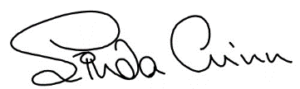 

Linda Ginn Richard Miller

Diocesan President Head of Finance, Mary Sumner House

Tel: 01728 648772 [Richard.Miller@mothersunion.org](mailto:Richard.Miller@mothersunion.org)

Linda.ginn@mothersunion.org