



**Join Us, Join In.**



www.musuffolk.org.uk



Charity No. 249726



No.67 Aug 2025

**This is the most important thing you can do this year for Mothers’ Union.**

Since 2020 our membership has fallen by 25%. An invitation from a friend is the most successful way to increase our numbers.

During the month of August please invite a friend round for a cup of coffee or tea, and talk to them about Mothers’ Union (MU). Tell then what you like best about MU and if they are a keen knitter, tell them about our knitting projects. If they are interested in supporting worldwide projects mention our successful MU literacy programme, and how we are making a difference by helping those who are now able to read, to set up their own small businesses.

Tell them they can join as a member or if that is not for them, then ask them to join as a Friend. Bring them along to a meeting, or event such as the Grandparent Day in September; more details are on page two of this newsletter.

If we can recruit 20 more members in 2025, we will have matched last year’s membership numbers, and stopped the decline, something that has not been achieved by any diocese in the past thirty years

**We are seeking someone to be our new Communication Lead.**

Do you have a friend or family member who could be our new Communication Lead for the next 18 months to help us promote MU during the 150th anniversary year of 2026. They do need to be an MU member, but someone who is good at writing and creating social media content. They don’t need to travel to meetings, as this is a home-based volunteer role with all expenses paid. The advert and role description are on our website [www.musuffolk.org](http://www.musuffolk.org),

**News from our branches**

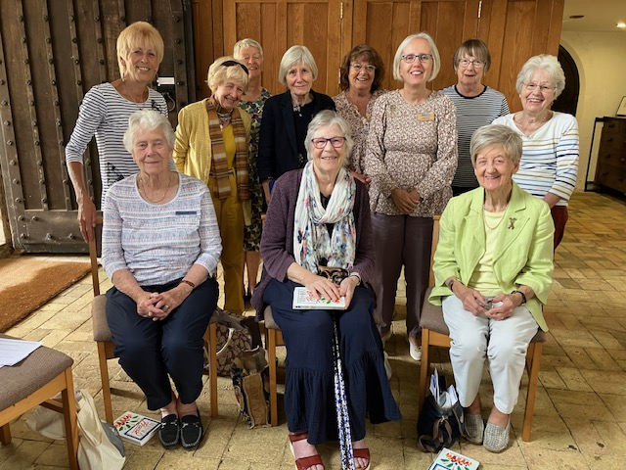

On July 18th at their Wave of Prayer service, several new members were enrolled by Jeanette Appleton to the Yoxmere benefice branch and another was welcomed as she moved to Westleton from a branch in East Sussex in Chichester Diocese.

**‘Tea by the Sea’, 2pm – 4.30pm in the URC hall, High Street, Southwold.**

Sue Norrington reports on the North Suffolk Area’s afternoon tea in Southwold on July 12th. The aim was to hold a fundraising event out of our usual area and to draw in new people.

We used the URC hall just off the High Street in Southwold and we had baked plenty of scones and cakes. We met new people when serving them tea, and had more conversations with those we met outside, as we talked to them about MU and encouraged them to come in.

£275.58 was raised for MU projects. We feel that there is a great deal of potential to raise awareness of MU and to fundraise for MU projects in Southwold. We can build on this first step and use it as a learning experience for future events.

**Summer of Hope:** The theme for the ‘Summer of Hope’ appeal this year is to bring gifts of peace to communities across the 84 countries where MU has a presence. Your afternoon tea events are not only about raising funds, but also to give opportunities to bring friends who have yet to join MU, whether as a member or a friend.

**Grandparent Day**: **Saturday, 6th September at Fressingfield Baptist Church,** School Lane Suffolk IP21 5RU. The theme of the event is to affirm, support and encourage grandparents of faith. At the Grandparent Day event in March, people who came gave the day four and five-star ratings. One person declared it was the best event she had ever attended.

The day starts at 10.00 with refreshments and registration and worship at 10.30am followed by a key note talk and panel discussion. After lunch there is a choice of workshops; featuring prayer-based art-reflection, mindful activities to share with grandchildren and a new workshop for grandparents who have grandchildren with special needs. The day closes with a short time of worship at 2.30pm. To book your place, email: [jeanetteappleton91@gmail.com](mailto:jeanetteappleton91@gmail.com).

**A Feast of Music: Friday, 19th September, 7.30pm at Barham Church**. Come along and be entertained and eat cake. Entry is free with a retiring collection for MU projects.

**September is ‘Bake and Make’ month:** The aim is to take our cakes and items we make and go outside the church so as to raise funds and the profile of MU with a new group of people. **Henley Branch** have already been doing this by having a cake stall when an orchestra meets in the village hall**. NSA** achieved this two months early with their Tea by the Sea event. The excellent display of posters across the parishes meant MU members from Norwich diocese, taking a short break in north Suffolk, heard about Tea by the Sea, and were encouraged to attend at their summer council meeting.

This photograph taken in 1968 was spotted by MU member Sheila Alderton in the East Anglia Times. It is an MU parade to St Mary’s church, Bury St Edmunds:

**Prayer Points:**

* **For our new Bishop Reverend Joanne Grenfell**
* **For the Grandparent Day on September 6th**
* **For the ‘Summer of Hope’ events across our diocese.**