



Mothers’ Union Lady Day Service
March 25th 2pm Ipswich Minster
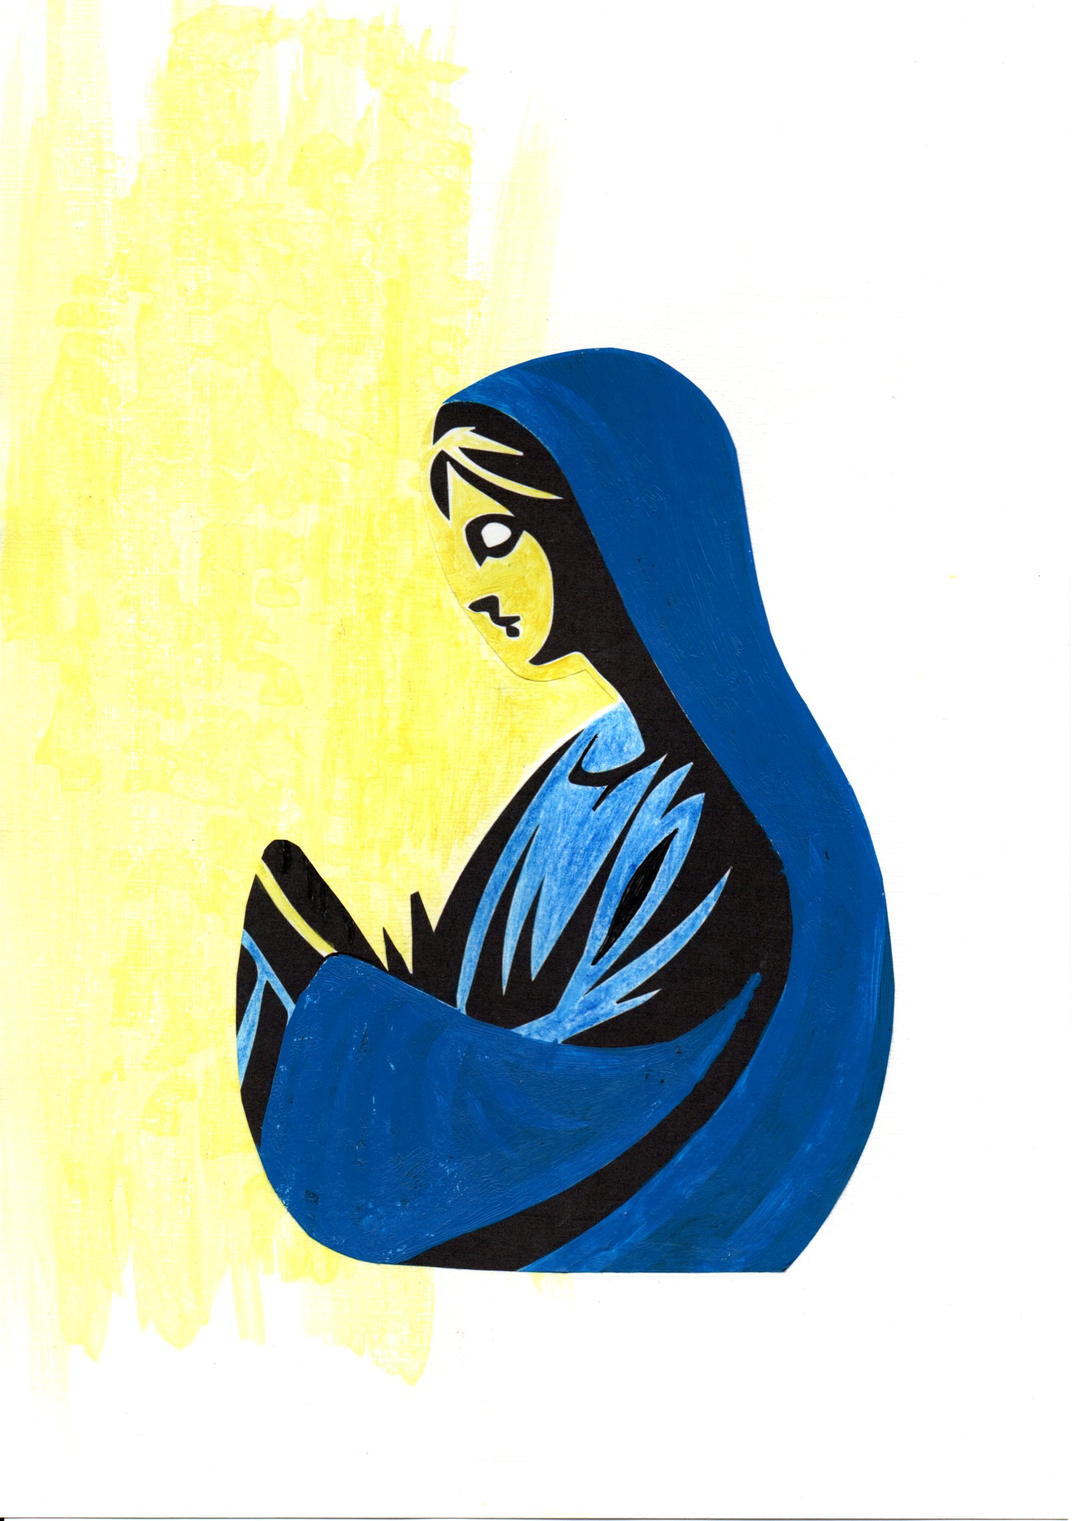
Tower Rd, Ipswich IP1 3PB

President and Preacher
The Venerable Samantha Brazier Gibbs
Archdeacon of Ipswich

Tea will be served after the service

