
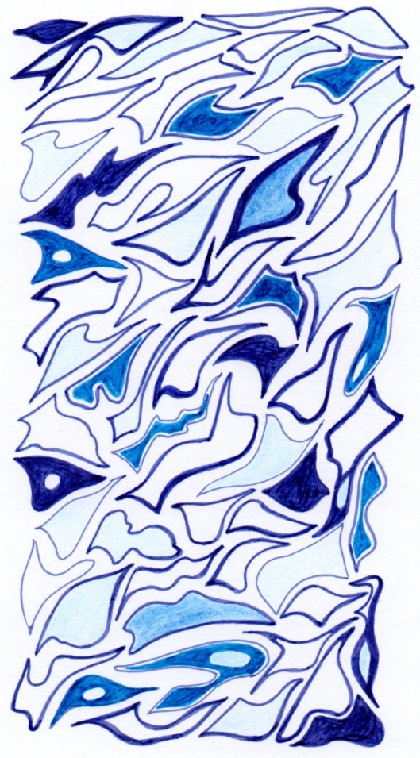

Service of Healing on the Feast of St Luke
Saturday 18th October at 3pm
Venue: St Felix church,
Walnut Tree Ave, Rendlesham IP12 2GG

Led by Rev’d Catherine Forsdike with Rev’d Mandy Reynolds

Refreshments will be served after the service.
Nearby car parking, the church has level access

