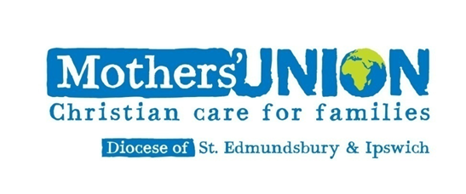

Ipswich Area Coffee Morning

   

Saturday 16th November 2024

10am ---12noon.

St Michael’s Church Centre Martlesham

  

Supermarket Stall Bottle Tombola Pound Stall

Christmas Draw MUe Stall

Entry £1.00 All Welcome