**Mothers’ Union Diocese of St Edmundsbury and Ipswich**

There is still time to sign up for our Re-Imaging Mothers’ Union Discovery Day on June 23rd 10.00 am to 3pm at Shepherd’s Drive Baptist Church Ipswich IP8 3SL.

Just send your contact details to Jeanette Appleton at e: [Jeanette.Appleton@mothersunion.org](mailto:Jeanette.Appleton@mothersunion.org) or phone m: 07768418942

This day is an opportunity for members of branches, across the diocese, to come together to Re-Imagine Mothers’ Union through prayer, reflection, and group discussion. Introducing a new resource from central Mothers’ Union: Metamorphosis Bitesize.

As always, we will start the day with a cup of coffee or tea. Then because we are people of faith, the first part of the day will be devoted to Listening to God, discerning God’s will for the future of Mothers’ Union in our diocese.

In the afternoon we will focus on how to start the journey forward for Mothers’ Union. Reassured that God has a vision for the future of Mothers’ Union in our diocese.

Bring a packed lunch to enjoy and browse the MUe stall .

A map is provided below for those travelling by car. The church is signposted after leaving the roundabout by Tesco. There is a large car park by the venue which is approached from Laburnum Close. Do not be put off by the barrier, this will rise as your car approaches.

The No 13, bus from central Ipswich via the Railway station to Tesco London Rd stops on Shepherd Drive, opposite the church.



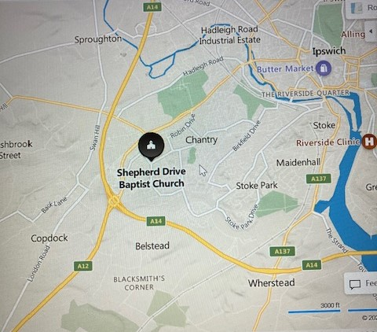 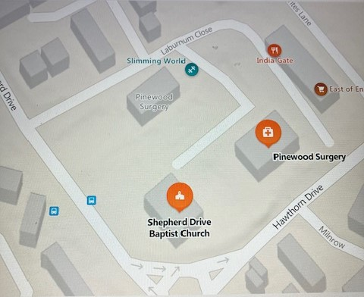

Re-Imagining Mothers’ Union

Discovery Day

June 23rd 2023

Our aim during this day is tore-imagine Mothers’ Union through prayer, reflection and group work. To enable Mothers Union members to re-imagine their branches, Mothers’ Union roles and explore a new way of being Mothers Union.

**Programme.**

10 – 10.20 Registration and coffee

10.20 Welcome: Linda Ginn

10.30 Session 1: Listening to God, Ourselves and Others: Led by Richard Appleton

12.00. Midday prayers

12.05. Lunch

12.45. Session 2: Discovering our Vision. Led by Jeanette Appleton

14.00. Session 3: Celebrating our Resources Led By Sue Norrington

15.00 Closing prayer.

     