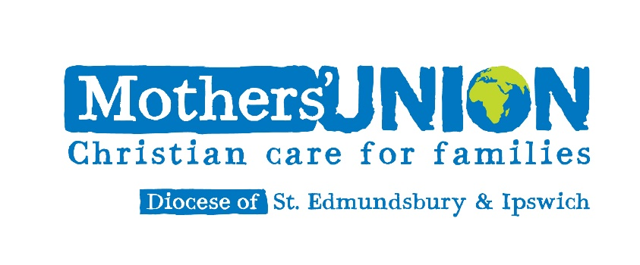

**Holy Communion Service**

**on the feast of the Annunciation of our Lord to the Blessed Virgin Mary**

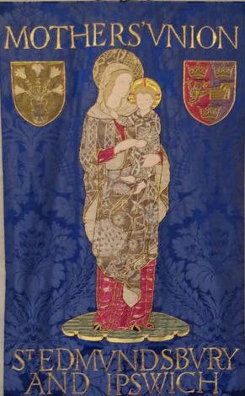

Friday 24th March 2023 at 2.15pm

at St Michael’s and All Angels Church, The Drift,

Martlesham Heath, Ipswich IP5 3PL

Led by Rev.Catherine Forsdike,

Chaplain of St Edmundsbury and Ipswich Mothers’ Union

The service will be livestreamed for those unable to attend in person https://www.youtube.com/watch?v=O0Hgdz4OenA

**MUe stall available**

**Tea/Coffee and Biscuits after the Service**

**TRANSFORMATION NOW !**