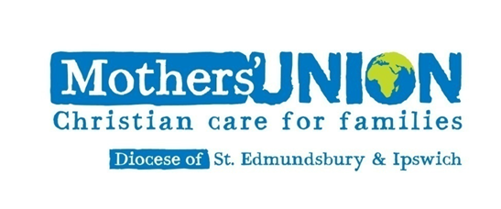

Ipswich Area Fellowship Coffee Morning

   

Saturday 18th November 2023

10am ---12noon.

St Michael’s Church Centre Martlesham

   Storecupboard Stall Bottle Stall Book Stall

Christmas Draw MUe Stall

Entry £1.00 All Welcome