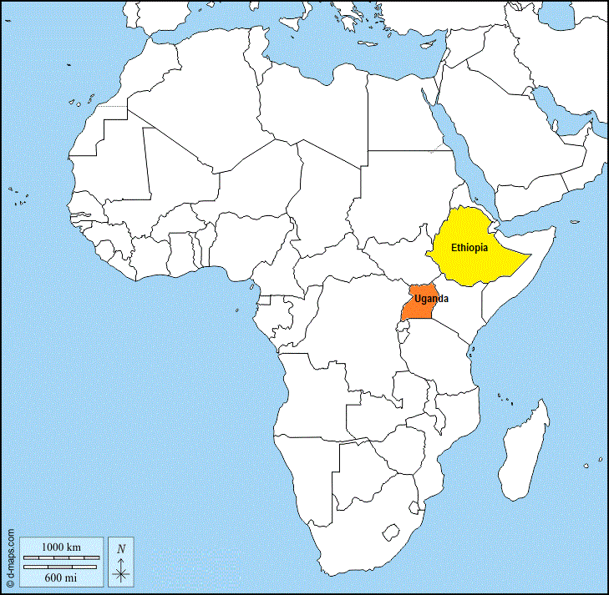

Ethiopia and Uganda – A Faith and Environmental Perspective

A presentation by

Amanda Langan

on Tuesday 11th October 2022 at 2pm

in the Barham Church Hall

All welcome

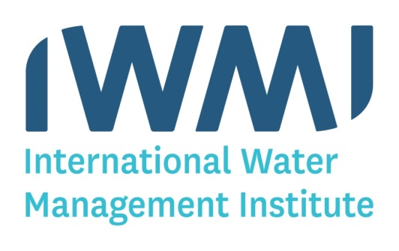Come and learn more about:

the work of the **International Water Management Institute**

the Christian community in Ethiopia

child beggars in Lalibela

and eco-friendly sustainable tourism in Uganda

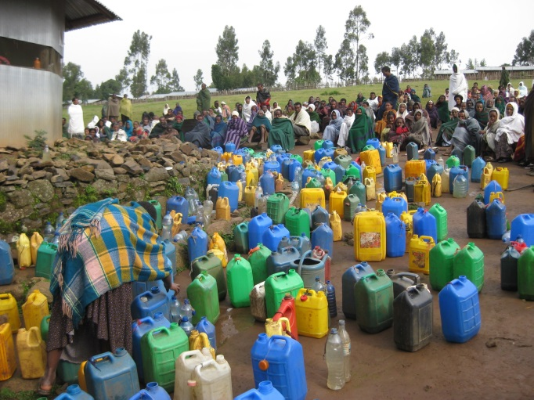

*Priests blessing water collection at the source of The Nile*

*Photograph by Dr Simon Langan*

*Director of Digital Innovation &*

*Country Manager, Sri Lanka*