

**Lady Day and Commissioning Service**

**With Holy Communnion**

Friday March 25th 11.30 am

**President and Address: Rt Rev Tim Stevens**

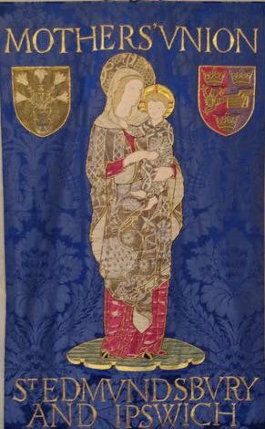

St Edmundsbury Cathedral

Angel Hill, Bury St Edmunds IP33 1LS

The service will be livestreamed for those unable to attend in person on the cathedral Facebook page <https://www.facebook.com/stedscathedral>

You are welcome to bring a packed lunch to eat in the cathedral. Tea and Coffee will be available after the service and MUe Stall will be present.