

**Service**

**with Holy Communion**

**on Mary Sumner Day**

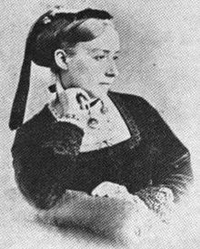

Monday 9th August 2021 at 11.30am

at St Edmundsbury Cathedral

Angel Hill, Bury St Edmunds IP33 1LS

President and Address**:** Rev’d Ben Edwards

This year we celebrate 145 years of Mothers' Union and pay tribute to Mary Sumner on the 100th anniversary of her death giving thanks to God for all she has achieved in life, empowering women and mothers worldwide, and establishing the home as a place of religious education and growth all of which is in keeping with our Diocesan commitment Growing in God".

**Bring Lunch to eat in Bury Gardens after the Service**