Reports for July Council Meeting

Mothers’ Union - D P Report for the July Council Meeting.
Our last Council was on the 18th November last year, and who would have guessed what would have been in store for us! How wonderful that we have a Heavenly Father who knows, sees, understands and is in complete control of everything even though we don’t always see the bigger picture. All we have to do is to “trust and obey”!
Just before our AGM on the 17th March I attended Microsoft Teams training sessions from MSH, and on each occasion Clare followed this up an add-on slot to help me understand what was going on… Initially it was an intensive introductory training week, which later became weekly sessions with the IT Department at MSH. A very challenging time!
Since the AGM it feels as if I have constantly been using the computer – I have attended zoom meetings with Trustees, with our Cluster group (Ely, Norwich, Peterborough and Lincoln) and with MSH - Richard Miller specifically talking about the pros and cons of Direct Debits; webinars on “Rebuilding Hope and Confidence” and “Praying with Purpose”; worship services devised by MSH for Lady Day and “Thy Kingdom Come” on YouTube; DP Elections Briefings (and I’m delighted to report that Julia Jamieson has joined the Central Trustee Board, Kathryn Anderson will continue to be our Provincial President, and Sheran Harper will serve another term of office as our Worldwide President). I have also attended an intensive three-day zoom conference for Diocesan Presidents in May, and have been delighted to be invited to join in and speak at several zoom branch meetings. The Commissioning Service at Newmarket has been postponed and rescheduled for December, and I’ve had the joy and privilege of signing long-service certificates for members across the Diocese.
Branches, Deaneries, and MSH have all been keeping in touch with members directly through regular prayer, newsletters and reflections, updates and briefings. We have also seen the launch of our new Connected magazine replacing Families First, and information through the letterbox about this year’s Summer of Hope campaign. Trustees too have been circulating monthly newsletters keeping all our members – Branch, Diocesan, Indoor, Central and Life Vice Presidents - in touch with all that is happening. MSH too have kept all members on the database informed with letters from Bev (CEO) and Sheran Harper (WWP) giving a global perspective.
As Trustees we have routinely met together on zoom to ensure the smooth working of our Mothers’ Union in the diocese, and on hearing the sad news of Keith’s retirement after thirteen years as our Diocesan Treasurer, we have recently called extra zoom meetings to pray, discuss and seek God’s guidance for the way forward. We send our send loving thoughts, prayers and good wishes to both Keith and Ann and thank him for all he has done for us. If anyone in your branches feels that God may be calling them to serve our Mothers’ Union in this capacity, please get in touch/see website.
As I write, we are on the threshold of our Wave of Prayer – a time when members around the world will be thinking specifically of us and holding our diocese in prayer before God. How amazing that we have a bond of fellowship – a bond of connection - with 4 million other MU members around the world! We are also looking forward to our first face to face service in the Cathedral, to be followed by a picnic in the Abbey Gardens to celebrate the life and work of Mary Sumner to whom we owe our unique role for women within the Church, and give thanks to God for all she has achieved in life, empowering women and mothers worldwide, and establishing the home as a place of religious education and growth. We do indeed have much for which to praise God, rejoice and give thanks.
Finally, a thank you to all our trustee team and officers for all they have achieved in this difficult covid-era – each using the gifts, skills, talents and opportunities in God’s service for the benefit of all. An exciting future is opening up in new and imaginative ways, and we are all a part of it!
Linda Ginn 7.7.21

Vice President’s REPORT for Council Meeting July 2021
All he Branch Reports for the year ending December 2020 have been submitted.
The information compiled has been recorded as ‘Statistics for the Year’ and ‘Branch Donations’ all relating to the year ending December 2020.
Clare has submitted the requested information to MSH.
The contact details of branch ‘leaders/contacts’ has been given to the Secretary to update the Directory.
Some of the information we collect is not sent to MSH and a review of our Annual Return form is planned.
In view of the events surrounding COVID the branch donations were good which is a testament to the commitment of the membership and Branch Organisers.
Cathie McGregor. July 2021
Ipswich Area Report

I was able to deliver Drain Bags for the Breast Team also Cot Quilts and Memory bags for the Special Baby Unit at Ipswich Hospital these were what were given to me the last time we were all able to meet together which was beginning of last year.

Monica gave me some crocheted blankets which a member from Martlesham Branch had made and they have gone to the Jamie Cann Home at Ravenswood in Ipswich. They were very pleased to have them they use them in the day room and to put over the residents’ knees for a bit of warmth if it is a bit chilly. We do have a member in the home there who I keep in contact with as she is a member at St Mary Stoke.

I will let members know when more Drain Bags, Cot Quilts, Memory Bags, Knee Blankets and items for the Woman’s Refuge are needed.

All being well Ipswich Area are hoping the Coffee Morning will go ahead on Saturday 20th November 2021 at Martlesham 10am – 12noon.

Once again thank you all for your continued support.

Sandra Griffiths
Ipswich Area Rep

Faith and Policy report July 2021
Prayer and Fellowship is the bedrock of Mothers’ Union and this is how we have sustained ourselves and fellow members during the last 17 months. Our midday prayers are a daily connection with the four million Mothers’ Union members worldwide and our Wave of Prayer is the three days when the prayers of all these Mothers’ Union members focus on our diocese and those dioceses that we are linked with.
Our fellowship has been different to how it was before the pandemic. But this has continued whether through phone calls, letters and cards, emails or by zoom meetings. Perhaps also in recent weeks with some outdoor meetings in small groups.
As we move forwards our monthly meetings may change but the prayer and fellowship that Mothers’ Union membership gives will always be the same.
Lady Day service was viewed 144 times, and some of these viewers were watching the service together in their homes with family members. Thank you to everyone who took part in the service. If you haven’t seen the service, it is still available on YouTube from the link on the musuffolk Facebook page.
Wave of Prayer: The Wave of Prayer service 2021 is currently on the musuffolk.org website. Once again members may find it easiest to pray at home during the three days allocated to St Edmundsbury and Ipswich of July 16th – 18th. If members cannot get to a Wave of prayer service, for whatever reason, they can add their prayers by lighting a candle and placing their Mothers Union prayer book by the candle while remembering all the MU members in our link diocese of Lake Malawi, in Malawi, Byumba in Rwanda, Lucknow in Northern India and Jalingo in Nigeria.
‘For Better, For Worse’. At a recent mini-MU meeting at East Bergholt and Brantham branch six of us were discussing the topic of marriage and as a result a new chapter has been added to our book ‘For Better, For Worse’ entitled THE IN LAWS! This will include experiences of having an in-law as well as the way in which we have chosen to be a mother-in-law/ father-in-law. You can always send you contribution in as ANON, or give yourself a nom de plume for this chapter.
Shine a Light
I am sorry to be mentioning Christmas when we are still only in July, but our November council meeting will be too close to the beginning of Advent for this project to happen in 2021.
This lovely idea came from Chichester Diocese. The idea is that members produce either by knitting, crocheting, quilting, sewing or by card, STARS! The design is up to you. Then come a sunny day in mid-December, when there is no wind, either hang them or ask someone else to hang them, on bushes, low tree branches or place them on gate posts, for children to find them on their way home from school.
On each star attach a loop, and on that loop, a small business size card with one side saying
“This star is a gift with love from Mothers’ Union.
Please take me home and put me on your tree.”
On the other side
“Mothers’ Union is a Christian organisation supporting families
We wish you and your family a Happy Christmas
www.musuffolk.org

Please ensure this message is typed for clarity.
In John 8:12 Jesus says “I am the light of the world. Whoever follows me will not walk in darkness, but will have the light of life.” So, let us ‘Shine A Light’.
In true Blue Peter style here are some that were made earlier

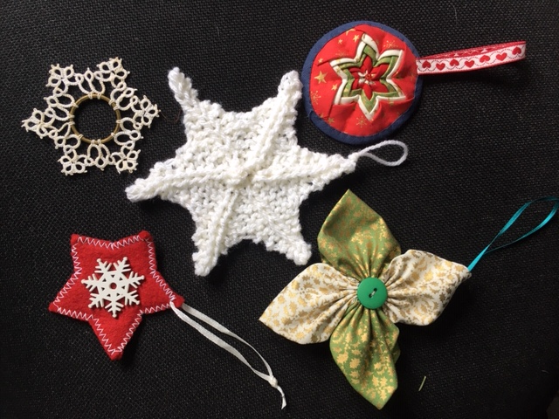
Jeanette Appleton
Faith and Policy Trustee
Diocesan Members Report for MU Council Meeting on 21st July
I have continued to send out newsletters each month to Diocesan Members. In June the mailing included the Wave of Prayer Service ready for members to use in July.
Six members from Rattlesden Branch have recently decided to become Diocesan Members, although they will continue to meet in a more informal way.

Sue Norrington -July 2021

A.F.I.A.
Sadly, I have not arranged any holidays or days out for this year.
As we still can't use our AFIA funds to send families away on holidays we decided to give the ladies at the Women's Refuge a treat - two large baskets of pampering gifts. These included toiletries, nail varnish, hair products and chocolates!
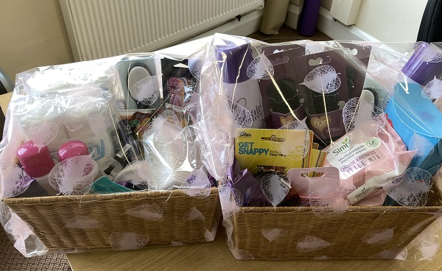
With the rise in families staying in the UK for holidays this year, I think it will be very difficult to arrange last minute holidays.
MU could offer A day at the Zoo, a theme park, maybe train fare to have a day sightseeing in London or Cambridge. Afternoon tea, National Trust properties, Stream Railways or Duxford.
I have a copy of ‘Great Days Out in Suffolk and Norfolk’ which has loads of ideas, but most are in Norfolk.
Thank you to members to have been using easyfundraising, this is the link to the home page
https://www.easyfundraising.org.uk/causes/stedsipswichmu/.

These are just a few stores you can shop at online, there are over 5,800 stores to choose from !!!
Val Jeffreys A.F.I.A. Trustee
Reports for Council July 2021
MUe
Thank you to all members and branches who have ordered MUe items from me or direct from Mary Sumner House. All sales contribute to our grant of 10% sales which does help our Diocesan funds. The Autumn / Winter catalogue will be out soon, and I will post catalogues out to branches, Diocesan members will get theirs from Sue Norrington.
Membership database
The MSH membership database was used for the Connected mailings, and I have received very few reports of members who didn’t receive their magazine. It is now also holding people’s preferences for future mailings from MSH, and members can opt out of gaming, resources & appeals or all mailings. The wording on the opt out slip didn’t make clear that the third option actually means no mailings at all, including Connected, so if anyone ticked that box but does want to receive the magazine then please let me know and I can change it for you. Please continue to let Beryl know of any address changes, new members or bereavements so that I can keep the database up to date.
Clare Thomas
North Suffolk Area Report for Council July 2021

The NSA Committee are meeting on 13th July to discuss plans for the NSA Morning which we hope will take place in Fressingfield on Wednesday 22nd September. All being well, it will take the usual format, starting with a service in church then moving to the hall for time to enjoy each other’s company, raise funds at some stalls, listen to a speaker and share lunch. Anji Dawkins has agreed to be our speaker and will update us on the diocesan link with Kagera.

We are also starting to prepare for the pop-up shop, I-Chameleon in Halesworth which we will be running from 21st to 27th October. All donations of good quality bric-a-brac, household goods, preserves, books, toiletries, toys etc will be most gratefully received. Please contact me if you would like them to be collected.

Anna Vessey
NSA Representative

Secretaries Report – July Council meeting.
Since the last council meeting, I have been keeping in contact with branches by sending any information that has come from Linda/Mary Sumner house or trustees.
Unfortunately, we were not able to use the Marquee in the Bishop’s Garden this summer due to Covid restrictions.
I have been in touch with Penny (who is repairing the Diocesan banner) to ask how near to completion it is? Penny has said it was a much bigger job than was thought, she said it has been more of a conservation project than a repair as it was in a much worse state than we expected.
I will be searching the internet to find a plastic cover for the banner to hopefully preserve it for visitors etc to see. It must not be rolled or folded as this is how some of the damage occurred plus the moths have had a ‘feast’.
I continue to send information to branches, life vice presidents etc. which I know is appreciated.
Our next Council Meeting is on Wednesday 24th November at Fressingfield .
Beryl Mee
Diocesan Administrator/Secretary

