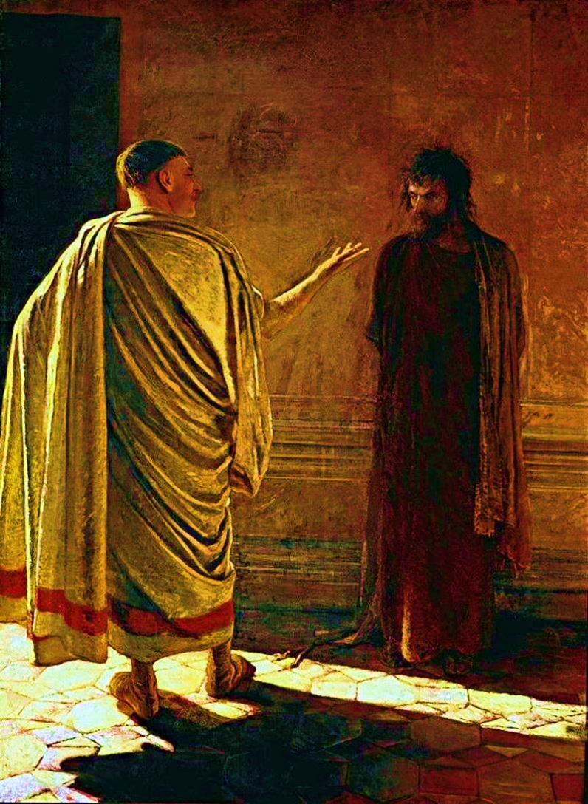

(Photograph downloaded from: July 2020 from: https://en.wikipedia.org/wiki/John_18:38)
‘What is truth?’ (Nikolai Nikolaievich Ge: 1890-94; painted in 1890)
The painting is based on John 18:37-38: “Then Pilate said to Jesus, 'So you are a king, are you?' Jesus answered, 'You say that I am a king. For this I was born, and for this I have come into the world, to bear witness to the truth. Everyone who is of the truth listens to my voice.' Pilate said to him, 'What is truth?' After saying this, he went back out to the Jews and told them, 'I find no guilt in him'”.
Tom Wright’s commentary, ‘John for Everyone’, in which the Gospel is based on his own translation, re-words the question as, ‘Truth! What is that?’ This subtle difference emphasises more the question’s cynicism, if not scorn.
Pilate is an interesting man and figure. The account of him in the Gospels generally shows him to be empathetic to Jesus and his situation, although ultimately he gives in to the mob-aggression of the Jews and ‘washes his hands’ of him, thereby sentencing him to death. As a result of this action Pilate is specifically named and shamed in the creed we say, week after week. It has also generated the frequently-used phrase, ‘washing our hands’, a metaphor for abrogating responsibility and walking away from our responsibilities. You might want to reflect on whether naming and shaming is what Christ would have wanted and whether it is Christ-like so to do.
The painting is clearly of two men and in two halves. Contrary to how the presence of Jesus is traditionally portrayed in paintings as being in the midst of or surrounded by light, here he is very much in the dark, in the shadow of both the wall and Pilate. However, his posture is not one of dejection or defeat but a quiet dominance that, although in the dark and under the intimidating gaze of Pilate, he has a knowledge that is denied Pilate. Jesus’ face is resolute, even stern and his eyes fixed on Pilate’s face.
In contrast, Pilate is in the light, possibly to reflect his assurance and certainty of his authority and power. He adopts a rather mocking attitude, in both his body language and his facial expression; although difficult to see, his question is spoken with a sneering expression. His question, ‘What is truth’, could possibly be described as rhetorical; however, most would describe it more as snide and cynical. He probably believed that truth was relative; that truth was whatever the majority of people agreed it was or whatever was expedient to achieve their personal and political goals. And so it remains in 2020 with people trying to define truth according to how it meets or fits in with their own needs; this is not exclusive to governments and politicians and industry, but to everyone.
One could very reasonably argue that failing to recognise the truth is bad, but recognising the truth and then denying or ignoring it is much worse.
It is uncertain whether Pilate was aware of what he was saying; or whether he genuinely believed Jesus, or that he considered that there was no way this man could be a ‘king’. However, he was sure that Jesus was not guilty of any charge but failed to persuade the screaming mob outside of his opinion and ‘verdict’. It is then strange that despite Pilate repeating the fact that he could find no basis for a charge against Jesus, his behaviour indicated otherwise, having him flogged and allowing the Jews to kill him through crucifixion, a Roman form of punishment… But we know that Jesus’ death was necessary so that we all might live.
The truth was standing before him: ‘I am the way, the truth, the life’ but Pilate did not see it; many still do not see or understand it today.

Christ Jesus, when temptation urges us to abandon your truth,
you pray within us.
And you encourage us not to remain in darkness,
but to live in your light.

Roger of Taizé

