Transformation Now!

w
ww.musuffolk.org.uk

Charity No. 249726

September 23 No.44

I Chameleon - North Suffolk Area will again be running a Pop -Up Shop in Halesworth, from 12th – 18th October, selling donated items to raise money for MU projects at home and abroad. If you are turning out and have any contributions of china, glass, household items, fabric, pictures, books, jewellery, bric -a -brac, etc, please contact Anna Vessey on 01379 588389.
The shop will be open from 10am to 4pm from 12th -18th October (except Sunday). Lots of bargains to be had and a selection of MU cards will be available. Do come and see us if you can at I Chameleon, 9 The Thoroughfare, Halesworth, IP19 8AH.
North Suffolk Area Morning -This will be held at St. Peter and St. Paul Church, Hoxne on Tuesday September 19th from 10am to 1.30pm. Further details from Cathie McGregor 01379 668434.
Ipswich Area Coffee Morning will be held on Saturday 18th November at St Michaels
Church, Martlesham - 10am – 12noon. More details nearer the time. Sandra Griffiths 01473 254653.
MUe - The Christmas/Autumn /Winter Catalogue has lots of cards and gifts. Clare Thomas 01473832808 clare.thomas@btinternet.com - is happy to help you with your order.
News from our Cathedral Branch. In July and August, members have been able to participate in the Cathedral Summer Fair, a Sea Sunday Service. and a Wave of Prayer Service. The Branch baked scones, biscuits and tray bakes for the Chapter 4 meeting on Thursday 27th July; this gives Congregation members time to get together over coffee and cake and listen to a speaker and have a good chat together. The next meeting on Sept 28th will be a coffee Morning in aid of funds for Ukraine. All are welcome in the Edmund Room, St Edmundsbury Cathedral. Our Summer outing was to Crow’s Hall, Debenham on Tuesday 22nd August. A very hot afternoon, the owner of Crow’s Hall, (Caroline Spurrier) gave us a wonderful talk about the Hall and her Family Tree. 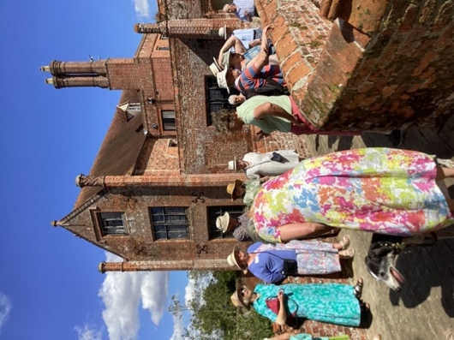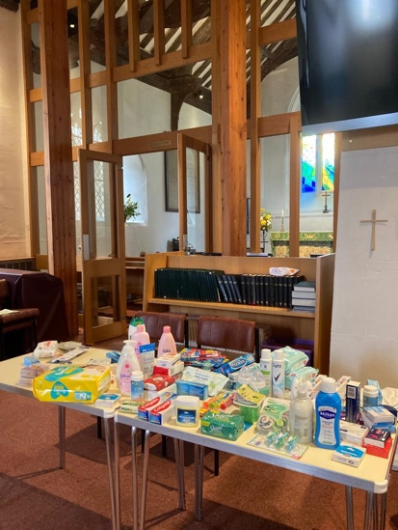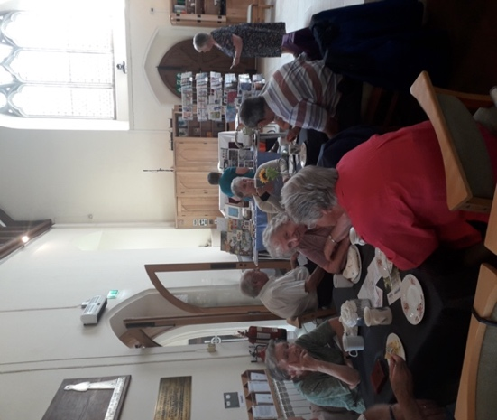 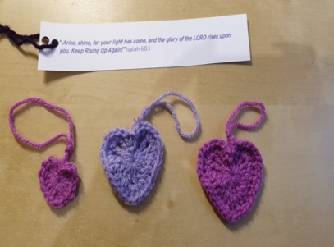
Rise UP! Hearts
Cream Tea
Ukraine donations
Cathedral Branch

Walton Branch hosted an afternoon Cream Tea in August which was enjoyed by everyone.
Kesgrave Branch asked members to bring essential items that could be sent to Ukraine at their Wave of Prayer Meeting in July, and were overwhelmed by the contributions they received. Kesgrave church has been supporting Ukrainian families who have moved into the area.

Fressingfield and Yoxmere Branches recently held afternoon teas to raise money for the Summer of Hope Appeal. The Farm Shop Fellowship Group (ex-Wickham Market branch) and Hoxne Fellowship Group also raised funds for this appeal at their Wave of Prayer tea/service.. Thanks for the support received for these events.
We need YOU
We have a hardworking team to run Mothers’ Union in St Eds and Ips. but we could really do with some extra help, as some Trustees will be coming to the end of their 6 years of office at the end of 2024. Most of all we rely on the prayerful support of our members. However, could you take on one of the jobs that need to be done? Monica has been looking after Indoor Members for a while and has enjoyed this role but she would now like to pass this on to somebody else. It is a role that can be done at home and needs minimal computer skills. Could you be the one to help us keep in touch with Indoor Members? These members receive mailings, about 6 times a year by post. Easter and Christmas cards are sent to them together with Prayer diaries and the Connected magazine. Some other jobs could be split to fit in with the time you have available. Please phone DP. Linda on 01728 648772 or VP Jeanette on 01473 311487 if you think you could help.
Rise Up! - Respond Inform Support Empower Unite Prayer
After the Healing Service at the Cathedral at 10.30 on 18th October, our multitalented Treasurer Amanda will be holding a Crochet-A-Long - to teach ladies how to crochet the heart from the Rise Up! 16 Days of Activism MSH website resources. Amanda will explain how these crochet hearts can be used in a church display to highlight the 16 Days of Activism. Please bring a packed lunch or have a quick bite to eat and come back. Amanda will be around for a couple of hours after the service.
Please bring some double knitting yarn, preferably in a shade of purple, lavender etc to match the colour theme of Rise Up! 2023 16 Days of Activism, or in a colour of your choice, and a size 4 or 5 crochet hook. This is a crochet pattern only (no knitting instructions are available – but if you need a knitted heart pattern, there is one on the musuffolk website). It would be helpful if you know how to start with a magic loop, but if not, Amanda can show you it on the day or she can show you a slightly easier start method, that will leave a small hole in the middle of the resulting heart instead. This Crochet-A-Long is not suitable for absolute beginners who have never held a crochet hook before. For that please use the video link in the MSH website Rise Up! 2023 resources.

Community of Interest- Against Modern Slavery and Trafficking – Update from Christine Ward - The new MU banner was proudly on view on Ipswich Cornhill, at Holbrook Co-op and Capel Co-op as we supported the Police and Community Advisors, out in the community, to raise awareness of this terrible exploitation. With piles of leaflets and hand-outs we talked with enquirers and shoppers. Julie and John are willing to visit Branches and share their experiences. Many of you may follow the Clewer mailing and I can recommend it; there are videos and courses available for our use. On our musuffolk website you will find details of a course called Understanding County Lines for Parents, Grandparents and Guardians County lines is becoming one of the most prevalent forms of modern slavery, affecting children and vulnerable adults across the country. This course will help you understand the problems and dangers.
If your Branch would like to receive an interactive session for a meeting then I would love to visit you. Please contact me on cmward1@btinternet.com or phone 01473 327697. We’re in Holbrook now but I’m happy to drive and don’t worry about numbers.
Prayers Lord God, you set captives free, your Spirit searches restlessly for those in despair, that they may find the life you are calling them to. We pray for those who are trafficked and callously put to work here in Suffolk. Look with mercy on those who suffer in this way. May we who are blinded by shallow distractions in our lives, feel the fear of the cornered and be roused to action. Through Jesus Christ, our Lord. Amen

