

**Transformation Now!**

August 2022, No. 32

www.musuffolk.org.uk

Charity No. 249726

**Emergency Prayer Chain**

Quite a long time ago I looked after the Emergency Prayer Chain team. I enjoyed doing this immensely but when I took on Faith and Policy, I had to give it up. Jean Haste took over from me, but she has now sadly died. While praying I felt led to take it back and as prayer is very important to me I feel very committed and excited, ready to lead it forward.

We will pray for all sorts of needs - accident, illness, bereavement, mental illness, worldwide crisis, financial poverty, loneliness and many others. Those contacting us do not have to be Mothers’ Union members.

I am getting my team together and I will be circulating posters very soon.

If you would like to join us you would be very welcome.

Please let me know if there is anyone you would like us to pray for.

Phone: 01473 231558 Email: [susan.doe1@btinternet.com](mailto:susan.doe1@btinternet.com)

*Sue Doe*

**Treasurer’s Note re Direct Debits**

I have been asked by a concerned branch member whether the Direct Debit amount taken for your subs will automatically rise each year in line with inflation. This will **NEVER** happen. The total amount of each year’s subs are decided by the Trustee Board. As Membership Secretary Clare Thomas then tells MSH what our subs will be for the next year. **THAT** is the only amount that MSH are permitted to debit automatically from your bank account. I hope that allays any concerns. *Amanda*

**Direct Debits**

Members have the option again to sign up to pay their subs by Direct Debit, if they wish to. Branch Treasurers have been sent some paper forms and information about Direct Debits. More copies are available from Clare Thomas, or they can be downloaded from our website. You can also sign up online at: <https://www.mothersunion.org/st-eds-and-ipswich-direct-debit>.

**Please sign up BEFORE 1st November** to allow time for the Direct Debit to be set up ready to take your 2023 subs in January. If anyone has any questions about Direct Debits please contact Clare Thomas on 01473 832808 or [clare.thomas@btinternet.com](mailto:clare.thomas@btinternet.com). *Clare*

**North Suffolk Area - I Chameleon Pop Up Shop, Halesworth**

**13th - 19th October 2022 (not Sunday)**

If you have any china, glass, household items, jewellery, fabrics, pictures, books etc that you would like to donate for the Pop Up Shop, please contact Anna Vessey on 01379 588389 or Sue Norrington on 01728 660280.

Please come and visit the shop, which will be open from 10am to 4pm each day except Sunday. Thanks to the generosity of our members, we always have an interesting range of goods to sell for MU Funds, and it is an ideal opportunity to talk about the work of MU with our customers. *Sue N*

Her Majesty Queen Elizabeth II

This is my first time writing our monthly newsletter and I cannot continue without acknowledging the sad loss of our patron, Her Majesty Queen Elizabeth II.

May her quiet, uncomplaining, dedicated, Christian service be a long-lasting example to us all.

At my confirmation, on Platinum Jubilee and Pentecost Sunday, Bishop Martin described her demeanour as “grace under provocation”, and boy did she have some provocation during her 70 year reign!

Life isn’t easy, it’s not meant to be. God never promised us that it would be but, like Her Majesty, God sent the Holy Spirit to support us through the tough times, and to celebrate with us in the good times.

**May she rest in peace and rise in glory.**

*Amanda*

*Try saying yes, be brave*

*Ephesians 4: 29 - 32*

**Branch Events**

Martlesham branch held an Afternoon Tea along with a Bring & Buy Sale on Wednesday 7th September, to fundraise for Overseas Aid.

We raised £123.00 and everyone had an enjoyable afternoon. We were supported by several non-members who were very interested in the work of MU overseas.

*Mary Stalley*

*In progress 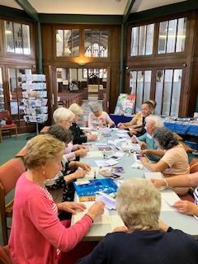 The finished articles* 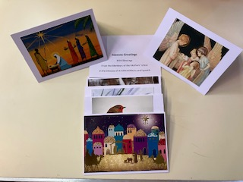

**Christmas Cards for Prisoners Workshop - East Bergholt - Thursday 8th September 2022**

It was a pleasure for Di Barker and I to attend the workshop for making Christmas cards for prisoners, held in St Mary’s Church, East Bergholt (see pictures below). MU Members, and friends, joined the workshop for all or part of the day. Di Barker explained the best way to glue the pictures, recycled from used Christmas cards, onto the printed blanks. We started at 11.30am and carried on until 3pm, with 22 participants helping throughout the day to make 614 cards. This was an excellent result and gave us a good start towards the 1,500 cards that will be needed for delivery to the prisoners at High Point Prison, near Newmarket, later in the year. Diocesan Members support this project by donating money to help with the costs involved and by saving their Christmas cards for us to recycle.

East Bergholt MU Branch also sang Happy Birthday today to two of their members - Joyce had her 90th birthday and Wendie had her 80th. Congratulations to them both.

Our thanks go to Jeanette Appleton for organising this workshop.

*Sue Norrington and Di Barker*

Two further sessions have been arranged to make more Christmas cards for prisoners -

Tuesday 20th September at Gt. Barton Institute IP31 2RJ from 1pm - 5pm

Wednesday 28th September at Sancroft Hall, Fressingfield IP21 5PB from 2 - 4pm All welcome, please contact Christine Christian for further information. Phone: 01379 853977

It was with sadness that we heard of Her Majesty the Queen’s deteriorating health at lunchtime today. In East Bergholt, we offered prayers for her Majesty, remembering her support as Patron of the Mothers’ Union. As I write this report, the death of Her Majesty the Queen has been announced. May she rest in peace and rise in glory. Our thoughts and prayers are with all who mourn her loss, especially her family.

*Sue Norrington*

**2023 Subscription**

The 2023 subscription has been set at a total of £24.50. This is made up of £21 for MSH, a £1 increase on 2022, plus £3.50 for our Diocesan funds, a 50p increase on last year. *Amanda*

*Acts 2: 1 - 4*

**Forthcoming Dates**

*Thursday 22nd September* - North Suffolk Area Morning.

*Friday 23rd September* - Zoom Trustees’ Meeting to discuss feedback from Re-imagining MU branch & area events.

*Sunday 25th September* - Church of England Generosity Week begins.

*Wednesday 28th September* - Christmas Cards for Prisoners Workshop at Fressingfield branch. The workshop starts at 2pm and finishes at 4pm. All materials are provided, along with refreshments. Sue Norrington will be there to teach everyone what to do. Come along to the Sancroft Memorial Hall, Fressingfield, IP21 5PD for an afternoon of fun & fellowship. Please let Christine Christian know if you will be attending on 01379 853977 - we’d hate to run out of cake!

*Tuesday 4th October* - Creationtide ends.

*Tuesday 11th October* - **“Ethiopia & Uganda from a Faith & Environmental Perspective”**.

A presentation by Amanda Langan at Claydon & Barham Branch, Barham Church Hall, Barham, Ipswich, IP6 0PT. All welcome from 2pm till 4pm. Clare is bringing the MUe stall too. **Booking essential**, please contact Amanda on 07906 584675 or by email at amanda.langan@mothersunion.org.

*Thursday 13th - Wednesday 19th October (except Sunday)* – NSA I-Chameleon Pop Up Shop (see above)

*Friday 21st October* - Trustee Board Meeting.

**Cathedral Visit**

Cathie McGregor visited the Cathedral recently to view the Creation tapestries, which she says were wonderful.

In the Cloister passage there was a display of pre-loved wedding dresses, attire and accessories from the St Nicholas Hospice Care shop at 87 St John’s Street, Bury St Edmunds. The shop, which is open Monday to Saturday 9am to 5pm, specialises in bridal and associated wear and Cathie felt that as it fits with the MU aim to support marriage and family life, and particularly as we are living in severely straightened times, she wanted to bring it to members’ and clergy’s attention.

They offer pre-loved wedding dresses, from sizes 8 to 26, for as little as £50. They also have an extensive range of exquisite bridal wear, bridesmaid dresses, suits, shoes, bags and accessories. In addition they are partnering with local independent dry cleaners Farthing’s at 17 Whiting Street, Bury St Edmunds, who are offering a 20% discount on professional cleaning for bridal wear bought from St Nic’s. A receipt will need to be shown.

Any purchases made from the shop supports the Hospice’s work with people in West Suffolk and Thetford who are living with long-term and life-threatening illnesses.

*Cathie McGregor*

**Away From It All Holidays**

Rev Andrew Dotchin of Felixstowe was able to deliver a Bag of Love to a family. They had been referred to me by Andrew, requesting a holiday. Sadly, they did not have transport, then with the cost of living going up very quickly I could not arrange a holiday. So, I put together a Bag of Love, with toys for the 4 children, vouchers for Dad and a Tesco voucher to spend on treats, food or essential school uniform. We have received thanks from four very happy children, and a grateful Dad. He has sent us photos of the children that he is happy for us to share with you.

   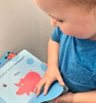

*Val Jeffreys, AFIA Trustee*

**Ipswich Area - Making a Difference**

Sandra and Christine had great pleasure in presenting Maureen Reynel at the FIND warehouse with 16 single duvet sets, and matching fitted sheets, in exciting designs for young people, together with 5 fitted sheets for double beds and pillowcases. Maureen had shared with Christine how she was determined that families with young people should have new bedding, appropriate to their ages, and like their friends at school. She also needed some fitted sheets and pillowcases for double beds.

Christine was delighted to find that Dunelm had a sale on and for £220 we fulfilled Maureen’s wish-list. Maureen also told us that she had spent £1,000 on school clothing, so far, but more was needed. As we can’t give her money, we offered to buy gift cards and Maureen asked for Primark ones. Partnership is a key word in our Re-imagining MU thinking so, before purchasing £100 of vouchers, Christine is going to contact Primark to see if they would be willing to match that figure. It is worth a try for a real need.

We hope members are pleased that the generous fundraising from Ipswich Area is reaping a good harvest.

We received a big thank you from FIND and we hope the young people enjoy sweet dreams.

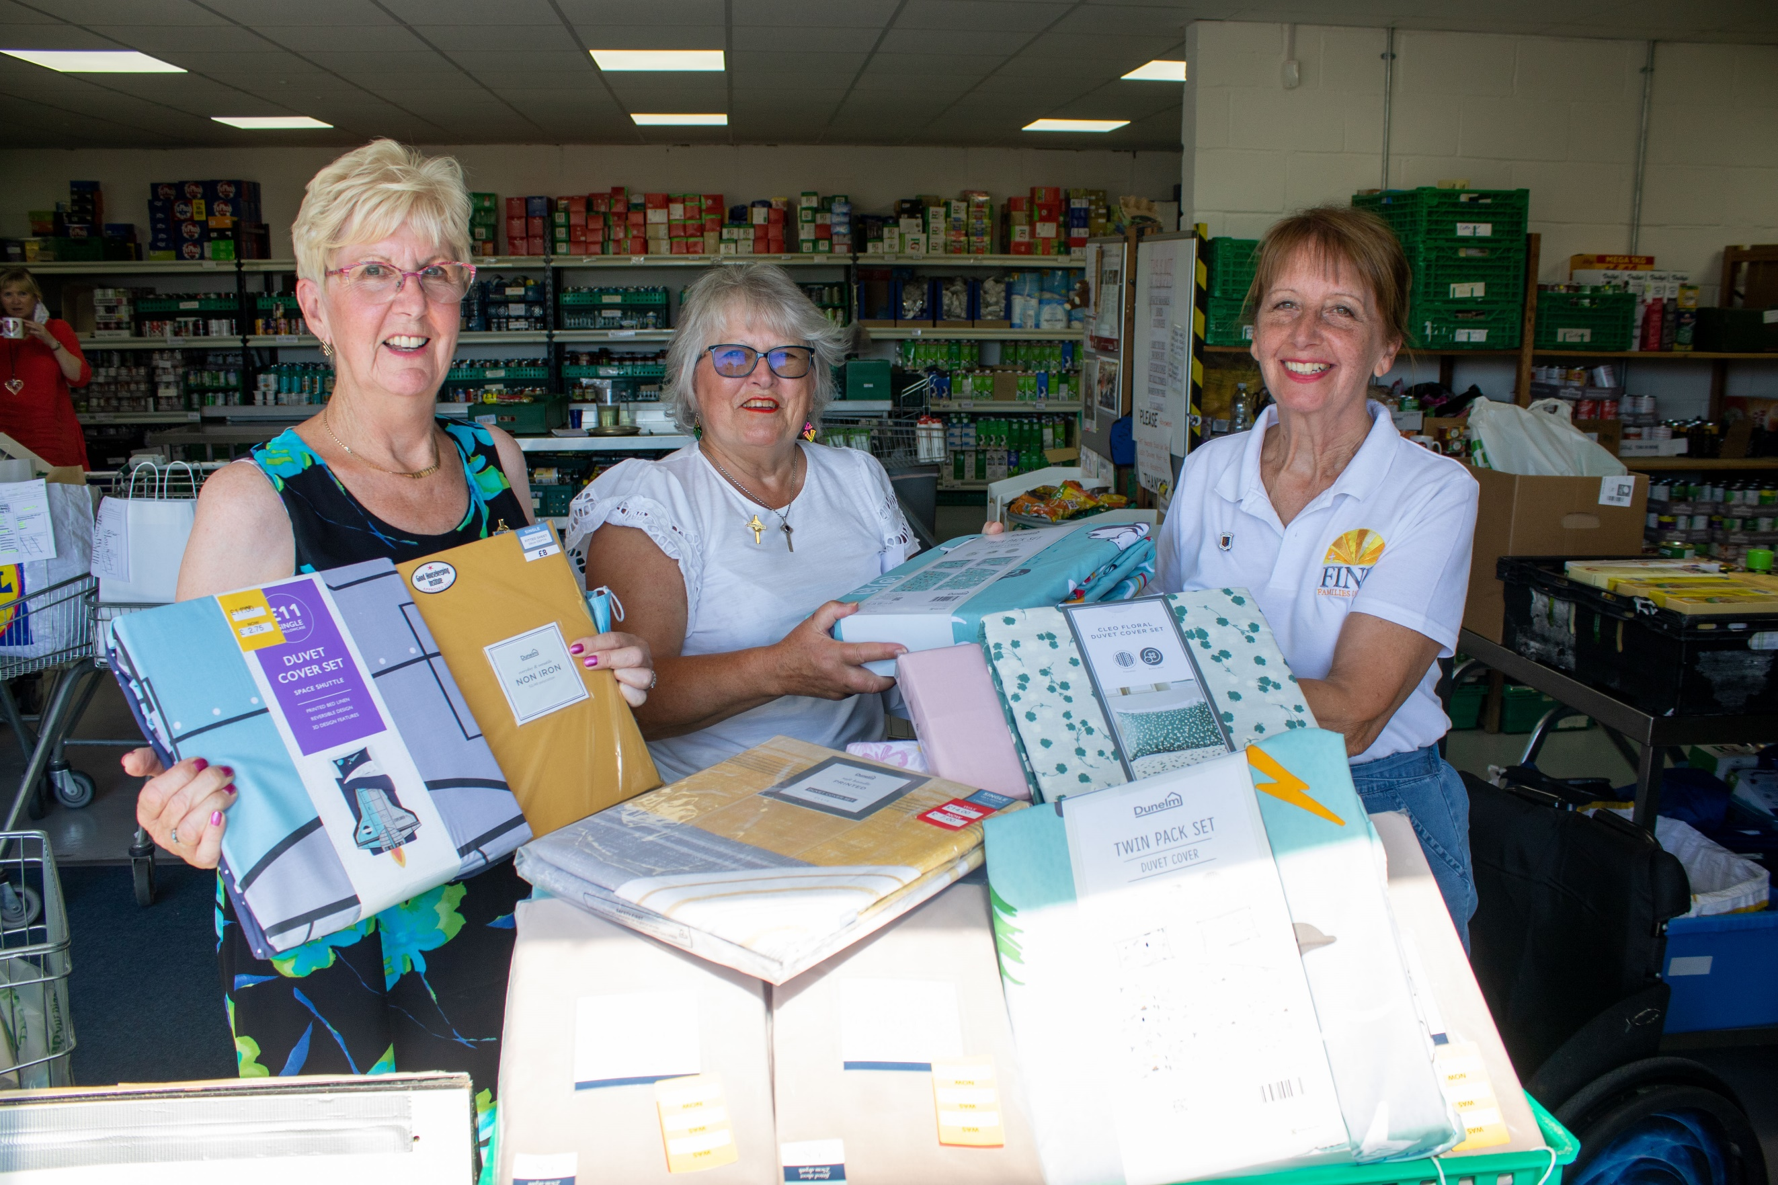

*Christine Ward*

**MU Charity Day at Frogmore House and Garden - Wednesday 31st August 2022**

I was privileged to be able to visit this significant Royal House and Garden, which is in reality a park, studded with magnificent specimen trees from across the globe given and planted by representatives and royalty from across the world over the past 300 years. The weather was warm and dry, enabling exploration across the winding paths, around the lake to the many stopping off places including Queen Victoria’s tea room, the Iron Bridge, the Royal mausoleum where Victoria and Albert are at rest, Sundial, Swiss Seat, Gothic Ruin and much more.

We arrived before opening time and joined the queue - the event was very well attended and we were able to purchase tickets for Frogmore House which had been given to Queen Charlotte by George III over 300 years ago. This has always been used as a private residence with the interior reflecting this.

The MU had a stall at the entry with a refreshment marquee beside the house. During tea taking we sat with strangers and engaged in interesting conversations. The visitors were not all MU members and I took the opportunity to share information about our wonderful movement. I met one MU member from Bury St Edmunds.

We stayed over in Windsor and visited the Castle where the magnificent Coronation gown was on display as part of the Platinum Jubilee exhibition.

I write this after the events surrounding the death of our beloved Queen and the proclamation of our new King Charles III. I am honoured and grateful that I was able to make this visit to help raise funds for the MU during this momentous year.

We are bereft of a generous patron and devoted monarch, who always put her Royal duties first, and this was her final gift to the Mothers’ Union.

*Cathie McGregor*

**Community of Interest Lead for Communications, Media & PR**

Some of you may have seen that I appeared in the Ipswich Star, East Anglian Daily Times and online with a crochet blanket that I donated to Barham Church’s September Fete. I donated the blanket to Claydon & Barham MU for them to raffle as part of their stall for funds towards the restoration of the church bells project.

Contacting the press was my first, experimental, foray into the world of media and I learnt two important lessons. Firstly, contact the press well ahead of time, because the article ended up being published after the Fete had already taken place; and secondly, ask to proof read the text before publication, because they didn’t get it quite right, despite my sending all the details by email.

You can read the online article and see some lovely pictures of the blanket at: www.ipswichstar.co.uk/news/health/amanda-langan-blanket-crystal-and-crochet-ipswich-9250422

Over the coming weeks and months I would like to start working with branch leaders to help get MU back into the public consciousness, post Covid, by providing some articles and suggested wording for items to go in our local free papers, such as In Touch, and in other village and parish magazines. Please do contact me if you would like any help writing, or publishing, news items or your branch programme.

*Amanda*

**MUe Sales News**

I received a spreadsheet from MSH recently, detailing the MUe sales that St Eds & Ips have made in 2021, and the amount of the TRG (rebate) that we have earnt back on those sales.

Penny and I are delighted to discover that we have come in 6th position out of 64! Many Dioceses with far more members than us have earnt much less.

Our TRG is £889.13 for 2021. The Trustees had already decided that this money should go to the Indoor Members Fund to assist with increasing postage costs. However, in light of the amount of the grant, Amanda will be raising it at the October Trustees’ meeting to discuss whether the monies should be split between other Funds as well.

*Clare Thomas*

**Ipswich Area Report**

Ipswich Deanery held a Tea & Cake Afternoon in July at St Mary Stoke. It was a most enjoyable afternoon with plenty of chatter and friendship. Clare & Penny brought the MUe stall, there was a bring & buy stall and a raffle. We raised £208 for Ipswich Deanery funds. I would like to thank St Mary’s for hosting the afternoon.

Ipswich Area will be having their Coffee Morning on Saturday 20th November, at St Michaels Church, Martlesham, from 10am till 12noon. All will be welcome.

Thank you to you all for all your support.

*Sandra Griffiths - Ipswich Area Rep*

**Hoxne Fellowship Group - Little Lambs Update**

The ‘Little Lambs’ mother and toddler monthly session has restarted after the summer break. We welcomed five little ones from the surrounding villages, including two who were new; one with their mum and one with their nannie.

An enjoyable session was had with toy cars, puzzles, printing shapes with paint and closing with the ‘Owl Babies’ story and our goodbye song. The grownups enjoyed chatting, sharing ideas and drinking tea.

*Cathie McGregor - Hoxne Fellowship Group*

**Re-imagining MU Conference Feedback**

We have had 3 face-to-face and 2 Zoom meetings so far, with one more face-to-face meeting to go as I write. The level of engagement and enthusiasm shown by members has been inspiring. The Trustees feel confident that we can meet our target, set for us at the end of July’s Re-imagining MU Conference at the Liverpool Hope University, of feeding back 3 key points to MSH by the end of the month, but this is merely the start of an exciting journey into the next few weeks, months and years.

The feedback so far has been both forward thinking and backward reflecting. Some of us have discovered that the MU aims and objectives used to be simpler, more straightforward and only 3 in number. We learnt that MU changed to the present 5 aims and objectives in the 1970s. It feels like the time may be right to consider returning to a simpler set that may, in fact, be far more appropriate for the changes in society that have taken place over the past 70 years of Her late Majesty’s reign.

I think we have all been encouraged by what we have learnt from, and shared with, each other during the feedback events. Thank you to everyone who has taken part for your willingness to contribute and for your open minds.

We now have feedback to consider at all three levels of our organisation, to MSH, at Diocese level and at branch level. We look forward to providing you with more updates very soon.

Thank you once again to Christine and Catherine for making the long trip to Liverpool, for being our delegates and St Eds & Ips representatives whilst they were there, and for participating in the feedback events back on home turf. Thank you too to Jeanette for her involvement in the original concept and for facilitating much of what has gone on in recent weeks.

*Amanda*

*Please, be kind to one other. We are all doing our best to navigate this strange old thing called life.*

**Important message to Branch, Deanery and Area Leaders**

Please would you ensure that you distribute this, and all future newsletters, immediately to your members, either by email or in print. **Please** don’t hold on to them and hand out 3 or 4 in one go.

This will ensure that members are kept up to date with everything that is going on in a timely manner - there will be a lot to impart in the coming weeks and months.

Thank you! - *from* y*our Trustee Board*

**Editor’s Note**

I have hugely enjoyed collating this month’s newsletter. I really hope you enjoy it.

Thank you to everyone for sending in such wonderful items.

I will write more about my plans for my new role as Community of Interest Lead for Communications, Media and PR in the coming months, but please feel free to contact me if you have any ideas, questions, suggestions, or would like any help with writing items in the meantime.

I will ensure that the Bags of Love article, which arose from the Ipswich Area Re-imagining Feedback Coffee Morning, appears in next month’s newsletter, after it unfortunately missed the September deadline.

If you have any comments or feedback on any item in here, or on the somewhat different layout, or on any other matter please either email me at amanda.langan@mothersunion.org or call me on 07906 584675.

Thank you & blessings to one and all.

*Amanda Langan - Diocesan Treasurer & COI Lead for Communications, Media & PR*