Transformation Now!

www.musuffolk.org.uk

Charity No. 249726

October 2023 No 45

Annual Gathering York September 22nd
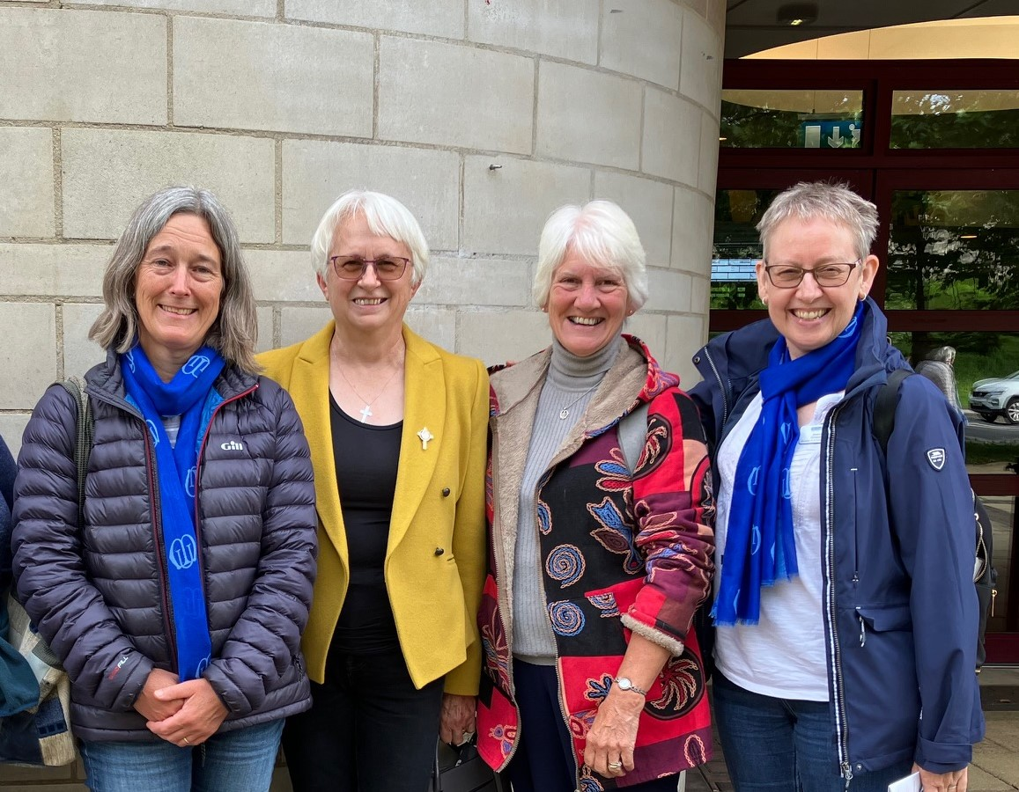
MU members from several branches across the diocese attended the Annual Gathering in York last month. The programme included a key note speech from our Worldwide President Sheran Harper who shared stories from MU projects and outreach across the globe. This included feedback from the Burundi literacy project over the past 20 years. 165,000 participants have now completed the course and 144,000 of which now have a qualification related to reading and writing. A new Savings and Agriculture group has been formed on the back of the literacy project, providing much needed resilience to the communities in Burundi.
The Team from MSH launched the new campaign to raise awareness of domestic abuse, with the title: RISE UP Against Domestic Abuse. The Aim is to ensure that our activism against domestic abuse happens 365 days a year and not just during the 16 Days of Activism.
The hope is that members and churches will unite and take part in this challenge completing various activities to achieve bronze, silver and gold awards. Information and resources for the challenge can be found on the main MU website: mothersunion.org.

Feedback from the fundraising events held nationally this year, £87,000 was raised for “Make a Mother’s Day” and £45,000 has been raised so far for the “Summer of Hope Appeal.”

In the afternoon there was a presentation on supporting the clergy relationship Galatians 6 v 9. The need to be a bridge in uncertain times was highlighted and the role of Mothers’ Union to stand in the gaps, in their church and community. To be the gift of reconciliation and peace-making, to have the gift of faith to be joyful, to keep the faith and to do the little things. This topic resonated with Jeanette Wallond from Southwold and Reydon branch as their congregation are nearing the end of an interregnum and look forward to welcoming their new vicar shortly.

Growing Mothers’ Union remains a challenge. The key is for us to ensure that our invitations, whether to friends or family members be personal, and we must also be persistent, remembering to key our focus on just being Christians together.
Archbishop Stephen Cottrell continued this theme in his address at Evensong for Mothers’ Union in York Minster. As he spoke of Mary Magdalene by the tomb on that first Easter Sunday he closed by saying that Mothers’ Union is there to wipe away the tears and point people to Jesus.
Is there a Mothers’ Union Branch in Arizona? Sue Norrington shares this encounter: After a downpour of Biblical proportions on the way to York Minster, our group from the Diocese of St Eds and Ips found a row of seats towards the back of the nave.

Almost without us noticing, the row in front of us was taken by a family of five – Mum, Dad and three boys. Holding the Order of Service for Evensong, the Mum turned round to ask, “Are you a Mothers’ Union member?” “Yes,” I said “Are you a member too?” “No, but I’ve just read your objectives and they are so important”
“You should join Mothers’ Union,” I said and she replied, “Is there a branch in Arizona?’

We looked on our phones but no branch near to her home could be found. This was a Christian Mum of 7 children, 6 boys and 1 girl – who was obviously deeply concerned for her children’s spiritual development. Their holiday in the UK had been a long time in the planning and here they were participating in our MU Evensong! We gave her information about MU websites, an MU polo shirt and a badge. We welcomed her. Evensong in the Minster with a full congregation, wonderful singing, a holy place of prayer and power was a moving occasion for us all. At the end of the service she was crying, overwhelmed she said by all these Mums( Moms!) We spoke again. We wished her a safe journey home we hugged her. We may not have a branch in Arizona but MU prayerful concern reaches there as it does so many other places across the world.

There will be more information from the Annual Gathering at our Diocesan council meeting in November at the new venue of Coddenham Village Hall, Mary Day Close, Coddenham, IP6 9SR 9.30-1.00 pm on Thursday November 30^{th.} A video of key presentations will also be available on YouTube.

Healing and Wholeness service Wednesday 18th October 2023 at 11.00am
At St Edmundsbury Cathedral Bury St Edmunds, IP33 1LS Rev Catherine Forsdike will preside and the preacher is Canon Pastor Matthew Vernon. The service will be live streamed via Cathedral Facebook page. You are welcome to bring a packed lunch for after the service that can be eaten in the cathedral or visit the Pilgrims Kitchen for refreshments. Please invite friends and family members to attend this special occasion, everyone is welcomed.

If you are unable to attend the Healing and Wholeness service there is a Clewer Anti-Slavery day Lunch and Learn Training on Wednesday 18th 2023 at 13.00 to 14.00 via zoom. To book your place get free tickets from clewerinitiative@churchofengland.org website. There are also details of the Clewer lent course for you to download.

Lilian Rose
The death has been announced of Lilian Rose on Tuesday 22nd August aged 84.
Lilian worked at Diocesan office as a secretary in many different departments, as well with a variety
of clergy over the years. She was Mothers’ Union diocesan secretary working with three Diocesan Presidents, Joyce Starling, Catherine Prophet, and Val Jeffreys. Her funeral took place at St Mary’s Coddenham were Lilian worshipped and also played the organ. Members of Mothers’ Union attended her funeral. Please remember her son Simon and daughter Charlotte and their spouses together with her 3 grandchildren, in your prayers.

Plug into the power of prayer; This prayer has been written for the Rise Up campaign, please make this part of your prayers.
God of justice, peace and compassion, Heavenly Father, Creator and sustainer of all,
We thank you that you gave yourself, your own Son, to give every person the opportunity to turn from darkness to the light of your presence and love.
We know that all those who endure cruelty and abuse are precious in your sight, that no tear falls without your knowledge and love, and we ask that they would know your presence, strength, comfort and wisdom – even in their fear, confusion and pain.
We commit ourselves, those who have experience of abuse, those whose loved ones have experience of abuse and those of us who enjoy safety and peace in our relationships – to RISE UP against domestic abuse in all its forms.
We pray - for your compassion as we seek to RESPOND – for your wisdom as we become better INFORMED – for your gentleness as we try to SUPPORT – for your strength as we hope to EMPOWER – and the mark of your Holy Spirit that UNITES us together to work and PRAY unceasingly, until situations change and freedom, life and love is restored to all. In your dear and powerful name, we cry out to you together. Amen

