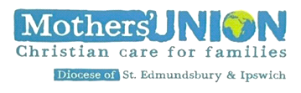

Transformation Now!

www.musuffolk.org.uk

Charity No. 249726

November 2022 No 34

What are we doing on Global Day Saturday 26th November?

This year Mothers’ Union members are coming together on Saturday 26 November, marking it by wearing special #nomore1in3 badges, available from our online shop. (You can also make use of purple scarves from last year’s event, or make your own awareness ribbon pin.)
Mothers’ Union members are being asking to hold a one-minute silence at 1.03pm on 26 November 2022 (linking to the no more 1 in 3 theme). This might be on a small scale, in homes or branch meetings, or on a large scale – in community venues, churches and cathedrals.
Central Mothers’ Union want to make this as big as we can, combining the voices of our four million members around the world – calling for action on an international scale and in the countries where we live. When holding a group event, wear your badges to show you are making a stand against gender-based violence.

If you take photos of your one-minute silence please consider posting them on our MU Suffolk Facebook page. Or send them to: clare.thomas@mothersunion.org to be posted on our diocesan website. musuffolk.org
Speak up for those who cannot speak for themselves; ensure justice for those being crushed. Yes, speak up for the poor and helpless, and see that they get justice. Proverbs 31:8-9 (NLT
Re- Imagining Mothers’ Union
All the feedback from the various discussion sessions held in September were collated and three main themes emerged as priorities that you, the members, have identified.
- Introducing new ways of being Mothers’ Union
- Raising the profile of Mothers’ Union
- Working more visibly within the church and community

An action plan has been sent to Mary Sumner House with details of how each of these priorities will be achieve. Come to Council 10.00am on Wednesday 16th November at the Salvation Army Centre Violet Hill Stowmarket to hear more about how we are moving forwards with re-imagining Mothers’ Union.

Agents of Hope
At the recent Diocesan Synod Bishop Martin talked about Christians being Agents of Hope. Let us borrow this phrase, so that when anyone asks you about Mothers’ Union, tell them we are Agents of Hope. Agents of Hope through our prayers, the items we donate, the items we create, the fellowship we share and the ways in which we serve our communities.

New Craft Projects
Following an event at the cathedral in October during Prisons week a new knitting project has been launched. Knitting brightly coloured hats, scarves and gloves for the prisoners at Highpoint. These items can be left at the cathedral to be collected and taken to Highpoint, or bring them to council.

Mary Sumner set up Mothers Union to support new mothers. Since we are not able to knit for the Neonatal Units, we have a new craft project which enables us to once again support new mothers. Health Visitors and midwives in Suffolk would appreciate us knitting a teaching resource to promote breast feeding. The pattern is available on our website and there will be copies of the pattern at our council meeting on November 16th. This is an ideal project to use up small balls of any colour of wool. Lise Locke, the head of the Suffolk Infant Feeding team would love to give every member of her Suffolk wide team one of these resources.

Making Mothers’ Union visible
So that we can promote Mothers’ Union a new batch of “Made by Mothers’ Union with love,” labels will be available at council. These are ideal for sewing to all the knitted items you make. You can contact Cathie McGregor: catherinemcgregor211@gmail.com if you need some sent to your branch.

Promoting Marriage is one of our aims. St Nicholas hospice in St John’s Street, Bury St Edmunds has a bridal shop selling pre-worn vintage, modern bridal wear. Please share news of this shop with couples having their weddings in your parishes.

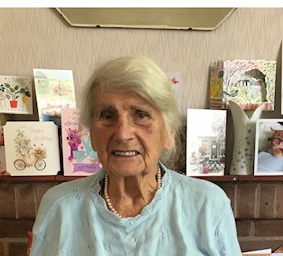
What is the secret of a long life?
Judging by the fact that we have 8 Mothers’ Union members who are over 100 years old, it could be a life dedicated to serving others and enjoying the fellowship of a Mothers’ Union branch.
Many congratulations to Ivy of Bures branch who, at 101 last month, has just joined this very special club.

Ipswich Area will be having their Coffee morning on Saturday 20th November, 10am – 12 noon at St Michaels Martlesham. Do come and support this excellent time of fellowship as well as being a most successful fund-raising event. Bring friends and family along as well.

North Suffolk Area had a busy week with the i-Chameleon pop-shop, raising £2,000 for Mothers’ Union general funds. The work does not finish when the pop-up shop closes as the unsold items need collecting, sorting and sending on to other places, where they can be sold or put to good use.

St Margaret’s branch Ipswich are back in full swing and at their meeting this month members spent time considering ways in which they could re-imagine Mothers’ Union in their branch. Their members have over 300 years of Mothers’ Union membership between them. A wonderful witness of the presence of Mothers’ Union in the centre of Ipswich.

Prayers:
Lord of justice and mercy,
who has called us to be the body of Christ,
use us as his hands and feet in the world;
to raise awareness of what must be challenged,
and to address the plight of the vulnerable.
We unite together across the world
to champion the cause of justice
and to offer up our prayers for all who
are affected by gender-based violence.

