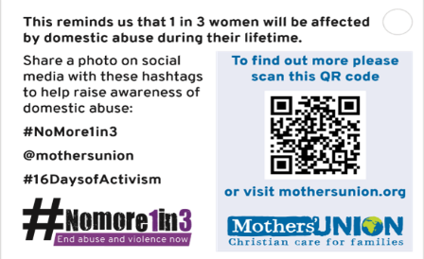
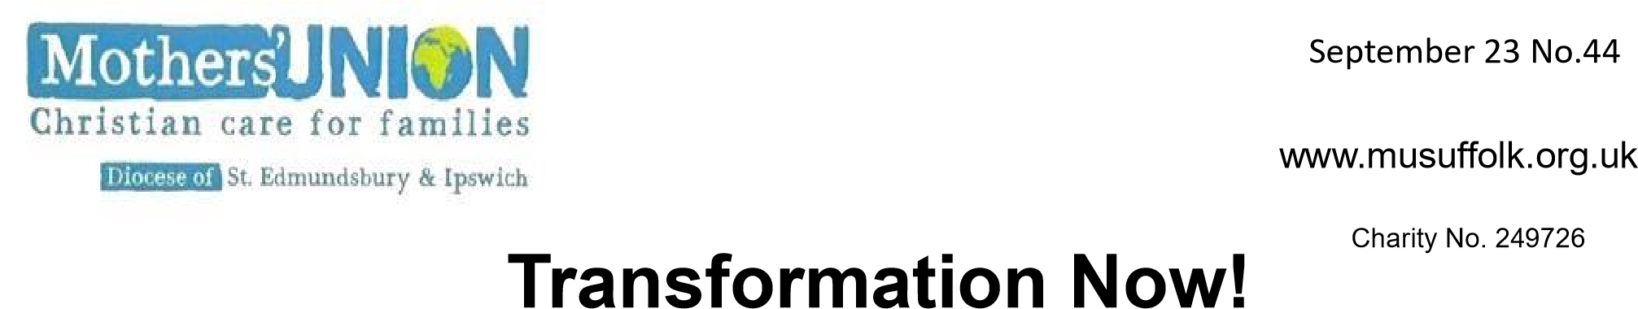
November 23, No. 46

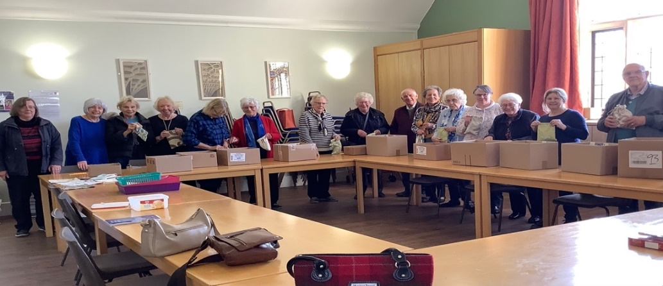
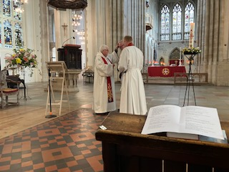
St Luke's Day A service of Healing and Wholeness on the feast of St Luke (18th October) for the Mothers' Union was held in our Cathedral at Bury St Edmunds. It is always good to worship at the Cathedral, and we were made to feel very welcome. The service was led by our Chaplain, Rev Catherine Forsdike (and still nursing a shoulder injury, she appreciated a little help from her husband, Alan), The address, given by the Canon Pastor, the Rev Matthew Vernon, was both interesting and inspiring, and our former Treasurer, Keith Foulds, enthusiastically played the organ accompanying meaningful and well-chosen hymns. Around 30 MU members participated in receiving both the Anointing and Holy Communion. How much our world needs healing and wholeness, especially as our thoughts turn to recent events abroad and domestic violence at home. The service was a beautiful and healing oasis in a troubled world. Our sincere thanks go to all who made it possible.

Cathedral Branch Members
St. Luke’s Day Service

Recent Cathedral Branch Activities
In October at the Prison Sunday Service, members made Scones, Cakes and Biscuits for the discussion afterwards in the Edmund Room. For our monthly meeting our Branch filled handmade bags with toiletries collected by our members and Cathedral Congregation. Forty- two bags were filled ready to be given to the Bury Refuge Centre.

Well Done MU Members. We know that many MU members participate in activities in our parishes. They deliver Open the Book in local schools, help with foodbanks, assist at ‘Meet up Mondays’ and support toddler groups. A new Toddler Group is being planned in Yoxmere Benefice and we pray that it will thrive. Don’t forget to make a note of MU member’s involvement in these activities through the year, just as you record when craft items like drain bags and knitted hats are produced. The records that we keep are put together and show the impact Mothers’ Union is having in our communities.
I Chameleon – North Suffolk Area ran the Pop-Up Shop in Halesworth again in October. Thank you for all the items that were donated and to all the people who supported the shop. It is always a good opportunity to promote MU and to be visible in the High Street. We talked about MU with our customers and handed out leaflets. It is always a busy time preparing to open, running the shop and clearing up but it is very much a team effort. Unsold items were given to local charity shops and books went to Sibton Church for their next book sale. This year, our takings, over the week, exceeded £2,000 which was a very pleasing result.

Ipswich Area Coffee Morning will be held on Saturday 18th November at St Michaels
Church, Martlesham - 10am – 12noon. There will be a range of stalls and everyone is welcome. This year we will be buying gift vouchers to support the women at the Refuges in Ipswich and Bury St. Edmunds. Further information from Sandra Griffiths 01473 254653.
A message from Clare Thomas
We are aware that there have been some problems with members not receiving ‘Connected’ in other dioceses, and we would be grateful if you could let us know if you have not received your recent copy. Some members have opted out of ‘Resources and Campaigns’, and therefore would not receive Connected, but all other members should have received their copy earlier in October. Clare Thomas (01473 832808) can help with this.

A date for 2024 to put in your diaries at Claydon and Barham Branch
On the 9th of March we have Richard Platt speaking to us about how he has overcome his deafness.
He has an amazing story to tell as he was born with no hearing and with much help has found his voice. He now helps young people as Chair of a Charity to learn to speak. We meet at 2-00pm in Barham Church Hall. Please contact Jane Whight on 01473830543 for more information.

Ways of being Mothers' Union Needham Market branch meet on the 3rd Wednesday at 12noon in a member’s home. We are a small group and just enjoy meeting together over lunch. Our branch leader shares the latest Mothers' Union news. We always end with prayers, with different members sharing this role. We do have speakers but these can be from our church or we pick a topic to discuss.

Community of Interest Against Modern Slavery and Trafficking The issues and concerns at the heart of the ‘16 Days Activism against Gender Violence’ are also found in our work with Modern Day Slavery. Please include those being Trafficked into Slavery and people working in Suffolk with victims and survivors of Modern Slavery in your prayers. Mothers’ Union and other organisations work to raise awareness of MS &T in the wider community. We are the eyes Clewer needs and Suffolk Police depend on us to be aware of pointers to MS&T ‘right where we are’. This link reaches resources to raise awareness in our church life and worship https://thirtyoneeight.org/downloads
If your Branch would like to receive an interactive session for a meeting, whatever the size of your group, then I would love to visit you. Please contact me on cmward1@btinternet.com or phone 01473 327697. I can also post you a card with helpline numbers to display in your Church/community. Christine Ward
The Global 16 Days Campaign is an international campaign to challenge violence against women and girls. The campaign runs every year from 25th November, the International Day for the Elimination of Violence against Women, to 10 December, Human Rights Day. More information can be found at www.musuffolk.org.uk
Metamorphosis Bitesize Evaluation Survey – a request from Sarah at Mary Sumner House asking branches to help with the online survey - https://forms.gle/ZjcA2MebKDaD1X9k6. It is designed to gather quick responses to get feedback, and to have an idea of what could/did motivate you to use Metamorphosis Bitesize. What has it contributed to you personally, your church and your community? Would anyone be willing to have a half hour chat with her to talk about how they’ve found the resource and how they’ve used it? - Contact Sarah via Linda Ginn at 01728 648772.
Prayers
In our troubled world we pray for areas where there is animosity, grievance, hatred or war. We pray that in these areas new seeds may grow to encourage a spirit of good will, a wish for conciliation and reconciliation, a quest for kindness and mediation.]
Thank you for all those who help others in the neediest parts of our world. Although we don’t know them or the people they help, we pray for them. Amen
Pray not for Arab or Jew - For Palestinian or Israeli – But Pray rather for ourselves – that we might not divide them in our prayers but keep them both together in our hearts. Amen

