Transformation Now!

www.musuffolk.org.uk

Charity No. 249726

March 2023 No 38

Re-Imagining Mothers’ Union Discovery Day:
Friday June 23rd 10am to 3pm
Venue: Shepherd Drive Baptist Church, Ipswich IP8 3SL
We look forward to having Mothers’ Union members from branches across the diocese come together, to share ideas and address the challenges of running branch accounts, maintaining branch leadership roles and growing branch membership. As well as developing new projects and outreach programmes.
Shepherd Drive Baptist Church on the Pinewood estate is a modern, fully accessible building with a large car pack, just a short distance from Suffolk One and the Tesco store at Copdock. To book your free place contact: e: Jeanette.Appleton@mothersunion.org. m: 07768 418942
Quiet Day North Suffolk Area are organising a Quiet Day at St. Peter’s Church, Holton on 26th June, from 10am to 3pm.The day will be led by Revd. Margaret King, who will use Icons as a theme during the day. Tea and coffee will be provided but you will need to bring a packed lunch. To book a place please contact Janet Walkey on 01986 872594.
Branch Meetings – if you have a Speaker for a meeting, please offer travelling expenses which should come from your Branch Funds.
A.F.I.A. – Away From It All is a Mothers’ Union holiday or day out scheme. Money is raised by MU members in our diocese to support this scheme. It is open to anyone who is under stress. The applicant is asked to complete an application form and someone who knows them in a professional capacity like a doctor or a headteacher also needs to fill in a referral form. Holidays or days out can take many different forms. Please contact AFIA Trustee Val Jeffreys at afiamusuffolk@gmail.com for a grant application form or further information.
Lady Day - Holy Communion Service – This will be held at St. Michael’s & All Angels Church, The Drift, Martlesham Heath, Ipswich IP5 3PL on Friday 24th March at 2.15pm. and will be led by Revd. Catherine Forsdike.
Suffolk Show - 31st May - 1st June– This year Mothers’ Union has an opportunity to be involved in the Church Tent at the Suffolk Show. It will be an opportunity to talk about MU and to have literature available as well as suitable Children’s activities. If you can offer any help with this please contact Linda Ginn on 01728 648772.
Can you help? - Mothers’ Union in St Eds and Ips, currently has need of a Diocesan Treasurer and an Emergency Prayer Chain Co-Ordinator. The Diocesan Treasurer does not have to be an MU member. Could you help us, or do you know someone who could? Please contact Linda Ginn about these posts on 01728 648772.
Baptism Book – We are starting to think about writing a Baptism Book that could be given to parents when their child is baptised and would contain suitable prayers. If you have any original material that we might include please email me – Sue Norrington at. farthings@btinternet.com. We cannot use prayers from other publications, because of copyright issues.
Marriage Week 2023. St. Mary Stoke in Ipswich decided to arrange a display in Marriage week this year. We have never participated before but thought this may help encourage couples to have church weddings. We have found when we used to attend wedding fayres ‘pre-covid’ several couples said they would think of holding their wedding in church instead of a hotel etc. We borrowed a wedding dress and bought a cheap dressmakers dummy to show it on. We had copies of wedding photos from members of the congregation past and present in an album (this caused great interest on the 2 Sunday mornings after the service). Our priest-in-charge Rev Sophie Cowen contacted two local schools and the children did paintings of the church and wrote about what love is. Their work was displayed around the church. There were also envelopes with appropriate passages from the bible for visitors to take and other wedding items displayed around the church. We had several visitors over the 3 mornings we opened the church, it was good to have members of the public enter the church to look at the display. We were able to talk to them and explain what Mothers’ Union is and that we have this week each year to promote church marriages. We will certainly be holding another in 2024 and hope more will visit us with a view to church weddings. Beryl Mee (It was an excellent display – well done! LG)
A photo of our display
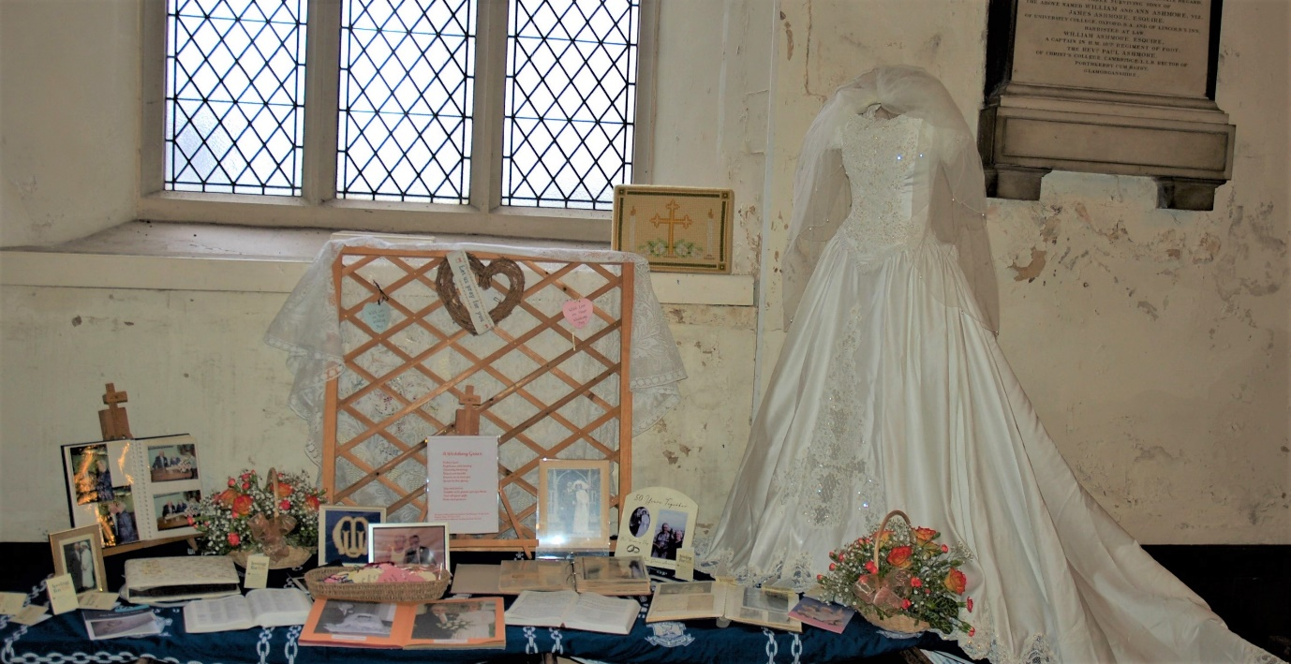
Vocations Fair – This event will be held in the Cathedral Cloisters on 29th April between 10am and 1pm. Mothers’ Union will be having a table to display MU literature and members will be available to talk about our work and how we can support clergy in Prayer and Action. If you can offer some help at this event, please contact Linda Ginn 01728 648772.
AGM St. Michael’s Church, The Drift, Martlesham Heath IP5 3PL on Monday 17th April at 2pm followed by a Council Meeting in person and via Zoom.
Prayers: Please pray for the work of MU in this Diocese and for new Trustees who will be needed to take MU forward as we reach the start of a new Triennium in 2025. We pray for prisoners and their families, for prison staff and for the Chaplaincy Team at Highpoint. Dear Lord, In an increasingly secular world please hear the prayers of Mothers’ Union members across the world as we strive to support marriage and family life.
I find that I often remember these words from the old MU Prayer.
Bless the members of the Mothers’ Union throughout the world, unite us in prayer and worship, in love and service, that strengthened by your grace, we may seek to do your will; through Jesus Christ our Lord. Amen

