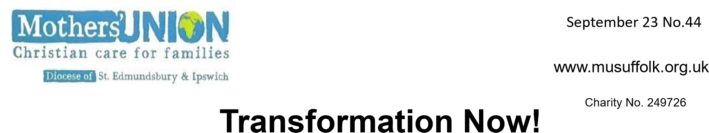
March 2024 Number 50 Number46
Lady Day Service. This year our service will be held on March 22nd at 11am. In St Peter & St Paul Church, Lavenham CO10 9SA. Maybe this could be an opportunity to look round Lavenham and have a pub lunch after the service.
North Suffolk Area Quiet Day will be held on Wednesday 26th June from 10am- 3pm in Wenhaston Church. The day will be led by Revd. Andrew Vessey. The MU Branch. in Wenhaston will
provide Tea/Coffee during the day. Please come and join us for this day of Reflection and Quiet - something that is often missing in our busy lives. To book a place or for further details please contact Christine Christian 01379 853977.

Ipswich Area has purchased 12 vouchers from ‘Pennikkity Pots’ to the value of £144 and has also purchased Easter Eggs for the Woman’s Refuge in Ipswich. Jane Leung will be doing the same for Bury St Edmunds Woman’s Refuge. Christine Ward is going to purchase 3 vacuum cleaners at £40 each and mattress covers and duvets sets for FIND. Thank you to you all for your continued support. Sandra Griffiths - Ipswich Area Rep.
MUe Most of us will have received the new catalogue recently which has some lovely cards and gifts.
Don’t forget that you can order through Clare Thomas 01473 832808 clare.thomas@btinternet.com who holds stocks of most items. Clare is able to deliver to some areas of our diocese and makes a small charge if she has to post items. Sometimes it is possible for orders to be collected from MU events which means there is no postage to pay.

90th Birthdays – Margaret Rollins sends out birthday cards to MU members who reach their 90th Birthday and then continues to do this for subsequent years. She relies on Branch Leaders to keep her informed if they have members who celebrate their 90th birthdays and also to let her know if there is a change in circumstances, so that a card is not sent inappropriately. Margaret relies on branch leaders to be her eyes and ears! She can be contacted on 01473 623868 mhrollins09@gmail.com
Our first Mothers’ Union Member’s Day was a great success. Sixty people came from across the diocese to St Michael’s Martlesham Heath for a time of faith, fun and fellowship. With the Metamorphosis Bitesize resource ‘Stepping out of the Boat’ as a basis for the day, members explored the challenges and opportunities of stepping out of their comfort zone as we meet the needs of our communities. There was a real buzz in the hall as people visited the Mothers’ Union pop-up shop and they were able to meet and chat with members from other branches. There were opportunities to find out about new craft projects and to discover ways to promote awareness of the issue of domestic abuse, alongside the national RISE UP campaign. Feedback from those attending was very positive. However, next time we need a venue with a larger car park and working hearing loop! Jeanette Appleton
Mothers’ Union A.G.M. April 23rd 10 am followed by Spring Council Meeting at 11am
The Coddenham Centre, Mary Day Close, Coddenham IP6 9SR

This is an important meeting for all Mothers’ Union members as we reflect on the activities and achievements of Mothers’ Union in our diocese during 2023. There is a large car park adjacent to the Coddenham Centre, for sole use of hall users and there is level access to the hall. This venue is close to the A14, A140 and A1120, just east of Needham Market, hopefully making travel to the venue as easy as possible for our members across the diocese. After the 45-minute AGM there will be time for refreshments and catching up with other members before we have our Spring Council meeting
Ipswich Area Coffee Morning is booked for Saturday 16th November 2024 at St Michaels Church Martlesham 10am – 12noon. Please put this date in your diary.
News from Kagera As I write this, Bishop Mike and a group of eight curates are in Kagera to learn and share what it means to be part of a link Diocese. Some of you may have seen in eNews or on Facebook the joy, the warmth, the love that is being shared. We continue to support some great projects there. Water tanks are being built, motorbikes bought, students being trained in theology and agriculture and an ophthalmologist is being trained. Last year we were able to take out refurbished laptops for the bible college and others and reading glasses for the hospital.
The 2024 Bishops’ Lent Appeal is well underway, but it’s not too late to order Lent Leaflets to learn of the transforming work being done there. Have you a laptop to donate or reading glasses? And Chris and I would love to come and talk to your group. Do contact us on kageralink@gmail.com
Anji &Chris Dawkins

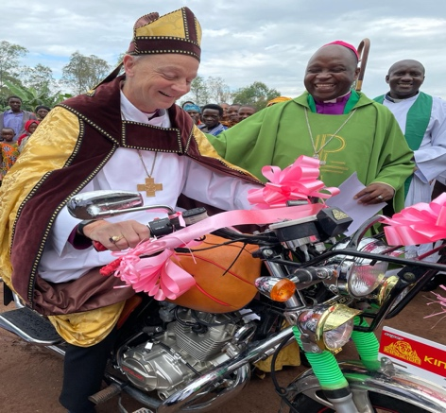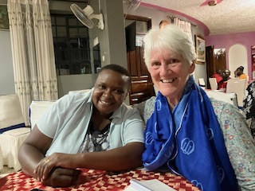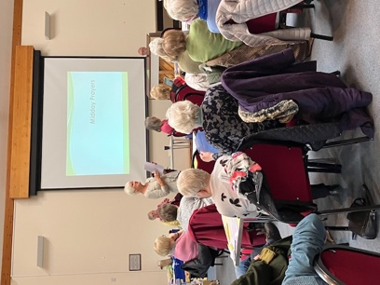

To all Mothers’ Union Members,
Life Vice Presidents, MU Friends and Supporters.
May the faith of Easter strengthen you
Its joy, gladden you
And its peace, remain with you

This comes to you with our love and prayers
from the St. Eds and Ipswich MU Trustees and Officers
Heidi Samuelson on Unsplash

DP Linda ‘s Visit to Kenya. Linda found out about the Anglican Church’s ‘Five Talents’ microfinance charity which works in partnership with MU. It supports Savings Schemes, Literacy and Numeracy Training and Business Training for communities across Africa. (See the recently published Burundi Report) The concept of the ‘Five Talents’ savings Group revolves around stewardship and Empowerment. Linda met Emmy Ronoh, a former MU Coordinator, who trains the trainers for this project and attended a monthly training session held in a small rural village. This session started with Prayer, allowed the women to deposit various amounts of money and had a teaching element from Frida. After the meeting Linda was taken to a profitable brick making business run by women. She saw other success stories showing that the group are exploring imaginative ways to increase their productivity and plan for the future. In December the Savings Group becomes self-sufficient and both Emmy and Frida will move on. The project empowers members through Education and Training so that they can take ownership of their own finances and earning potential.

