Transformation Now!

w
ww.musuffolk.org.uk

Charity No. 249726

May 2023 No 40

There are still a few places available for the Re-Imagining Mothers’ Union Discovery Day on June 23rd at Shepherd’s Drive Baptist Church 10.am to 3pm. Please contact Jeanette Appleton on 07768 418942 to book your place. Currently 24 of our 31 branches and Fellowship groups will be represented.
Quiet Day North Suffolk Area will be holding a Quiet Day at St. Peter’s Church, Holton on 26th June, from 10am to 3pm.The day will be led by Revd. Margaret King, who will use Icons as a theme during the day. Tea and coffee will be provided but you will need to bring a packed lunch. To book a place please contact Janet Walkey on 01986 872594.
Suffolk Show This year, Mothers’ Union had an opportunity to be present at the Suffolk Show. During the two days over many Mothers’ Union conversations were had with visitors to the Church of England tent and children were given some 120 MU stickers!
I Chameleon Pop Up Shop in Halesworth -12th -18th October 2023
This major fundraising event needs your support. They are looking good quality china, glass, household items, pictures, fabrics, jewellery, scarves, bric a brac etc. If you have any items like this, that you would like to donate, please contact Anna Vessey 01379 588389. Also don’t forget to put this date in October in your diaries and come and support this Pop-Up Shop in person and why not bring a friend with you.
Hunt the orange
Find a chocolate orange or a fruity orange
£1 per play
Choose your hat without touching it.
Keep your prize, but the hat is just the right size for a premature baby so please consider donating it to our local neonatal unit
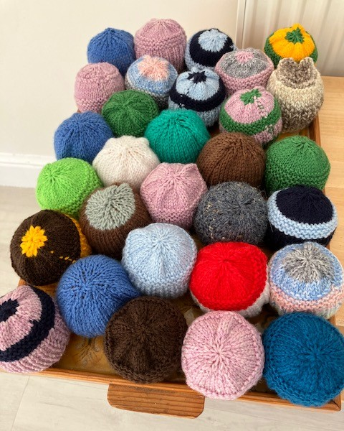
Summer of Hope. East Bergholt and Brantham branch had an Afternoon tea to support the Summer of Hope Appeal. One member introduced a new fund-raising idea Hunt the orange. Under the hats are mainly orange fruit with just a few chocolate oranges.
Two Events for the Summer of Hope Appeal
On Thursday 3rd August - 2.30pm - Fressingfield Branch will be having a Garden Meeting to be held on the Sancroft Hall Green in Fressingfield. There will be Stalls and Refreshments.

If you can’t make the Garden meeting then come to the -Cream Tea on Thursday 17th August at 2.30pm to be held in the Garden of Farthings, Sibton Road, Peasenhall IP17 2JF

The Cathedral branch had a very successful Strawberry Tea recently, raising £809.20. This, was achieved in part due to highly successful Blind Date with a Book stall. Wrap up a secondhand book, adding just the synopsis written on a label.. For £3 people chose their book blind, based only on the synopsis and not the artwork or title.
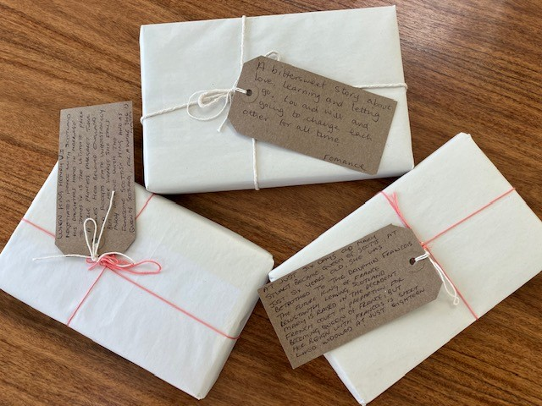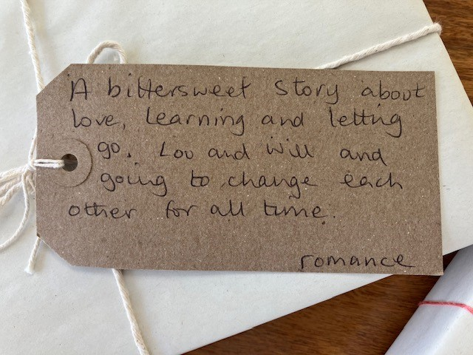
A very big thank you to Elizabeth Nunn for hosting this event and to some of Elizabeth’s family members for helping with the Teas and her granddaughter for selling jewelry.

Risk Assessments for all your extra events. A risk assessment should be carried out whenever your branch plans an event. It will help you to make the event safer for everyone - members and visitors. Our MU insurance will only cover your event if you have given details of the event and a copy of the risk assessment to the Diocesan Treasurer, Amanda Langan. There is a Risk assessment form for you to download from the musuffolk.org website under resources for branches. There is also an event checklist which is a good reminder of all the different things to consider when planning an event.
New Prison outreach project. Partnership with the chaplaincy team at HMP Highpoint has opened doors for a new Mothers’ Union outreach to support the families of offenders in HMP Highpoint. This new initiative needs a new team of people to steer it forward under the guidance of a new Community of Interest (COI) Lead. Contact Linda Ginn at Linda.Ginn@mothersunion.org if you feel called to be part of this new outreach providing Christian care for families.

Mary Sumner House need your help> Mothers’ Union are working with the Church of England to ensure we are all equipped to recognise and respond to domestic abuse. In partnership with colleagues that have been involved with Diocese of Melbourne and the Cumbria research project, we have developed a baseline survey which will allow us to further understand our current culture, behaviour, skills, and knowledge in terms of recognising and responding to domestic abuse.

The button below will provide you access to the survey, which is open to all to complete and completely voluntary. The survey is constructed around 15 multiple choices questions and takes 10-15 minutes to complete, with no personal identifying information required. You are able to specify if you are a Mothers’ Union member in the survey. If you receive a printed copy of this newsletter and you want to participate in this survey you will need to log on to our musuffolk.org website and access the survey that way, either at your local library, or through a friend/ family member with internet access.

Sur

Standing down at the end of 2024 are Monica Twaits Indoor members rep, Jancie Brett World Wide rep and Val Jeffreys AFIA rep. Trustees are so grateful to Monica, Janice and Val for their faithful service in these roles. With this advance notice we can pray that these important and very rewarding roles can be filled. All these roles are mainly administrative and can be carried out from home. Having access to email and a computer will be essential. Contact Linda.Ginn@mothersunion.org for more information
Summer of Hope Prayer
Lord, help us to love our neighbours that this may be a summer of hope for those struggling with life’s demands: To help create change for good, Lord, prompt us to pray. Where resources are lacking, Lord, move us to generosity. Lead us to take the steps we need to enable hope to grow into reality. Amen.

