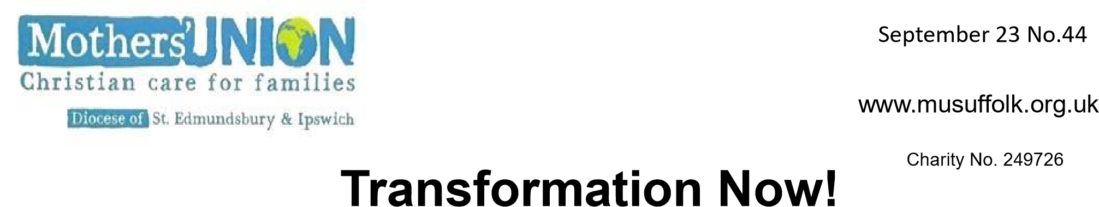
January 2024 Number48 Number46
Fressingfield Branch held their annual Advent service followed by a splendid tea, prepared and served by members. There were 40 people present to enjoy a very pleasant afternoon.
We also participated fully in the Rise Up campaign. There are six parishes in our Benefice, and we have MU members in four of them. Members crocheted, knitted and sewed purple and white hearts to enable us to put up Rise Up posters and hearts in five Churches. We prayed for them as part of our Advent service and also in Mendham church among the intercessions on the first Sunday of the campaign. We now have laminated copies of the Rise Up poster in the toilets of four village halls and one church (the only one with a loo). Christine Christian

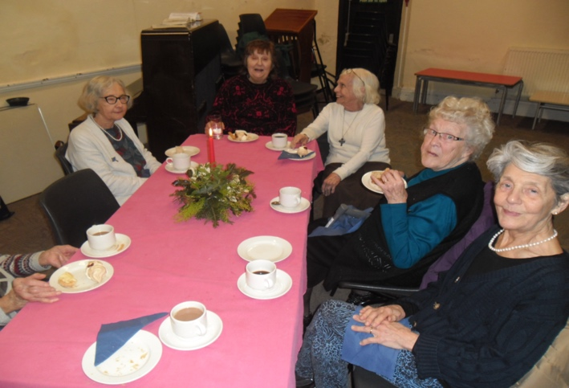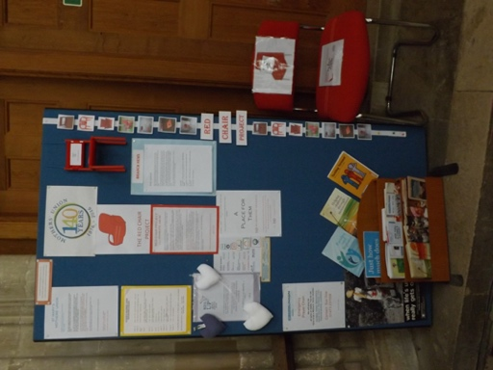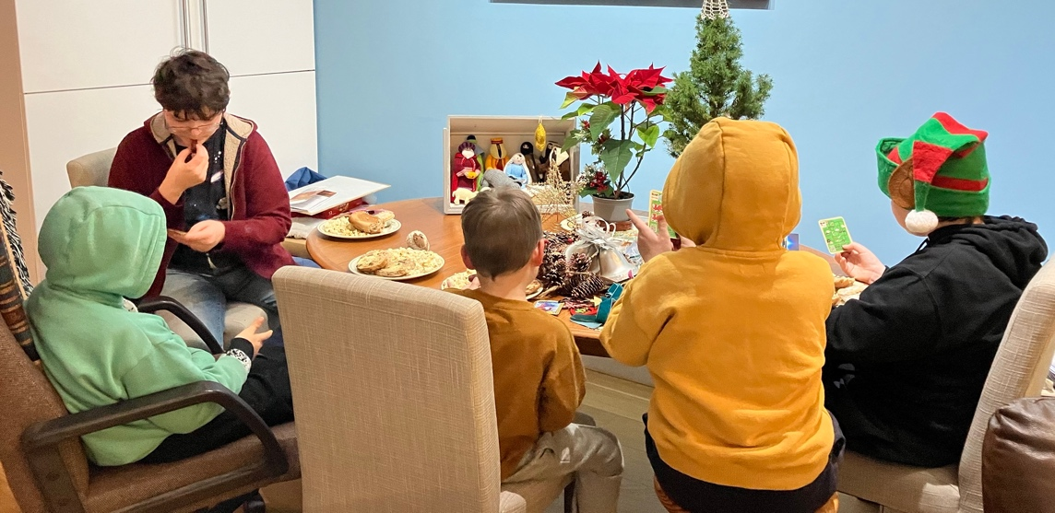
St Mary's Woodbridge Branch
The Notice Board in St Mary's Church, during November into December, was decorated to highlight 'The Red Chair Project'. A chair mirroring this was moved around the Church to catch visitor’s attention. The information on the Notice Board will remain, with a mini red chair, to highlight that domestic abuse happens every day of the year. Jean Cobb
Yoxmere Travelling Nativity - Linda gathered with her grandsons to talk about the nativity set and read the Christmas story together talking about how the birth of Jesus affects us today - 2000 years on. It was a lovely occasion. This was followed by drinks and cakes.
Prayer Diary for 2024 If you have not received your copy of the Prayer Diary please contact Clare Thomas 01473 832808 or Clare.Thomas@mothersuniuon.org

Please put the date for the Member’s Day in your diary
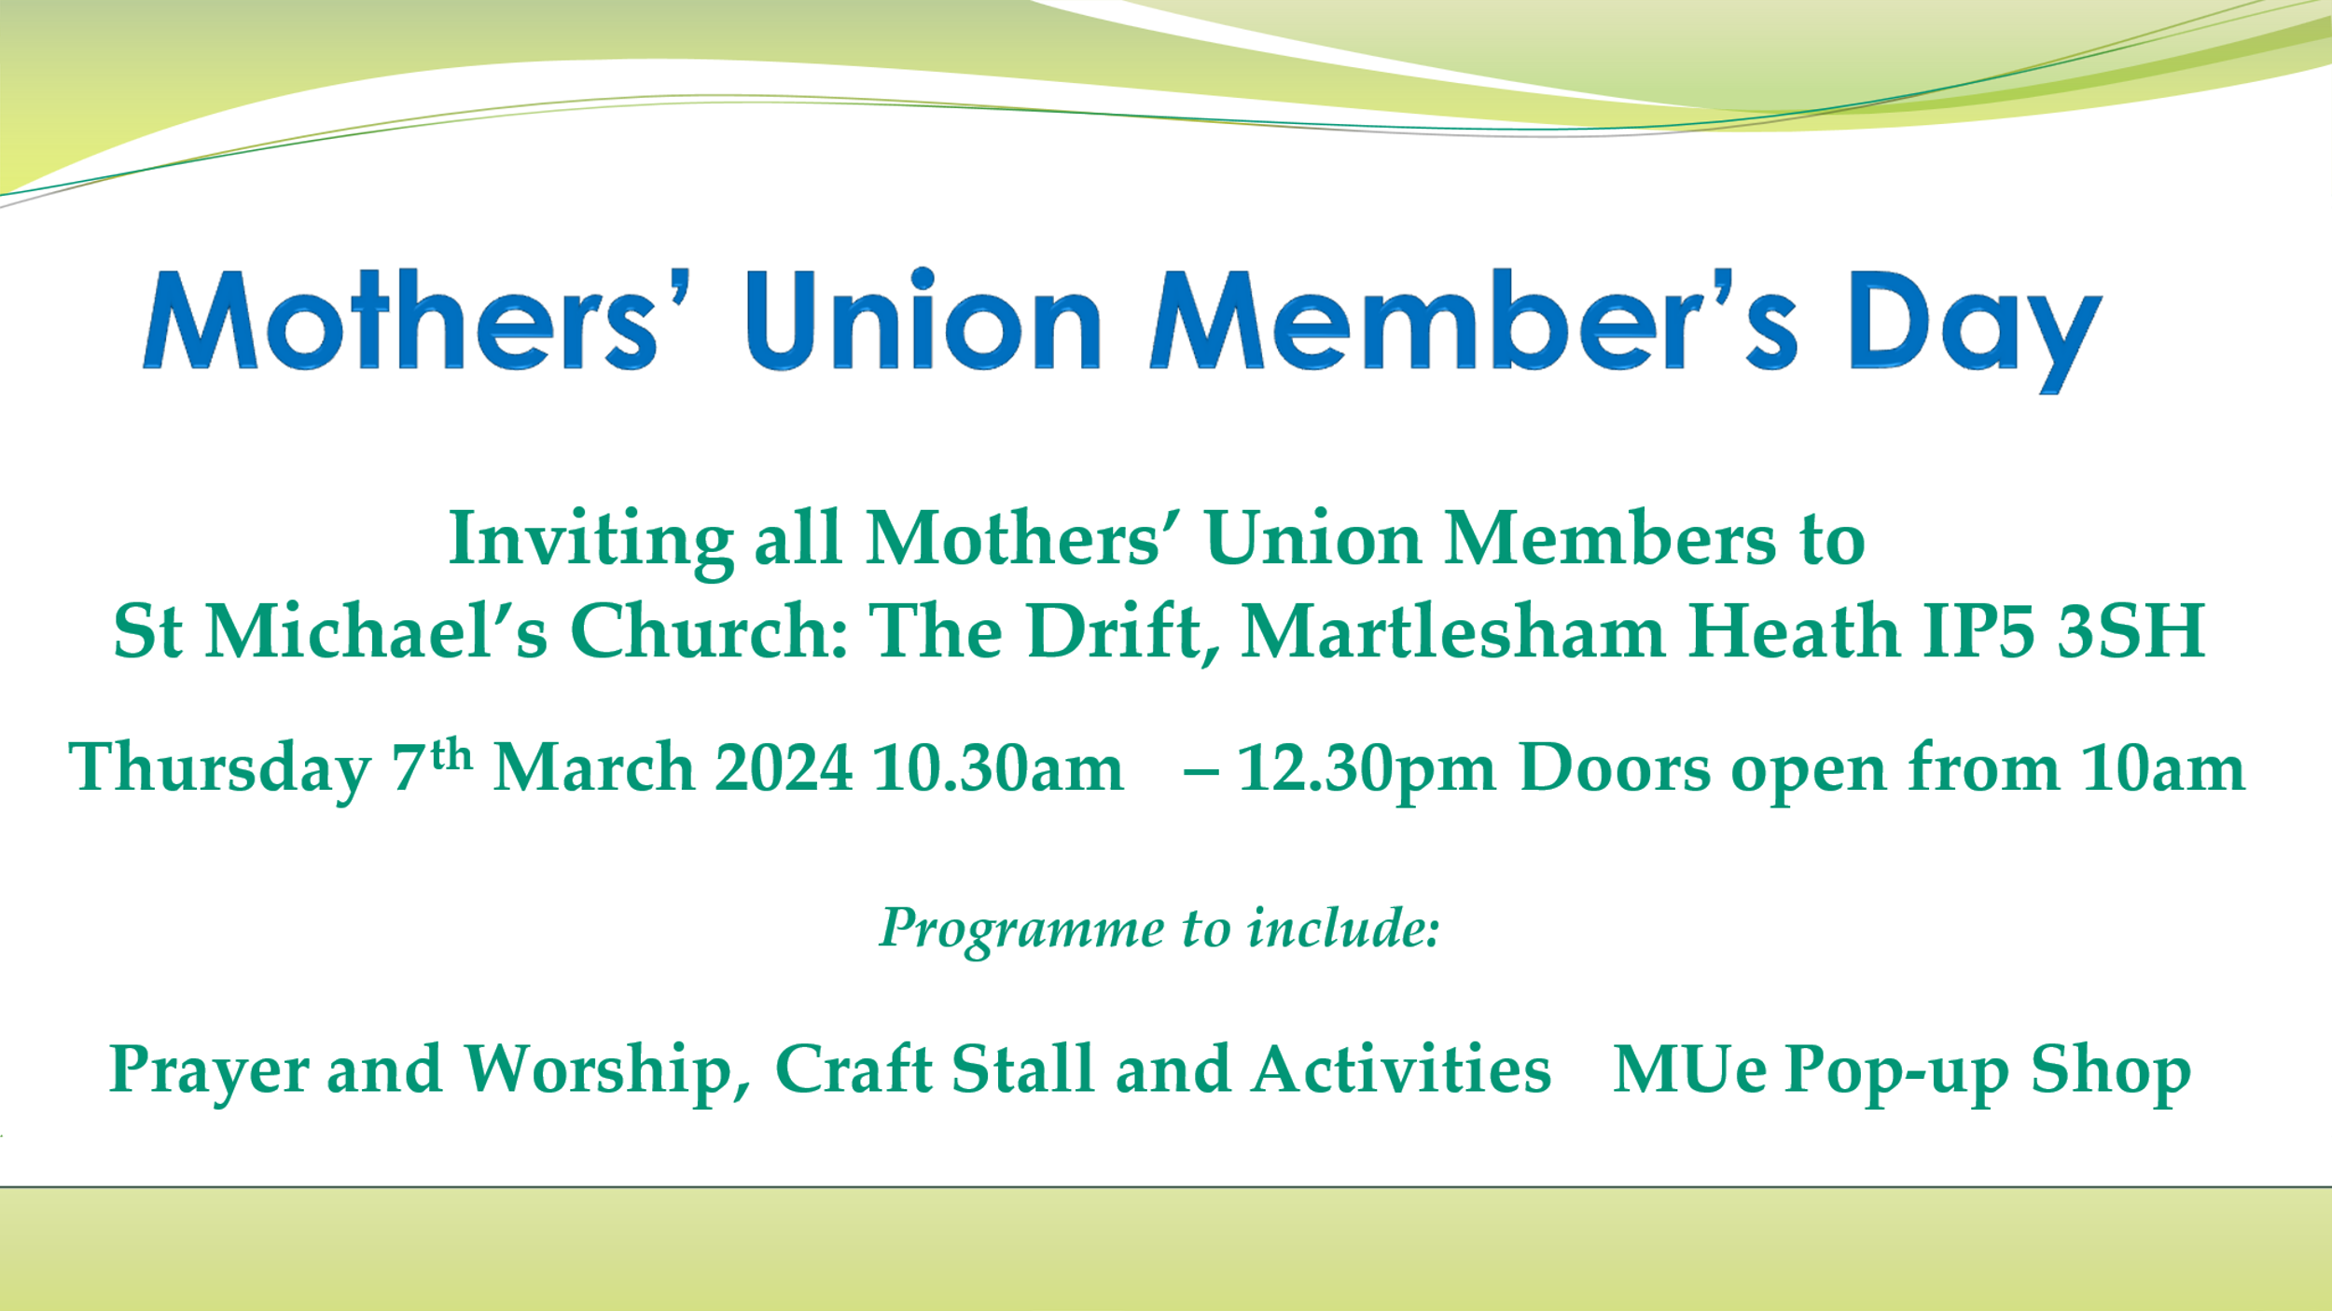
Message from VP Jeanette – Please can you send your 2023 Branch Activity and Goods Donated Logbook to Jeanette as soon as possible This helps Mary Sumner House to demonstrate the extent of our outreach projects and programmes, to justify our charity status. Some branches are not as active as others but whatever your branch has been able to do will be part of the positive impact that MU has in our communities. Send to Jeanette.Appleton@mothersunion.org or by post to Field View, Hadleigh Road, Holton St. Mary, Suffolk. CO7 6NP.
Lady Day Service. This year our service will be held on March 22nd at 11am. In St Peter & St Paul Church, Lavenham CO10 9SA. Maybe this could be an opportunity to look round Lavenham and have a pub lunch after the service.
Nominations for the four General Trustee posts close at the end of the month. We need people who are committed to and enthusiastic about Mothers' Union, with good independent judgement, an ability to think creatively and a willingness to speak their mind. The following role description shows that the Trustee Role is important but manageable. Can you help?
Role Description
-Attending four Trustee meetings and two council meetings a year.
- Bringing to the attention of the Trustees any issues that you have been made aware of that need discussion.
-Supporting the Diocesan President as they co-ordinate the vision for the development of the organisation’s work in the Diocese
-Keeping abreast of social policy issues so that you vote appropriately
Ipswich Area We raised £572.42p at the Coffee morning on Sat 19th November 2023 at St Michaels Church Martlesham. Thank you for donating items and coming to support us. It was a great morning with plenty of chatter and fellowship. This Christmas, instead of asking branches to donate Christmas Gift Vouchers for the local Woman’s Refuges, we used some of the money from Ipswich Area and the Woman’s Refuge fund. Ipswich Area has bought £300 of vouchers from Asda and Primark for Ipswich Refuge and biscuits and sweets for the ladies and staff. Jane Leung from the Cathedral Branch supported Bury Refuge in the same way. Thank you to you all for your continued support. Hope you all have a Happy and Peaceful New Year. Sandra Griffiths (Ipswich Area Rep.)
Prayers – ‘More things are wrought by Prayer than this world dreams of’ Alfred, Lord Tennyson
We pray for all those who have been poorly over Christmas and for their recovery.
We remember with gratitude the faithful service of MU members who have passed away during 2023. Please enfold in your love, all their families and friends
In this final year of the triennium, we ask that you will guide and support our Diocesan President Linda and our President Elect Jeanette, together with Trustees and Officers, as they make decisions about the future direction of MU.
We pray for the staff at Mary Sumner House, that they may provide effective support for branches across the world.
We hold in our prayers MU members in branches far and near as we work to prayerfully and practically support each other in whatever challenges are before us.
We thank God for many blessings as we reflect on the old year and embark on the new.
‘ O Thou who has given us so much, mercifully grant us one more thing – a grateful heart’ George Herbert
O Lord in your mercy- Hear our prayers. Amen

