Transformation Now!

www.musuffolk.org.uk

Charity No. 249726

January 2023 No 36

Prayers as we start a New Year
At the beginning of this New Year, I offer you my life. Come take my voice, may the words I speak be filled with encouragement and goodness. Come take my hands, may the work they create be generous and giving. Come take my feet, may the journeys I walk be led by your Spirit within. Come take my life Lord, for I love your goodness, your kindness and your leading. Amen

Re- Imagining Mothers’ Union in your parish
One of the priorities for our Re- Imagining feedback, that members so generously shared last September, was to raise the profile of Mothers’ Union within the church as well as the community.
One way in which we aim to do this is through a series of regular Mothers’ Union themed articles for the local parish or community magazine or newsletters. These will be sent to all branches via the branch leader and also to parishes without a branch, beginning in January 2023. Highlighting the work of Mothers’ Union and promoting membership of Mothers’ Union. These articles will be written in a format so that branches can add local news as well if they wish.
Another strand to raise our profile is to build relationships with the Clergy Readers and Elders. In order to achieve this, as a first step, branches are asked to promote the Mothers’ Union Mothering Sunday service and all the accompanying resources to their parish ministry team. Mothering Sunday is on March 19th. Mary Sumner House has also been asked to provide a Father’s Day service for June 18th.

Needham Market Mothers’ Union
MU has been collecting good quality clean secondhand coats for adults and children. These have been available for anybody that attends the Food Pantry on a Thursday morning. St. John’s Pantry is open from 9.30 to 11am each week. It is held in the ARK on King William’s Street. Choose your own food and supplies for £3 a bag – available to everyone who needs us. Val Jeffreys Branch Leader.
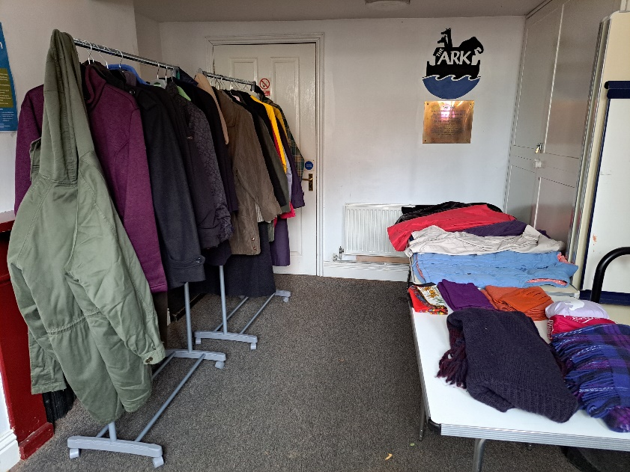
The Annual Gathering 2023 in York, is at the York Barbican on Friday 22nd September 2023.Tickets are now on sale. The programme is in development and will focus on member stories and how we are working together to sustain and grow Mothers’ Union into the future. Sheran Harper, our Worldwide President will be at the gathering and the Archbishop of York will be leading the celebratory service at York Minster that evening. If you would like to go to this event in York, please speak to Jeanette Appleton 01473 311487
Metamorphosis bitesize. Six sessions for small groups This is a new MU Resource for small groups. It describes Mothers’ Union’s approach to change and transformation. One or more of these sessions would make an ideal focus for a Branch Meeting. The Metamorphosis booklet gives starting points, Bible Study, Tools and Reflection for each session. For those wishing to go into this in more depth, there is an 8 session Metamorphosis Course which will start on 27th January. If you would like to do this course please speak to Linda Ginn.
News on the Christmas Appeal for South Sudan - This Appeal raised £69,500. This will allow financial and practical support for over 600 vulnerable women. They will go on to support many others - to challenge gender inequality, empower communities and build brighter futures.
Prayer Diary- We hope that every member has received a Prayer Diary. This should have arrived in time to start the New Year. If you have not received this publication, please contact Clare Thomas on 01473 832808, as soon as possible. Clare keeps our Membership Database up to date. Please let her know about any new members, any changes of address or the death of any member so that our records are kept up to date
Cards for Prisoners at Highpoint- Four branches have now booked workshops for making the cards that will be needed for Christmas 2023. If there are other branches who would like to make cards, please let me know and I will put you on the list for 2024. We would be happy to recycle any used Christmas cards you may have, for this project. We are also collecting new notelets/cards so that Highpoint has a stock of these items available at the prison for prisoners to keep in touch with their families. Sue Norrington 01728 660280.
Speakers at Branch Meetings – The Diocese is able to help with the travel expenses for a Trustee or the Diocesan President to speak at your branch once each year if required. For any other speaker you may arrange, we hope you will offer some travel expenses using your branch funds especially as there has been an increase in fuel costs.
Craft Items – MU members knit and sew many items like Seafarer’s Hats, Twiddle Muffs, Stars, Baby items and Drain Bags. Some patterns are on the MU website. We are trying to attach labels which indicate that the item has been made with love by MU. We are trying to form a small group that would check craft items and attach the labels, meeting about twice a year. If you think you could help with this please contact Cathie McGregor – catherinemcgregor211@gmail.com
2022 saw the loss of Queen Elizabeth as our Queen and our MU Patron. We are grateful for her example and enduring faith. We pray for King Charles as he moves towards his Coronation.
Prayers – We are aware that Prisoners who maintain links with their families and leave prison to return to a stable family life are less likely to reoffend. We pray for prisoners and their families, that visits and communication can be maintained. Please bless the work of MU in sending Christmas cards and providing cards and notelets for prisoners to send to their families as MU seeks to show the Love of God for those whose family life has met with adversity. We pray for the staff at Highpoint and the Chaplaincy team. We also pray for the victims of crime as they try to move on with their lives. Lord in your mercy. Hear our Prayer.

