# “NO MORE 1 in 3”

# Mothers’ Union

# Global Day Resource Pack 2020

# Introduction

# Mothers’ Union has produced a set of resources specifically for its members and friends, which you are welcome to use and to encourage others to use for our Global Day which is part of our 16 Days of Activism Campaign. We hope this helps to support our members and friends to join us for this new initiative from Mothers’ Union. This pack gives clear instruction on how you can get involved in our Global Day both practically (through taking part in our online protest and joining our online events) but also spiritually and raising funds. The pack can be distributed (for example, during meetings) or reproduced (for example, in church leaflets or as content for your own resources). Additional resources will be added as the Global Day approaches



# What is the Mothers’ Union Global Day?

Our Global Day is centred around the disturbing figure that “1 in 3 women worldwide have experienced domestic or sexual abuse” and that Mothers’ Union as a leading women’s organisation believe this to be unacceptable.

The Global Day will take place on the 5th December 2020 and our initial plans were to ask members to “to step out of their comfort zones” and find a central location where their diocese could hold a peaceful protest. We wanted the event to begin at 11am so it could end with midday prayers.

We were then going to add an ask for a fundraising event before or after the protest if possible “Cup of tea for no more one in 3” – this would be a simple tea and cake sale where members can raise the profile of the campaign whilst raising funds. We had planned to produce reflections and information leaflets for those attending to read whilst enjoying their refreshments.

We also wanted to encourage members to involve their Church communities by producing resources (intercessions, sermon outline etc) that could be used the following day in Church on 6th December. Again, this would be matched with fundraising potential for the collection to be donated to MU or for members to run a smaller coffee and cake sale after the main morning service.

It was hoped that things would be more “normal” by this point so that we could continue with our initial plans, however given the current climate, we have decided to take the majority of the activities online, with the hope that engaging with as many members as possible online this year will lead to building on the success next year when hopefully we can have events marking this day, in person, around the world.

Much press and research has also shown that cases of domestic violence have increased during lockdown and the pandemic and so there is more need than ever to join together and say “No more 1 in 3”

# Timetable of Mothers’ Union Global Day Events – 5th December

# 

|  |  |
| --- | --- |
| Online Protest launches | 9am – throughout MU social channels including Facebook, Twitter and Instagram |
| Online “Cup of Tea for No More 1 in 3”  Join us with a cup of tea as we take time out our day to reflect and pray for our “No More 1 in 3 campaign” This will be followed by Midday Prayers | 11.30am – Facebook Live and You Tube |
| No More 1 in 3 Global Day Service | 8pm – Facebook Live and You Tube |

*Please note all times are GMT*

# What is Domestic Abuse?

Domestic abuse can be defined as an incident or pattern of incidents of controlling, coercive, threatening, degrading and violent behaviour, including sexual violence. In the majority of cases by a partner or ex-partner, but also by a family member or carer. It is unfortunately more common then you may realise and in the vast majority of cases it is experienced by women and is perpetrated by men.

Domestic abuse can include, but is not limited to, the following:

* Coercive control (a pattern of intimidation, degradation, isolation and control with the use or threat of physical or sexual violence)
* Psychological and/or emotional abuse
* Physical or sexual abuse
* Financial or economic abuse
* Harassment and stalking
* Online or digital abuse
* Gender and domestic abuse

Domestic abuse is a gendered crime which is deeply rooted in the societal inequality between men and women. It is a form of gender-based violence, violence “directed against a woman because she is a women or that affects disproportionately.” (CEDAW, 1992).

Women are more likely than men to experience multiple incidents of abuse, different types of domestic (intimate partner violence, sexual assault and stalking) and in particular sexual violence. Any woman can experience domestic abuse regardless of race, ethnic or religious group, sexuality, class, or disability, but some women who experience other forms of oppression and discrimination may face further barriers to disclosing abuse and finding help.

Domestic abuse exists as part of violence against women and girls; which also includes different forms of family violence such as forced marriage, female genital mutilation and so called “honour crimes” that are perpetrated primarily by family members, often with multiple perpetrators.

**What is coercive control?**

Domestic abuse isn’t always physical. Coercive control is an act or a pattern of acts of assault, threats, humiliation and intimidation or other abuse that is used to harm, punish, or frighten their victim. This behaviour is designed to make a person dependent by isolating them from support, exploiting them, depriving them of independence and regulating their everyday behaviour.

Charities such as Womans Aid and MPs campaigned and succeeded in making coercive control a criminal offence. This marked a huge step forward in tackling domestic abuse. Coercive control creates invisible chains and a sense of fear that pervades all elements of a victim’s life. It works to limit their human rights by depriving them of their liberty and reducing their ability for action. Experts like Evan Stark liken coercive control to being taken hostage. As he says: “the victim becomes captive in an unreal world created by the abuser, entrapped in a world of confusion, contradiction and fear.”

**How do you know if this is happening to you or someone you know?**

Some common examples of coercive behaviour are:

* Isolating you from friends and family
* Depriving you of basic needs, such as food
* Monitoring your time
* Monitoring you via online communication tools or spyware
* Taking control over aspects of your everyday life, such as where you can go, who you can see, what you can wear and when you can sleep
* Depriving you access to support services, such as medical services
* Repeatedly putting you down, such as saying you’re worthless
* Humiliating, degrading or dehumanising you
* Controlling your finances
* Making threats or intimidating you

**Statistics on coercive control**

* In the UK there were 17,616 offences of coercive control recorded by the police in the year ending March 2019, compared with 9,053 in the year ending March 2018. (ONS, 2019).
* The CPS Case Information System recorded 1,177 offences of coercive and controlling behaviour in an intimate or family relationship where a prosecution commenced at magistrates’ courts in the year ending March 2019. 97% of defendants prosecuted for coercive and controlling behaviour in the year ending December 2018 were male. (ONS, 2019).

**Domestic Abuse Facts & Figures**

* One in three women experience sexual or physical violence -- most likely from their intimate partner (World Health Organisation)
* Almost one in three women aged 16-59 will experience domestic abuse in her lifetime (Office for National Statistics 2019)
* Two women a week are killed by a current or former partner in England and Wales alone (Office for National Statistics 2019)
* In the year ending March 2019, 1.6 million women experienced domestic abuse (Office for National Statistics 2019)
* Women are on average assaulted 35 times before they seek help.
* On average the police in England and Wales receive over 100 calls relating to domestic abuse every hour. (HMIC, 2015)
* According to CSEW data for the year ending March 2018, only 18% of women who had experienced partner abuse in the last 12 months reported the abuse to the police.

**Useful External Resources**

Mothers’ Union has developed many relationships and worked with a number of organisations over the past years to develop our stance against Domestic Abuse. We would like to draw your attention to some of their excellent resources which you can use alongside this pack.

Restored – Ending Domestic Abuse, A Pack for Churches - <https://www.restoredrelationships.org/resources/info/51/>

Restored – Handbook for Female Domestic Survivors of Abuse - <https://www.restoredrelationships.org/survivorshandbook/>

Anglican Consultative Council and the Anglican Alliance – Domestic Abuse and Covid 19 How Churches can Respond - <https://www.anglicancommunion.org/media/415112/2007-da-covid-19-churches_en.pdf>

It is vital that victims/survivors of domestic abuse know that they are not alone during COVID-19 and there is still help available in these challenging times.  This is highlighted in a [Government awareness campaign](https://www.gov.uk/government/news/home-secretary-announces-support-for-domestic-abuse-victims) launched on April 11.

[Blog by Bishop of London](https://sarahmullally.wordpress.com/2020/05/01/loving-as-christ-loved-during-covid-19/) - Loving as Christ loved during COVID-19

[Podcast](https://www.gloucester.anglican.org/2020/nelson-trust-and-rachel-podcast-episode-4/) - Bishop of Gloucester, Rachel Treweek talks to members of the [Nelson Trust](https://nelsontrust.com/)about domestic abuse

**Get Involved – Join our Online Global Protest**

As many of you know, we had asked our members to join together on 5th December in your local town centre or cathedral grounds to hold a visual, peaceful protest to draw attention to our campaign, followed or preceded by a tea and coffee morning “Tea for no more 1 in 3” where we would have also suggested that homemade products could have been on sale to raise funds.

However, times have changed and we realise that for many dioceses this will just not be possible and our members safety and security is our priority. Therefore, like much of our work this year we are going to take this protest online!

**We need you all to do the following, if possible:**

1. Print out our sign here <https://www.mothersunion.org/sites/default/files/resources/public/No%20More%201%20in%203%20Placard.docx> – or use this to create you own if you wish! Make sure it is clear it is Mothers’ Union and it includes the hashtags - #NoMore1in3 and #1in3NotMe
2. Ideally if you have 3 people in your household gather them together to get involved – all ages are welcomed and encouraged. If there isn’t 3 of you – don’t worry please still take your photo and join us.
3. We suggest that you all wear a plain black top or a MU T-shirt for this.
4. 1 person in the 3 (or one person if there are 1 or 2 of you) paint a cross over your lips – we have found the best way to do this is simply with a red lipstick but you can use plasters or tape or an alternative.
5. Take a photo of the three of you (or however many there are) holding up the sign
6. If you want to, you can also film yourself holding up the sign and saying: “No more 1 in 3”
   1. This can just be filmed on your phone – landscape is best!
7. Send your photo and / or video to [communications@mothersunion.org](mailto:communications@mothersunion.org) by 7th November – please note by sending us your photo / video, you are consenting to us using it across our social media channels, press releases and on our Mothers’ Union website

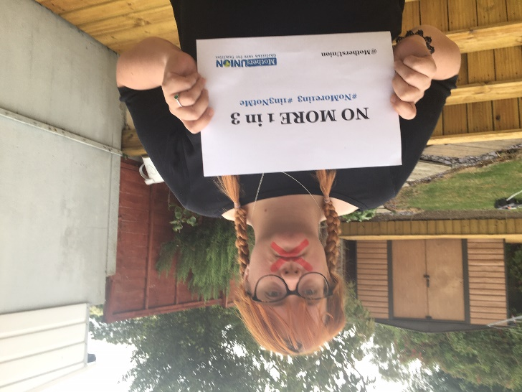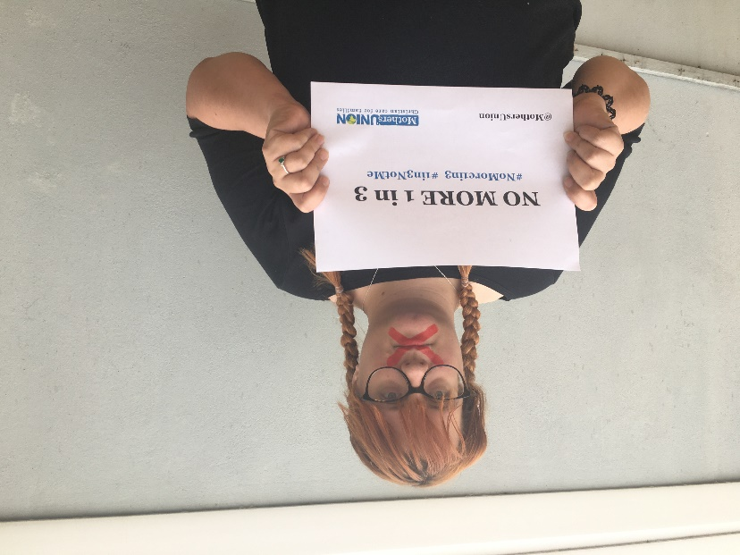The images and videos will be woven together to form a protest video that we will launch on the 5th December – we want to make sure we have as many members getting involved as possible so please do take some time in your day to get involved!

**Get Involved – Get Knitting!**

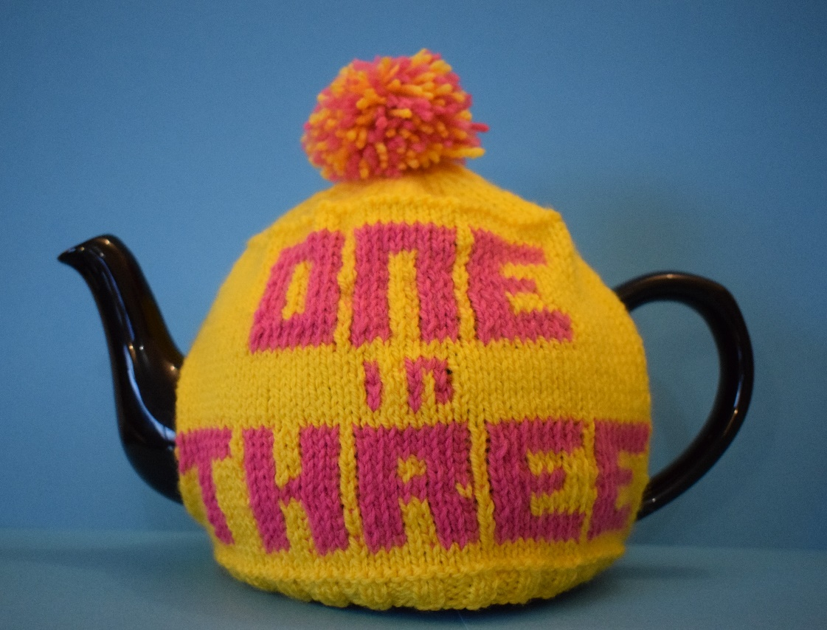

Part of our Global Day campaign is thinking about a “Cup of tea for no more 1 in 3”. We had planned that coffee and tea mornings would be a way to fundraise and draw attention and you will see that there is also an online “Cup of tea for no more 1 in 3” reflection at 11.30am on the day.

Therefore we produced a pattern for a No More 1 in 3 tea cosy! We encourage members to still go ahead and knit these – use them as awareness for the campaign and why not sell them to friends and family to raise money for Mothers’ Union!

Also we would love to see your creations – send them to [Communications@mothersunion.org](mailto:Communications@mothersunion.org) or tag us on your photos online!

**One in Three Tea Cosy Pattern**

**You will need:**

35g (1.2 oz) DK yarn in main colour

Oddment of DK yarn for contrast

2.75mm knitting needles

3.25mm knitting needles

Size:

To fit a teapot with a circumference of 45cm (18 inches)

Tension:

8 stitches and 10 rows in a 3cm (1½ inch) square

Abbreviations:

K Knit

P Purl

M Main colour

C Contrast

K2tog Knit 2 sts together

P2tog Purl 2 sts together

Front/back (make 2)

With 2.75mm knitting needles cast on 50 sts in M

Row 1 K2 P2 to end

Row 2 P2 K2 to end

Row 3 As Row 1

Row 4 As Row 2

Change to 3.25mm needles

Rows 5- 7 Knit

Row 8 Purl

Row 9 Knit 3M, 8C, 1M, 8C, 1M, 3C, 2M, 3C, 1M, 3C, 2M, 3C, 4M, 3C, 5M

Row 10 Purl 5M, 3C, 4M, 3C, 2M, 3C, 1M, 3C, 2M, 3C, 1M, 8C, 1M, 8C, 3M

Row 11 As Row 9

Row 12 Purl 5M, 3C, 4M, 3C, 2M,3C, 1M, 3C, 2M, 3C, 1M, 3C, 6M, 3C, 8M

Row 13 Knit 8M, 3C, 6M, 3C, 1M, 3C, 2M, C, 1M, 3C, 2M, 3C, 4M, 3C, 5M

Row 14 Purl 5M, 3C, 4M, 8C, 1M, 7C, 2M, 6C, 3M, 6C, 5M

Row 15 Knit 5M, 6C, 3M, 6C, 1M, 8C, 1M, 8C, 4M, 3C, 5M

Row 16 Purl 5M, 3C, 4M, 3C, 2M, 3C, 1M, 3C, 2M, 3C, 1M, 3C,6M,3C, 8M

Row 17 Knit 8M, 3C, 6M, 3C, 1M, 3C, 2M, 3C, 1M, 3C, 2M, 3C, 4M, 3C, 5M

Row 18 Purl 2M, 9C, 1M, 3C, 2M, 3C, 1M, 8C, 1M, 8C, 1M, 8C, 3M

Row 19 Knit 3M, 8C, 1M, 8C,1M, 8C, 1M, 3C, 2M, 3C, 1M, 9C, 2M

Row 20 As Row 18

Row 21 Knit

Row 22 Purl

Row 23 Knit 22M, 1C, 1M, 1C, 2M, 1C, 22M

Row 24 Purl 22M, 1C, 2M, 1C, 1M, 1C, 22M

Row 25 As Row 23

Row 26 Purl 22M, 1C, 2M, 3C, 22M

Row 27 Knit

Row 28 Purl

Row 29 Knit 12M, 8C, 1M, 3C, 2M, 3C, 1M, 8C, 12M

Row 30 Purl 12M, 8C, 1M, 3C, 2M, 3C, 1M, 8C, 12M

Row 31 As Row 29

Row 32 Purl 12M, 3C, 2M, 3C, 1M, 3C, 2M, 3C, 1M, 3C, 17M

Row 33 Knit 17M, 3C, 1M, 3C, 2M, 3C, 1M, 3C, 2M, 3C

Row 34 Purl 12M, 3C, 2M, 3C, 1M, 3C, 2M, 3C, 1M, 6C, 14M

Row 35 Knit 14M, 6C, 1M, 3C, 2M, 3C, 1M, 3C, 2M, 3C, 12M

Row 36 Purl 12M, 3C, 2M, 3C, 1M, 3C, 2M, 3C, 1M, 3C, 17M

Row 37 Knit 17M, 3C, 1M, 3C, 2M, 3C, 1M, 3C, 2M, 3C, 12M

Row 38 Purl 12M, 8C, 1M, 8C, 1M, 8C, 12M

Row 39 Knit 12M, 8C, 1M, 8C, 1M, 8C, 12M

Row 40 Purl 12M, 8C, 1M, 8C, 1M, 8C, 12M

Working in M only from this point

Row 41 Knit

Row 42 Purl

Row 43 K2tog, K46,K2tog (48sts)

Row 44 Knit

Row 45 K5, (K2tog, K5) 6 times, K1 (42 sts)

Row 46 Purl

Row 47 Knit

Row 48 Purl

Row 49 K5 (K2tog, K4) 6 times, K1 (36 sts)

Row 50 Purl

Row 51 K5, (K2tog, K3) 6 times, K1 (30 sts)

Row 52 Purl

Row 53 K5, (K2tog, K2) 6 times, K1 (24 sts)

Row 54 Purl

Row 55 K5 (K2tog, K1) 6 times, K1 (18 sts)

Row 56 Purl

Row 57 K5, (K2tog) 6 times, K1 (12 sts)

Row 58 (P2tog) 6 times (6 sts)

Cut off the yarn with about 15 cm spare and draw through the remaining stitches.

After you have knitted the second side and drawn the yarn through these stitches, tie the two ends together to secure the top.

**To make up**

Sew the sides together, leaving a gap for the handle and the spout.

For the spout side, I sewed 9cm down from the top and 3.5cm up from the bottom and for the handle side, I sewed 7cm down from the top and 2cm up from the bottom.

**To finish**

Make a pompom using both colours and add to the top of your tea cosy.

**Global Day 2020 Midday Prayers**

***A prayer to end the Cup of Tea for No More 1 in 3 reflection and lead into Midday Prayers***

**United in resolve**

**our voices join together**

**to speak out for the voiceless,**

**and proclaim the righteousness of God.**

God of justice and righteousness,

use us to speak against domestic abuse

with a clear and challenging voice

in a world where the vulnerable strive to be heard.

May our voices be heard in places of influence

on behalf of those who suffer in silence.

Make us strong and effective advocates

for those whose voice is too weak to be heard.

**We worship our holy Lord;**

**we pray for his kingdom on earth.**

**May his justice set the captives free**

**and his righteousness reign forever. Amen**

**Midday Prayers**

We unite together with our fellow members across the world in our Wave of Prayer, to bring our prayers to God for one another and the world he has called us to serve.

**Loving Lord, we draw near in faith**

**trusting not in the strength of our prayers**

**but in your power to answer.**

We pray for the work of our members worldwide to combat domestic abuse;

for their highlighting of the issue, their petitioning of governments

and their work with victims and survivors.

As a global family we embrace our mission to share your love

through speaking out for the vulnerable.

Help us play our part in creating a just and equal society

**Loving Lord, we draw near in faith.**

**We pray for the dawn of a better world**

**where all may live in safety. Amen**

Lord, we pray for the witness and work of Mothers’ Union worldwide.

Today we pray for our members in:

Akot in South Sudan; South West Tanganyika in Tanzania;

Aba & Irele-Ese Odo in Nigeria; Coventry in England and Cuttack in India

**We go from here, united in voice,**

**to proclaim the justice and righteousness of God**

**and the growth of his kingdom on earth. Amen**

**Global Day Bible Reflection**

***This bible study could be done if meeting in groups of six, online via zoom or even done at home with your family or on your own.***

At the heart of our campaigning against domestic abuse is our love for God, which motivates us to keep his command: to love our neighbour as ourselves.

*Love the Lord your God with all your heart and with all your soul and with all your strength and with all your mind; and, Love your neighbour as yourself.*

Luke 10:27 (NIV)

*Love the Lord your God with all your passion and prayer and muscle and intelligence—and love your neighbour as well as you do yourself.*

Luke 10:27 (The Message)

With such a well-known Bible verse the temptation is to use it without stopping to consider its implications, both for ourselves and those whom we accept as our “neighbour”; in this case those affected by violence and abuse.

So, it’s worth taking a moment to focus on the verse and the challenge it presents.

Reflect for some time on the verse, asking God to highlight words and phrases which will develop your thoughts and understanding.

After a while share together in pairs or small groups what has stood out to you personally. You may find that your individual strands of thought combine to bring new insight and motivation.

Then consider together the following in the light of the passage and your reflections on it.

* The Bible tells us to love, not just in word but in deed 1 John 3:18. In what ways do our actions to challenge domestic abuse show our love for God?
* The second command exhorts us to love our neighbours as ourselves. Reflect on how or whether we actually do love ourselves and how this is practically lived out. What are the stumbling blocks to loving ourselves?
* If we find it hard to love ourselves what implications does this have for those we are seeking to support?
* The victims and survivors of domestic abuse may find it hard to love both God and themselves. Reflect on how or whether they can be helped to do this and how this may benefit them in the long term?

We find this command in the context of Jesus being questioned on the way to gain eternal life. As we pray for God’s help in all we do to love our neighbour, we give thanks that we are able to show our love for God and his people though our actions; and that these will have eternal as well as earthly significance.

# Global Day 2020 Service outline

## *This service outline may be used and adapted for a variety of contexts. You could ask your local church to use this as a basis of their service on 6th December either in person or online or just use the intersession. You could use this to hold your own diocesan or branch service either in person or online via zoom*

## *Please add hymns and other prayers as wished.*

*As people arrive give them a link for a paper chain for them to write on before the service starts one short prayer, name of victim or survivor of domestic abuse or other appropriate word or phrase. If online ask beforehand for them to complete this before them. Assure them of confidentiality*

## Welcome and call to worship

Welcome to our service which is part of Mothers’ Union’s global action against domestic and sexual abuse. As we raise our voices on behalf of the voiceless, we also raise our voices in worship and intercession to our loving righteous God.

I love the Lord because he hears my voice  
and my prayer for mercy.  
Because he bends down to listen,  
I will pray as long as I have breath!

*Psalm 116:1-2 (NLT)*

We draw near in faith to the Lord who draws near to us with love

and hears our prayers for mercy.

## Opening hymn

*Collect the paper links during the singing of this hymn. Then during the service have volunteers create a chain from them ready for the intercessions.*

## Opening prayers and confession

Loving Lord,

who came to proclaim justice,

make us bold to speak out truth

and break the power of silence.

Loving Lord,

who came to minister mercy

make us agents of compassion

to release the oppressed from fear.

**Merciful and loving God,**

**forgive us when we have closed our eyes**

**to the sufferings of others;**

**when we have stayed silent**

**in the face of abuse and oppression;**

**when we have declined to challenge**

**unacceptable actions and attitudes.**

**Take away our selfishness**

**and fill us with new resolve**

**to proclaim justice and mercy**

**in the name of Christ. Amen**

## Readings

Jesus stood up to read, and the scroll of the prophet Isaiah was handed to him. Unrolling it, he found the place where it is written:

‘The Spirit of the Lord is on me,  
because he has anointed me  
to proclaim good news to the poor.  
He has sent me to proclaim freedom for the prisoners  
and recovery of sight for the blind,  
to set the oppressed free,  
to proclaim the year of the Lord’s favour.’

*Luke 4:16-19*

**A Woman’s Psalm**

O God, I am a woman in a violent world

let me know your peace.

Let blind rage born of despair

not find its target in me.

Let the value of my life

not be reduced to the jewellery I wear.

Let my family life not end

that life in a gang may begin.

Let rape not violate my body

nor anger ravage my soul.

Let fear not enter my heart

but caution sharpen my mind.

Let the light of Christ so shine in me

that I may reflect your love.

Let the joy that the apostles knew

infuse my spirit and alleviate my pain.

Let Love who suffered and died on the cross

find resurrection and new life in the world you love.

O God, I am a woman in a violent world

let me know your peace.

*Elizabeth Kaeton, (from Lifting Women’s Voices: Canterbury Press; 2009)*

## Hymn

## Homily *You may like to use the National Day Bible reflection as a basis for this.*

## Intercessions

*Bring the paper chains of prayers to the front and break them apart throughout*

*the intercessions, or during the moment for quiet prayer.*

Loving Lord,

hear our cries for justice

and break the chains of abuse

that all may live in safety.

Loving Lord,

hear our cries for righteousness

and break the chains of oppression

that all may live in freedom

*We take a moment in the quiet to bring our own prayers to God.*

Loving Lord,

hear our cries for mercy

and break the chains of fear

that all may live in peace. **Amen**

## Final Hymn

## Closing Prayers and Blessing

May God give us eyes

to recognise abuse where it exists.

May God give us a heart

to reach out in compassion.

May God give us courage and resolve

to make a difference wherever we are.

And the Blessing of God Almighty,

the Holy Trinity,

guide our steps today,

this week and always.

Go in peace and in resolve. **Amen**

*Source unknown*

## Global Day Prayers

Great God we give you thanks that you call us out of silence

to name hidden and domestic violence.

We pray for all those women who despite suffering from violence, continue to care for family and children, to grow and prepare food, carry water, earn a living and offer support to others.

We pray for women who are trafficked as domestic or sex workers; for women who are raped and do not know how to find words to name their pain or a way into the future.

We pray for transformation of our societies which often find it easier to judge the victims of violence than to solve the problems of injustice

We pray that women's voices may be heard and taken into account in all peace and reconciliation work.

We pray for a transformation in the violent way many men act towards and think about women.

We pray for right and just relations between women and men that together we may transform and overcome violence in all its forms and learn to celebrate our diversity and interdependence

We look forward to the age of peace, when violence is banished, both women and

men are able to love and to be loved, and the work and wealth of our world is justly shared. *World Council of Churches*

Stir us with a resolve not to be silent.

To speak out

against the abuse of power;

especially in our homes.

To speak up

for those who have been pushed down

in any way.

To speak to

the needs of those who are suffering

at the hands of another.

We pray in the name of Jesus Christ,

who extended his forgiving hands to all. Amen *Restored Church Pack*

Compassionate God,

may those experiencing all forms of violence

be given courage, hope and the means

to break free from their abuse.

We pray for all who live in fear of violence

and despair that life will ever change:

Bring to an end their suffering;

restore their sense of worth.

Bring to light deeds of abuse hidden in darkness,

that they may find safety and refuge, free from fear.

We pray for all to follow your example

of treating women with equality and respect.

We pray for the dawn of a better world

where justice and peace may flourish. Amen

**Global Day Creative Prayer Ideas**

## Inspired by God’s Word

This idea could work well when holding a vigil. When each prayer is shared a candle could be lit as a symbol of God’s light overcoming the darkness.

Provide Bible verses connected with aspects of domestic abuse on pieces of card or paper – there are some examples below but feel free to use your own ideas.

Give people opportunity to choose a card and then have a time of quiet for each to reflect on their verse.

Then take turns to use your verse for prayer. Each read out their verse and then either finish with *Lord in your mercy, hear our prayer* or if people are confident, speak out their own prayer arising from their reflection*.*

This idea could be combined with the use of a prayer tree with the verses hung on a tree after being shared.

## Prayer Tree

Provide a prayer tree along with labels for people to write their prayers on and hang on the tree. If you can participate in a service, you could bring the tree forward in the service and offer up the prayers as part of the intercessions.

Or you could use the same idea as part of your events for the National Day.

You may like to open this to the wider community.

*Instead of the thorn-bush will grow the juniper,*

*and instead of briers the myrtle will grow.  
This will be for the Lord’s renown,  
for an everlasting sign,  
that will endure for ever.* *Isaiah 55:13*

*Loving Lord,*

*we offer up these prayers*

*for all who are affected*

*by domestic or sexual abuse.*

*May blighted lives be transformed*

*through the healing power of the Spirit. Amen*

|  |
| --- |
| God created human beings in his own image. In the image of God he created them; male and female he created them. Then God looked over all he had made, and he saw that it was very good *Genesis 1:27, 31* |
| The Lord hears his people when they call to him for help. He rescues them from all their troubles. The Lord is close to the broken-hearted; he rescues those whose spirits are crushed. *Psalm 34:17-18* |
| Speak up for those who cannot speak for themselves;  ensure justice for those being crushed. *Proverbs 31:8* |
| Do not fear, for I am with you; do not be dismayed, for I am your God. I will strengthen you and help you; I will uphold you with my righteous right hand. *Isaiah 41:10* |
| Jesus said: Truly I tell you, whatever you did for one of the least of these brothers and sisters of mine, you did for me. *Matthew 25: 40* |
| He has sent me to proclaim that captives will be released, that the blind will see,  that the oppressed will be set free, and that the time of the Lord’s favour has come. *Luke 4:18-19* |
| Love the Lord your God with all your heart and with all your soul and with all your strength and with all your mind; and love your neighbour as yourself. *Luke 10:27* |
| Everyone who does evil hates the light, and will not come into the light for fear that their deeds will be exposed. *John 3:20* |
| The thief comes only in order to steal, kill, and destroy. I have come in order that you might have life — life in all its fullness*. John 10:10* |
| There is neither Jew nor Gentile, neither slave nor free, nor is there male and female, for you are all one in Christ Jesus. *Galatians 3:28* |
| Dear children, let us not love with words or speech but with actions and in truth.  *1 John 3:18* |

## Intercessory Biblical reflection

*You may like to show appropriate power point images to accompany this.*

*Have a few moments of silent reflection between each corporate response.*

**United in outcry**

**our voices join together**

**to speak out for the oppressed,**

**and proclaim the justice of God.**

### Let me not be put to shame, Lord, for I have cried out to you; but let the wicked be put to shame.

### [*Psalm 31:17*](https://www.biblegateway.com/passage/?search=Psalm+31%3A17&version=ESV)

### God of mercy,

### we trust in you to bring every deed into judgment, including every hidden and secret thing.

### *From* [*Ecclesiastes 12:14*](https://www.biblegateway.com/passage/?search=Ecclesiastes+12%3A14&version=ESV)

Who will protect me from the wicked?  
Who will stand up for me against evildoers?

*Psalm 94:16 (NLT)*

**God of justice,**

**embolden us to speak up for those who cannot speak for themselves,**

**that we may ensure justice for those being crushed.**

*From Proverbs 31:8*

### But you, Lord, are a shield around me, my glory, the One who lifts my head high.

### [*Psalm 3:3*](https://www.biblegateway.com/passage/?search=Psalm+3%3A3&version=ESV)

**United in response**

**our voices join together**

**to echo the pleas of the distressed,**

**and proclaim the mercy of God. Amen**