

**Peculiar Times!**

February 2022, No. 25

www.musuffolk.org.uk

Charity No. 249726

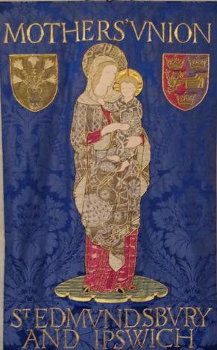

**Lady Day and Commissioning Service**

**March 25th 11.30am** **St Edmundsbury Cathedral**

President and Address: The Rt Rev Tim Stevens

Do come and support the board of trustees who will be commissioned at this service. If you are unable to attend in person there will be a livestream of the service which can be viewed on the Cathedral’s Facebook page: <https://www.facebook.com/stedscathedral>.

3

**Annual General Meeting March 16th 9.30 am for 10.am start**

**Salvation Army HQ: Violet Hall Stowmarket IP14 1NE**

Knitting and Sewing Projects

Current projects:

* Seafarers’ hats, Fiddle Muffs and Fiddle Blankets
* Items for the Shoe box appeal
* Drain bags for the oncology unit.

**Baby items are not currently accepted by Ipswich Hospital**

There is the **new role of Craft Lead,** as part of the new Communities of Interest, who will co-ordinate the many knitting and sewing projects MU undertakes.

To find out more about this role contact: Jeanette Appleton j[eanetteappleton@](mailto:eanetteappleton@)hotmail.com

m.07768418942

Are you someone with a flair for communication, interested in writing articles to promote the work of Mothers Union?

There is a new role in our diocesan officers team as Communication Lead as part of the Communities of Interest Initiative. If you are that person, DP Linda Ginn would love to hear from you:

E:Linda.Ginn@mothersunion.org

News from Val Jeffries: For the teachers in my grandson Sullivan’s class my daughter gave them a Mothers’ Union Ethical Gift. The Gift of Words. Here is the thank you card she received from the teachers.

**A prayer for February:** Thank you Lord, for all those who have been willing to step forward into Mothers’ Union roles for the next three years. Please bless, equip, strengthen and encourage them in all they do for your service. Amen

Unable to attend meetings, moving into a home? Once an MU member always an MU member.

Indoor membership is there for Mothers’ Union members so that they can continue to receive the support and be part of the Mothers’ Union that they have faithfully served for so many years, when they can no longer attend meetings.

Monica Twaits is our Indoor member contact and keeps in touch with Indoor members throughout the year.

Tel 01473623194 E: [montwaits@](mailto:montwaits@talktalk.net)btinternet.com

Mothers’ Union Golden Girls

Mothers’ Union members reach out and support a range of community and church groups such as Toddler groups and Luncheon clubs. Martlesham Mothers Union members support the local Golden Girls group. This group is for ladies who are on their own. They meet monthly at St Michael’s Martlesham and enjoy companionship together and provide mutual support. Meetings start and finish with prayer and include coffee and a chat. During lockdown they kept in touch by phone and had small meetings in members gardens.

Faith, Fun & Fellowship.

Over the years St Mary’s Stoke has had exchange visits with other branches. These visits have been so rewarding and enjoyable.

The first one was to Hayward’s Heath Mothers’ Union, as one of our member’s cousins was Branch Leader there and they came to us the next year.

We went to Haverhill as Rev Manette Crossman, who trained at St Mary’s, invited us to their church and the members of the church at Haverhill came to us for Afternoon Tea.

We have also been to Thurston & Great Barton Mothers’ Union and they have also come to our branch. All these visits gave our members the opportunity to share times of faith, fun and fellowship.

z

Newmarket Mothers Union

Congratulations to Newmarket branch! Linda Ginn visited their branch recently and enrolled five new members as well as commissioning Diedre Grosvenor as joint branch leader.

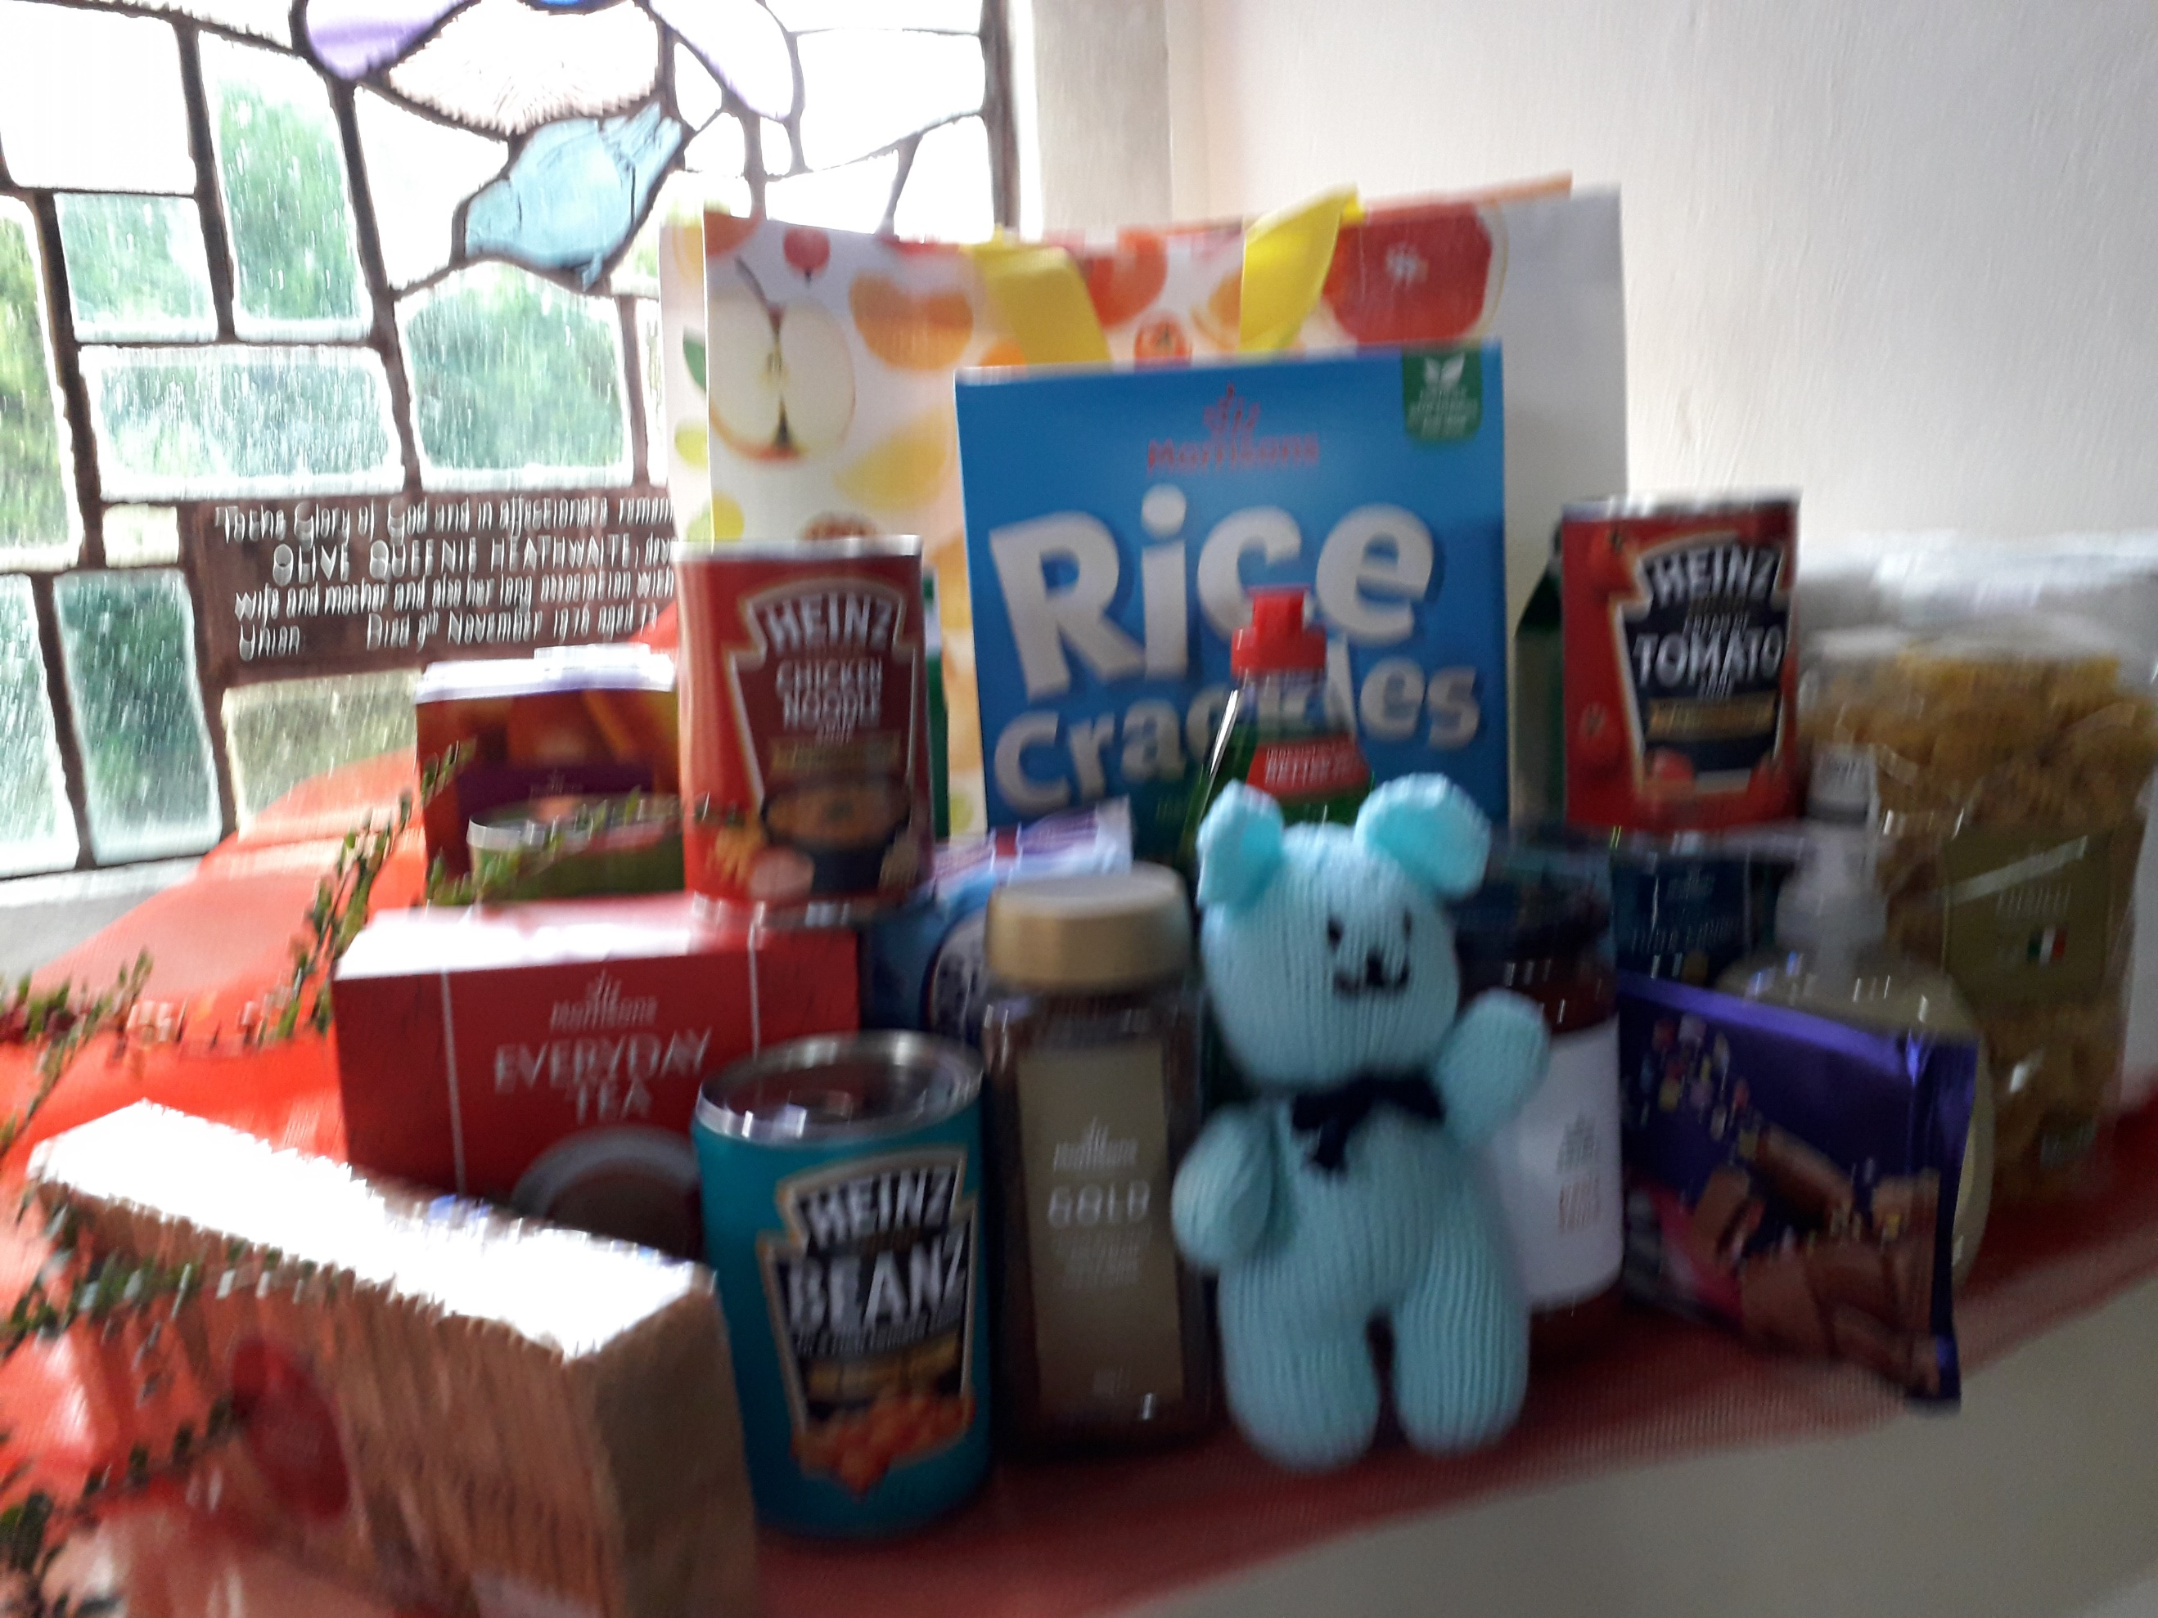

Members of Walton branch collect items for Emergency Food Bag. We pass these onto our Church's Pop-up Shop (food bank) with our love and prayers, for those in desperate need.

Is a member of your branch celebrating a 90th birthday this year?

90th Birthday contact Margaret Rollins will ensure a birthday card is sent on behalf of the Mothers Union: just email [mhrollins@gmail.com](mailto:mhrollins@gmail.com)

*Update your branch website page*

*Now is the time to update your branch page on our musuffolk.org website by sending the latest information about your branch to Clare.Thomas@mothersunion.org*