Transformation Now!

www.musuffolk.org.uk

Charity No. 249726

February 2024: No 49

News from around the Diocese
Two Mothers Union members from Kesgrave Mothers’ Union have recently been awarded Foundation Safe Guarding training. They completed this online and found it eye opening. Both members felt it was good to have this new knowledge and insight into potential safe guarding situations. They both were involved in helping with a Lunch Club and listening to children in the local school read. Kesgrave members recommend this outreach of listening to children read in school as it is such an important life skill, and so rewarding. Just approach your local primary school and ask if they need this support.
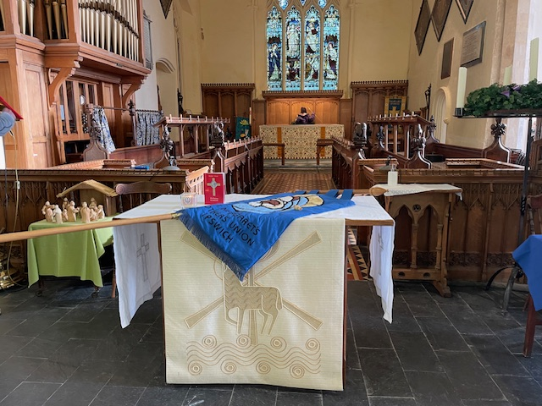
St Margaret’s Ipswich branch has closed. On Sunday 28th January, our Vicar Rev Sarah Geilesky was kind enough to mark the closure of our branch of the Mothers Union. We paraded our Banner, which was placed on the altar together with an MU Prayer Book and the candle we used at our services. Prayers were said using the prescribed format and everyone joined in the Mother's Union Prayer. We were pleased that Linda, Sandra and Beryl were able to join us and stay for our "Winter Warmer" lunch of soup, roll and pudding. It was a sad but fitting occasion.

We have an author in our midst
Sarah Nicholson, a member of Hadleigh Mothers’ Union branch, has written a book about her experience as a young widow entitled ‘Looking for lost glitter’ which is available from Amazon. Sarah writes: “When a loved one dies it is often the seemingly insignificant details that stir up the brightest memories. The colour of the top worn for the funeral, the sound of matches rattling in a coat pocket, eating sausages and chips for Christmas dinner”. Sarah is available as a speaker for an event at your branch or deanery. She can be contacted at: sarahnicholsonwriter@outlook.com.

New Mothers’ Union knitting project
The Forge Community Church in Forward Green near Stowmarket is asking for support to provide new mothers with the essentials for their newborn baby. With the cost-of-living crisis, expectant mothers are asking for help with essentials including hand-knitted blankets and clothes for 0 - 3 month old children. Referrals are made by midwives and health visitors. Requests have more than doubled since COVID and cost-of-living crisis.
Donations of nappies sizes 0, 1 and 2 are also greatly appreciated. Drop off points for all donations are:
- The Mix, 127 Ipswich Street, Stowmarket IP4 1BB
- The Willows Children Centre, Magdalene Close, Ipswich IP2 9UX,
- Sporting 87 Office, Unit 2, Northern Way, Bury St Edmunds IP32 6NH
- The Forge Community Church, C/O Debenham Leisure Centre, Gracechurch Street, Debenham IP14 5BL.
Alternatively, they can be brought to Council and someone will deliver them for you.

Lady Day Service; 11 am Friday March 22nd, St Peter and St Paul’s Church, Lavenham CO10 9QT
Because March 25th falls in Holy week this year our Lady Day service is on Friday 22nd March. Make a day of coming to Lavenham, stay for lunch after the service and then explore the village and add in some shopping.

Make a Mothers’ Day
March 10th is Mothering Sunday. Give a ‘Gift if Dignity’ is the theme this year for Make a Mothers’ Day virtual gifts. You can choose a Mothering Sunday ‘Gift of Dignity’ from the Mothers’ Union catalogue or wwwmakeamothersday.org. Why not dedicate your gift to someone you deeply respect, or who has been there for you when you needed help? The deadline for all orders to be received is 1st March 2024.
‘RISE UP’ Campaign
- Have you already put up the RISE UP posters on the back of toilet doors in your church and community locations?
- Have you had a display of the white and lavender hearts and are you praying for victims of domestic abuse?
- Have you supported your local Women’s Refuge with donations?

If that is so, then there is a bronze ‘RISE UP’ award waiting to be applied for by your church or branch. Register your application on the RISE UP Against Domestic Abuse Award Levels.pdf (mothersunion.org). when you complete the application form, please can you ensure a church leader has signed the pledge and also that you have sent your photographs of the 'toilet door' posters in situ. Emily Brailsford, who is the contact person at MSH for this campaign, has been delighted with the response from branches all over the UK and thanks everyone for supporting this campaign.

Save this date!
This event is for all of our Mothers’ Union members and will be in the following format. It will start with tea, coffee and the usual excellent Mothers’ Union cakes.
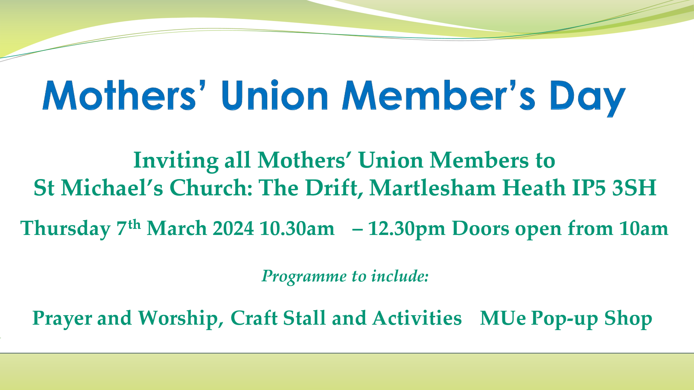

Following on from the Re-Imagining Day we will be using the Bitesize metamorphosis resource as the framework for the event. For full details see the Mothers’ Union Members Day programme, sent with this newsletter.

At the end of the formal part of the day there will be the option to stay for lunch at the Douglas Bader pub which is immediately next to St Michael’s church Martlesham. A table will be reserved for Mothers’ Union members. If you would like to stay for lunch, please contact Beryl Mee to book your place by March 1st secretarysuffolkmu56@gmail.com

Prayer Support for our clergy
Each month this year we will be praying for clergy in different deaneries in our diocese. This month please pray for the clergy in Clare and Colney deaneries.

‘Dear Father God, we pray for our vicars and all in our ministry teams in the deaneries of Clare and Colney. Please guide them in the decisions and priorities they have to make in this strange and worrying time.
Be with them as they phone, text, email and visit those who need their help and support. And please show us how we can best help and support them as they carry out your will. We ask this in the name of your dear Son, Jesus Christ Amen’
Adapted from a prayer by Joy Bolwell. Great Barton and Thurston branch.

Prayer for the month of February. Generous and loving God, you have provided all the resources for works of transformation which create a sustainable future. Help us to use your provision well to effectively serve our communities, wherever we live in the world. Amen.

