Transformation Now!

www.musuffolk.org.uk

Charity No. 249726

February 2023 No 37

Making Mothers’ Union visible: This is one of our aims as a diocese as we Re-Imagine Mothers’ Union.
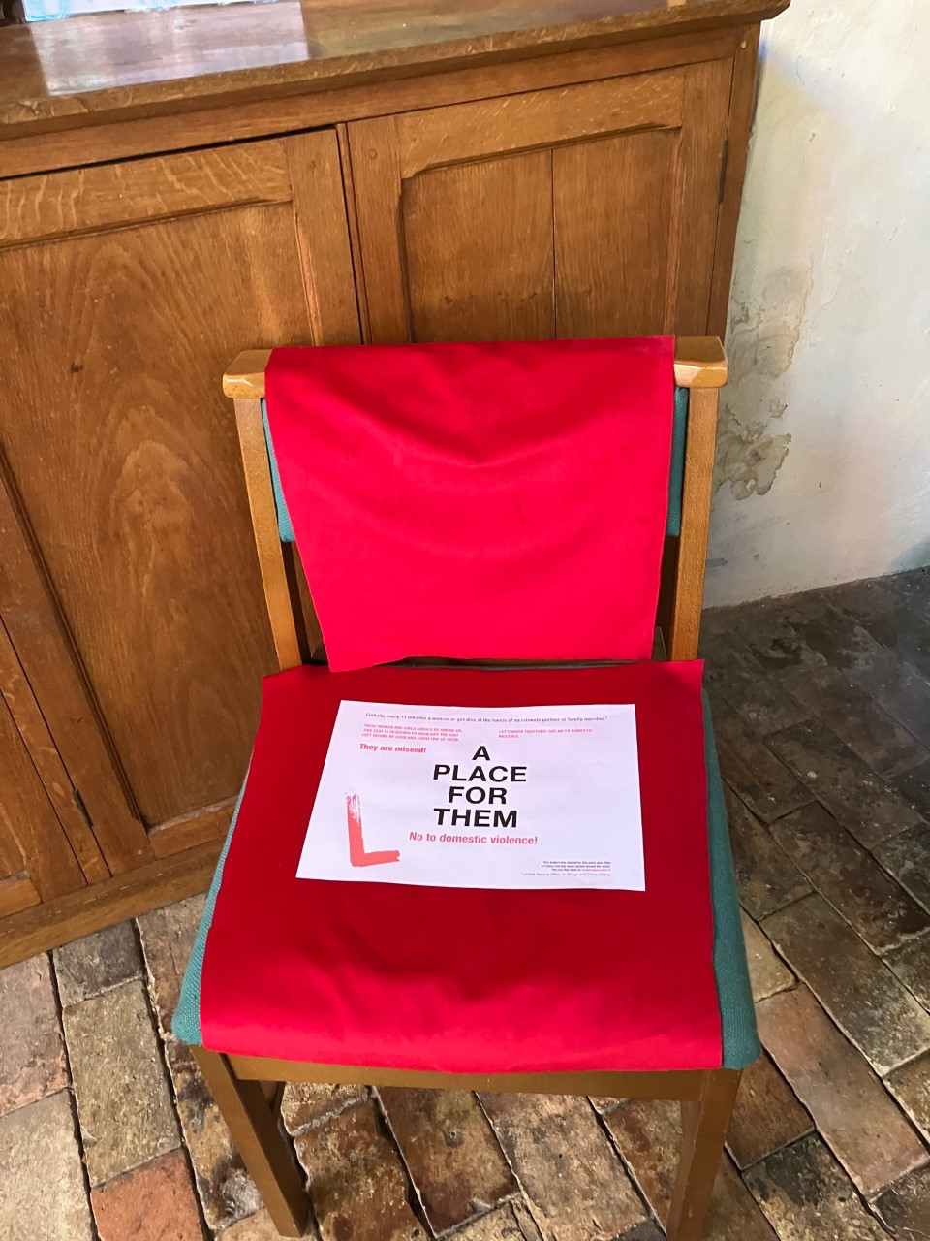
Restored and Women’s Aid:
Restored is a Chrisitan organisation that, like Mothers’ Union, has a vision of a world where women live free from the fear of violence. MU is working in partnership with Restored. We have the 16 days of activism against gender-based violence starting each year in November. But we don’t have to put this issue to one side for the rest of the year. One very visual way of raising awareness of just how prevalent domestic violence is can be shown through the Red Chair project initiated by Restored.
The Red Chair Project involves reserving an empty chair in a public place, such as your church or church hall, with a sign that highlights facts about domestic violence. The empty chair acts as a powerful symbol of the many women who've been killed through gender-based violence. For more information visit: The Red Chair Project - Restored (restored-uk.org)
Add to the display a note to highlight Mothers’ Union is working to raise awareness of the prevalence of domestic violence. We pray for the work of Restored and Mothers’ Union working alongside Women’s Aid to raise awareness of domestic violence.
New projects
Last year East Bergholt and Brantham branch was one of three branches who had meeting when they made Christmas cards for the prisoners at Highpoint Prison. It was a wonderful afternoon of fellowship and creativity. Keen to repeat this project in 2023, a call went out in early last month to the congregation for their 2022 Christmas cards to be donated to MU so that they could be recycled into new cards for Highpoint prison in 2023. As it happened the box placed in the porch was too small for all the donations that came in, which numbered over one fifteen hundred. Members of the congregation have also been asking to join in at the next card making branch meeting.
So be encouraged, let everyone know what your branch is involved with and don’t forget that prayer and fellowship are the most important activities which our branches engage in. When Hadleigh MU branch had a zoom Lent course during lockdown using resources from the Clewer Initiative, they had people from as far away as Devon joining their course. Clewer have produced a new Lent course for 2023 you might like to engage with as an individual or as a branch.
Coronation of King Charles 111 May 6th 2023:
Has your branch thought of a way to mark the coronation of King Charles 111 on May 6th? One branch in the Newcastle diocese is creating a number of crowns, which will form a trail round the village of Rothbury which the children can engage with. Ipswich branches will have been involved in the Angel trails this past Christmas, so will be familiar with this concept. The crowns can be two or three dimensional, made of fabric, yarn, paper, or card. Like the inspiring angels the crowns could be a variety of shapes and sizes all over your community. In schools, shops, on public buildings, on the pavements, in bedroom windows, wherever your imagination takes them!
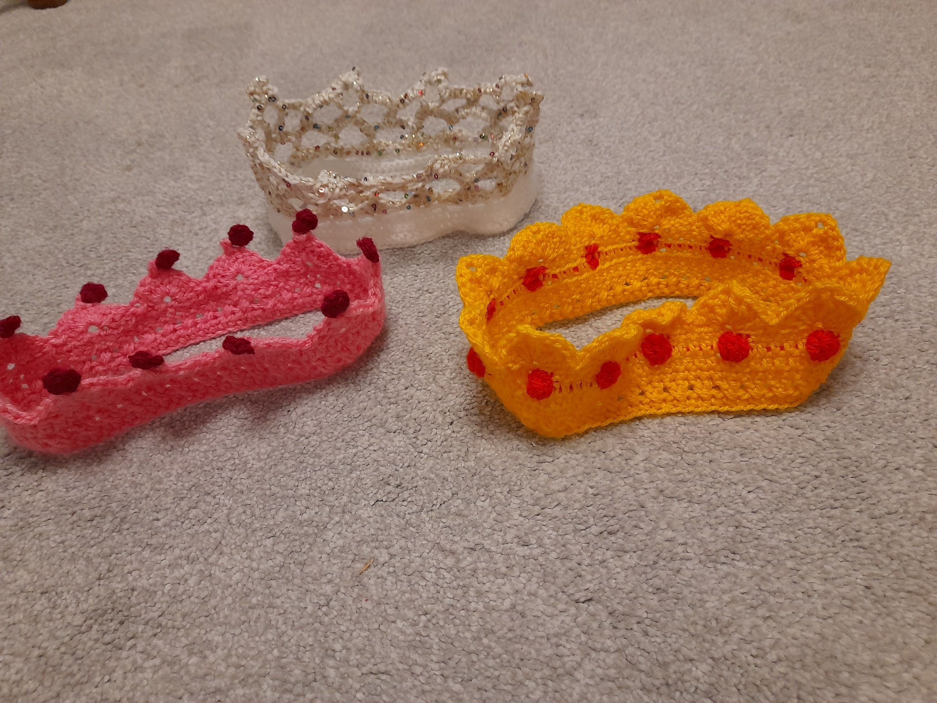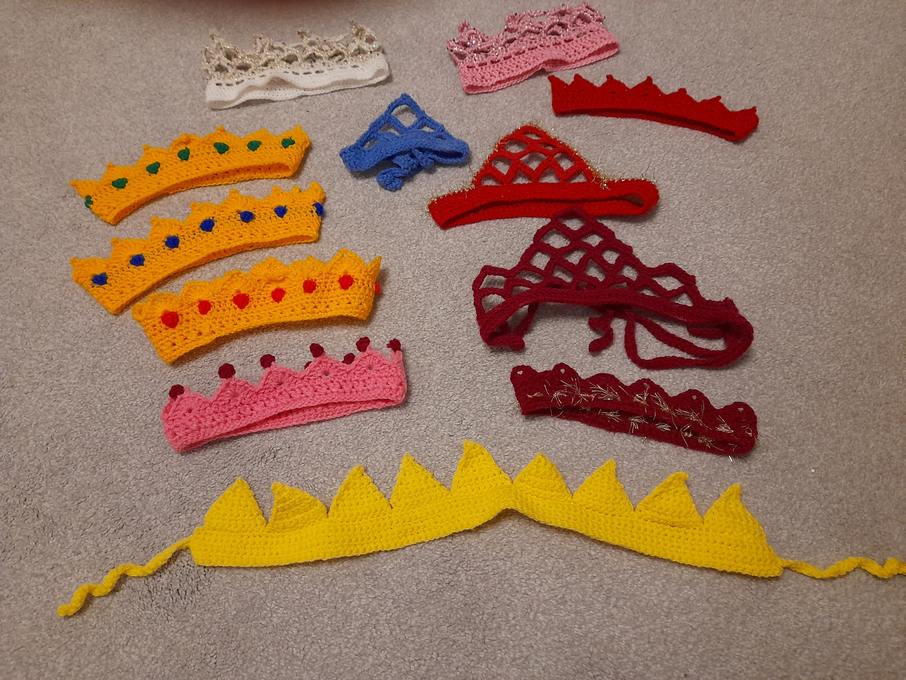
If you have already thought of a different idea to mark the coronation, please share this with the rest of the diocese.

Mothering Sunday resources.
Mothers’ Union has produced a number of resources for parishes to use with families. Whether it is exploring the bible, praying, ways to connect with God or ways to use music .If your ministry team is looking for new ideas for this year’s Mothering Sunday, including service ideas, children’s activities and a number of downloadable resources then why not download some of the children’s Mothers’ Day resources and show them to your vicar and ministry team.
Knitted Breast project:
Our project to support the Suffolk Infant feeding team is well underway. Lisa Locke the Infant Feeding Co-ordinator is very grateful and says that these ‘knitted breasts’ are much in demand by the staff. Our goal is to make one for each member of staff who would benefit, about 120 in total. So far about 30 have been sent and if you would like to join this initiative the pattern can be emailed to you. These are simple and quick to knit. Cathie McGregor catherinemcgregor211@gmail.com Craft C.O.I
Thank you for your 2023 subscriptions:
A big thankyou to Mothers’ Union members and branch treasurers for getting the 2023 subscription paid so early in the year. 20% of our membership are now paying by direct debit. Having these subscriptions going directly to Mary Sumner House reduces the work load of branch treasurers and our diocesan treasurers. One branch in our diocese has over 80% of its members paying by direct debit, that is one lucky branch treasurer!
Re-Imagining Mothers’ Union Discovery Day:
Friday June 23rd 10am to 3pm
Venue: Shepherd’s Drive, Baptist Church, Ipswich IP8 3SL.
We look forward to having Mothers’ Union members from branches across the diocese come together, to share ideas and address the challenges of running branch accounts, maintaining branch leadership roles and growing branch membership. As well as developing new projects and outreach programmes.

Shepherd’s Drive Baptist church on the Pinewood estate is a modern, fully accessible building with a large car pack, just a short distance from Suffolk One and the Tesco store at Copdock. To book your free place contact:
Jeanette Appleton e: Jeanette.Appleton@mothersunion.org. m: 07768418942

Prayers: This month in our MU prayer diary the focus is on Community Transformation.
The creative prayer on page 15, suggest a walk round your local community, asking God to highlight where there needs to be transformation of some kind, pausing to pray there. If you are not able to take an actual walk, prayrfully do so in your mind, asking God for the same insights.

