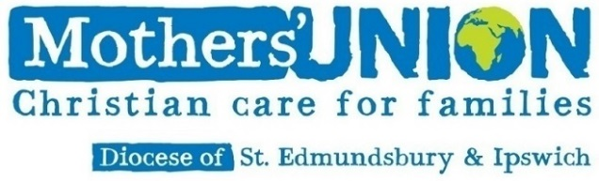
Event Checklist Form

- Is the event covered by the existing Diocesan Mothers' Union insurance? Check with the Diocesan Treasurer if you’re not sure.
- Who is the event intended for? Undertake a risk assessment of the safety of all possible types of participants. Send details of the event and a copy of the risk assessment to the Diocesan Treasurer.
- Will there be safeguarding issues? If so, get advice from the appropriate Parish Safeguarding Officer or the Anglican Diocesan Safeguarding Adviser. DBS checks may be required.
- Is there a building involved and, if so, is its insurance cover adequate for the event?
- Are there special requirements for the event such as bouncy castles, etc?
- If refreshments or food will be served, follow food safety standards as stipulated by your local council and the Food Standards Agency.
- Is there adequate lighting for the needs of the event and are all prohibited areas clearly marked and cordoned off?
- Are areas of access clearly marked and is there adequate access for wheel chair users and people with mobility issues?
- If using external contractors / hiring of equipment ensure they hold adequate insurance cover. Do not take their word that cover is in place – the ultimate responsibility for safely rests with the event organisers.
- Identify areas of danger and place clear notices to warn users of these. This will not automatically safeguard against a claim, but will act as a necessary warning.
- What first aid support is available / required? Is there a reasonable mobile signal in case of an emergency?
- Will toilets be available?
- Will microphones be required? Is there a loop system?
- Consider any other issues that could affect the smooth running of the event.
- Remember to tell people where the fire exits are at the start of the event.
- Consider how the event will reflect on the reputation of Mothers’ Union.

