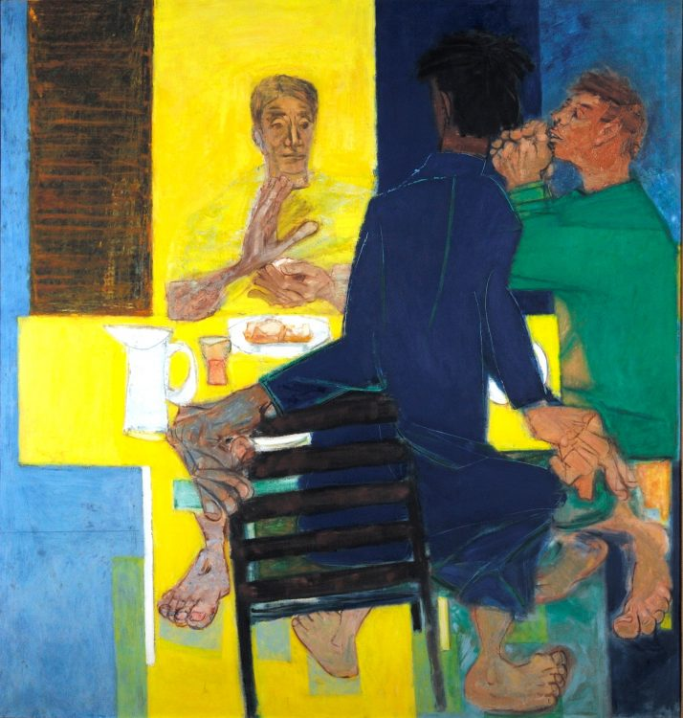
(Photograph downloaded from: https://www.seh.ox.ac.uk/blog/ceri-richards-supper-at-emmaus)
‘Supper at Emmaus’: Ceri Richards (1903-71): painted in 1958
(The painting hangs in the Chapel of St Edmund Hall, Oxford University)
(Based on Luke 24: 13-32)

The painting depicts the culmination, the final denouement, of the meeting of two of Jesus’ followers (“the others”) with Jesus on the road to, and ultimately in Emmaus. The two friends (from now on I will call them ‘disciples’) were walking, introspective and despondent, away from the tragedy that had occurred in Jerusalem. It is highly unlikely they would have witnessed Jesus’ death but they will have been present when Peter and the other disciple who ran with him, breathlessly recounted their discovery of the empty tomb when they returned (Luke 24: 9). It is important to note that Jesus had not yet appeared to the entire group of disciples. On the road, this was the moment, when, unannounced and un-recognised, just ‘came across’ these sad and dejected men. They opened their hearts and mouths to him but they did not yet realise who this stranger was… Until that is, in Emmaus and at supper, he ‘took bread, gave thanks, broke it and began to give it to them’. Then the penny dropped and they recognised him; they also acknowledged what they had felt, and perhaps what had led them to pour out their hearts to him as he walked and taught with them on the road. For me, this is one of the most moving and spine-tingling moments in the Gospels. It was the first time since outside the tomb, that Jesus had appeared in person – and not to his closest friends, the eleven disciples, but to the ‘others’ referred to earlier in chapter 24 (verse 9). This meeting cannot have been coincidental; it was deliberate and it was important. Jesus’ priority was to reach out to those on the fringe and those who were walking away, literally and metaphorically … And what was these disciples’ response? After the revelation at supper, they turned round and returned, not the next day when rested and when it was light, but “at once”, to Jerusalem, to share the good news with the ‘Eleven and those assembled with them’. Alleluia!

In the painting, Christ sits, illuminated by a cross of light which both outlines and absorbs him; he appears to be emanating from the light, the light that illuminated the darkness (as it did in opening the eyes of the two disciples at the table). Jesus is the only true light in the world, then and now. The two disciples react to their recognition of Jesus in very different ways. The one with his back to us stands up, in surprise and haste, knocking the chair to the side in his excitement. The other is seated at the end of the table with his eyes closed and hands clasped in what may be prayer, or in silent contemplation, possibly struggling to make sense of what he is seeing. The painter may have been trying to illustrate the extremes of emotion people – we – would likely feel and show when faced with such a seminal event.

The most unusual and striking feature is the disproportionate large size of the hands and feet of Jesus and the disciples; their prominence is further emphasised by the very narrow wrists and ankles. This specific feature calls to mind a prayer attributed to St Teresa of Avila:

Christ has no body now on earth but ours;
No hands but ours;
No feet but ours;
Ours the eyes through which he is to look Christ’s compassion to the world;
Ours are the feet with which he is to go about doing good;
Ours are the hands with which he is to bless men now.

Our hands and our feet provide specific and practical means of doing good; to help others and to bring the kingdom of God to all in this life, and today. How appropriate and relevant at this time of COVID19 and the increased need for such work.

Christ in his risen body gives his disciples the blessed bread, his body broken for all humanity, so that they – and we – might become his risen body in the world. This is, after all, what, as disciples of Christ we have been called to do. Amen.

