A new venue for Mothers’ Union November Council meeting

The Coddenham Centre, Mary Day Close, Coddenham IP6 9SR

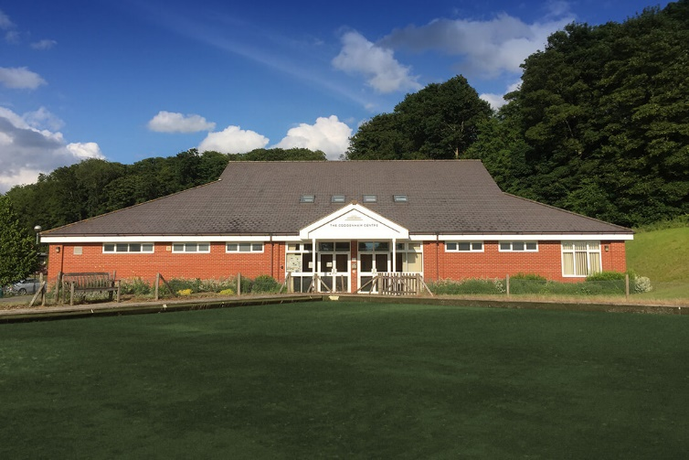

Coddenham centre has a large car park with several disabled spaces.
See the map below for its location in the village.

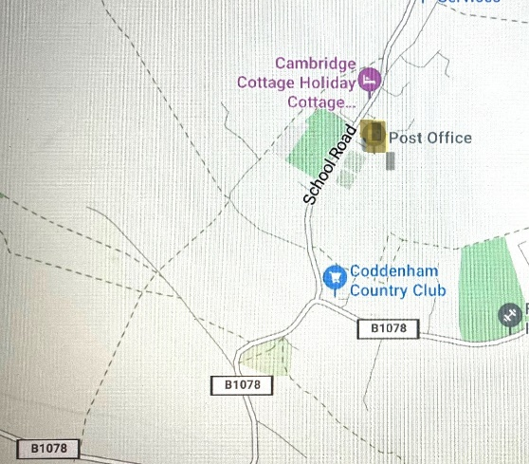

Coddenham Centre: Mary Day Close

