Transformation Now!

www.musuffolk.org.uk

Charity No. 249726

December 2023: No 47

News from across the Diocese
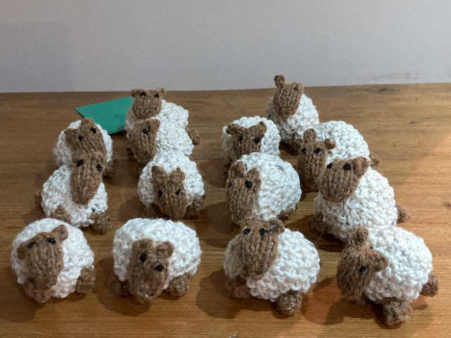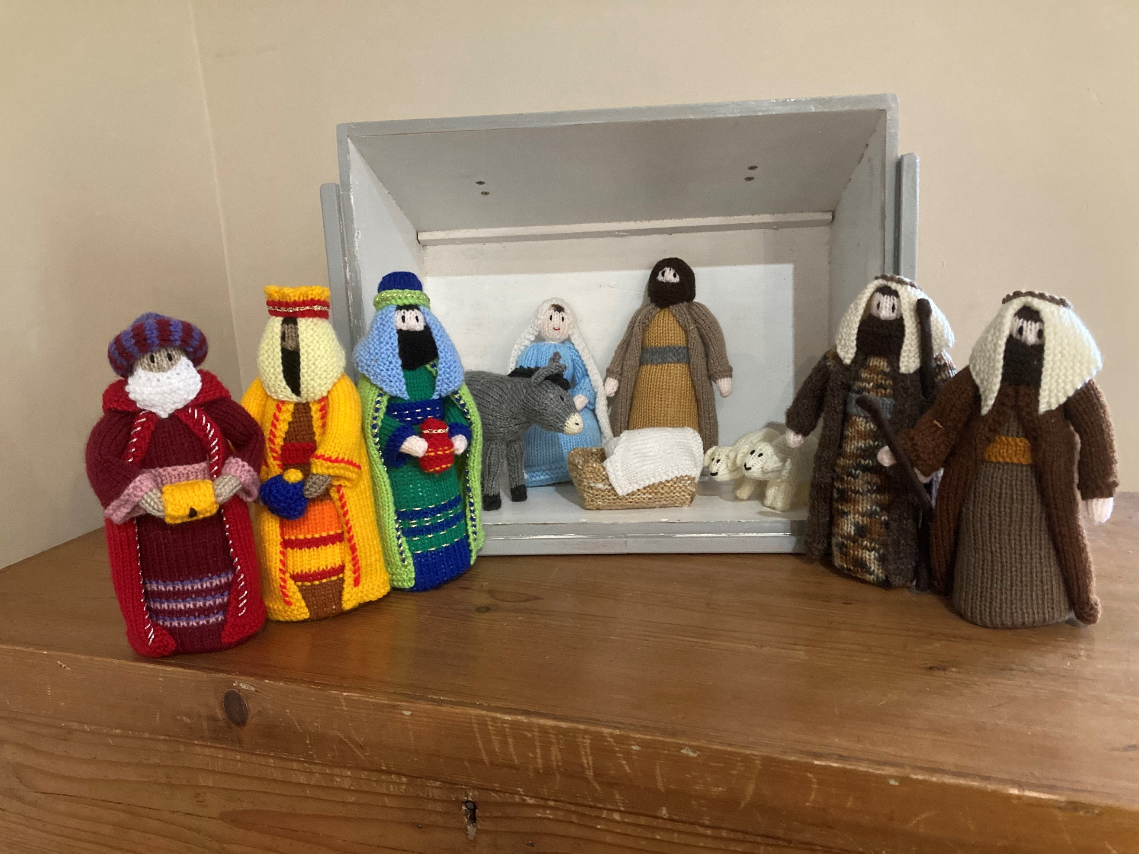
Yoxmere Benefice Mothers’ Union: Our branch now has a travelling Nativity set which will journey round the benefice during Advent. A travelling case was kindly made for us by the ‘Men’s Shed’ in Saxmundham. We have also made some small sheep tree decorations. One of these and a Christmas message will be given to each household that hosts our nativity to say ‘Thank you’.
East Bergholt and Brantham: Our branch is supporting the ‘RISE UP’ campaign by putting up RISE UP posters around our two villages in the village halls, our churches and other public meeting places. At our November meeting, we started to make ‘moving bags’ for the Ipswich Women’s refuge. We have invited the church congregation, friends and family to donate toiletry items and towels so that we can continue to make them. In addition, two prayer trees will go in each of our two churches on November 26th at the beginning of the 16 days of activism, to highlight the fact that one in three women are affected by domestic abuse.
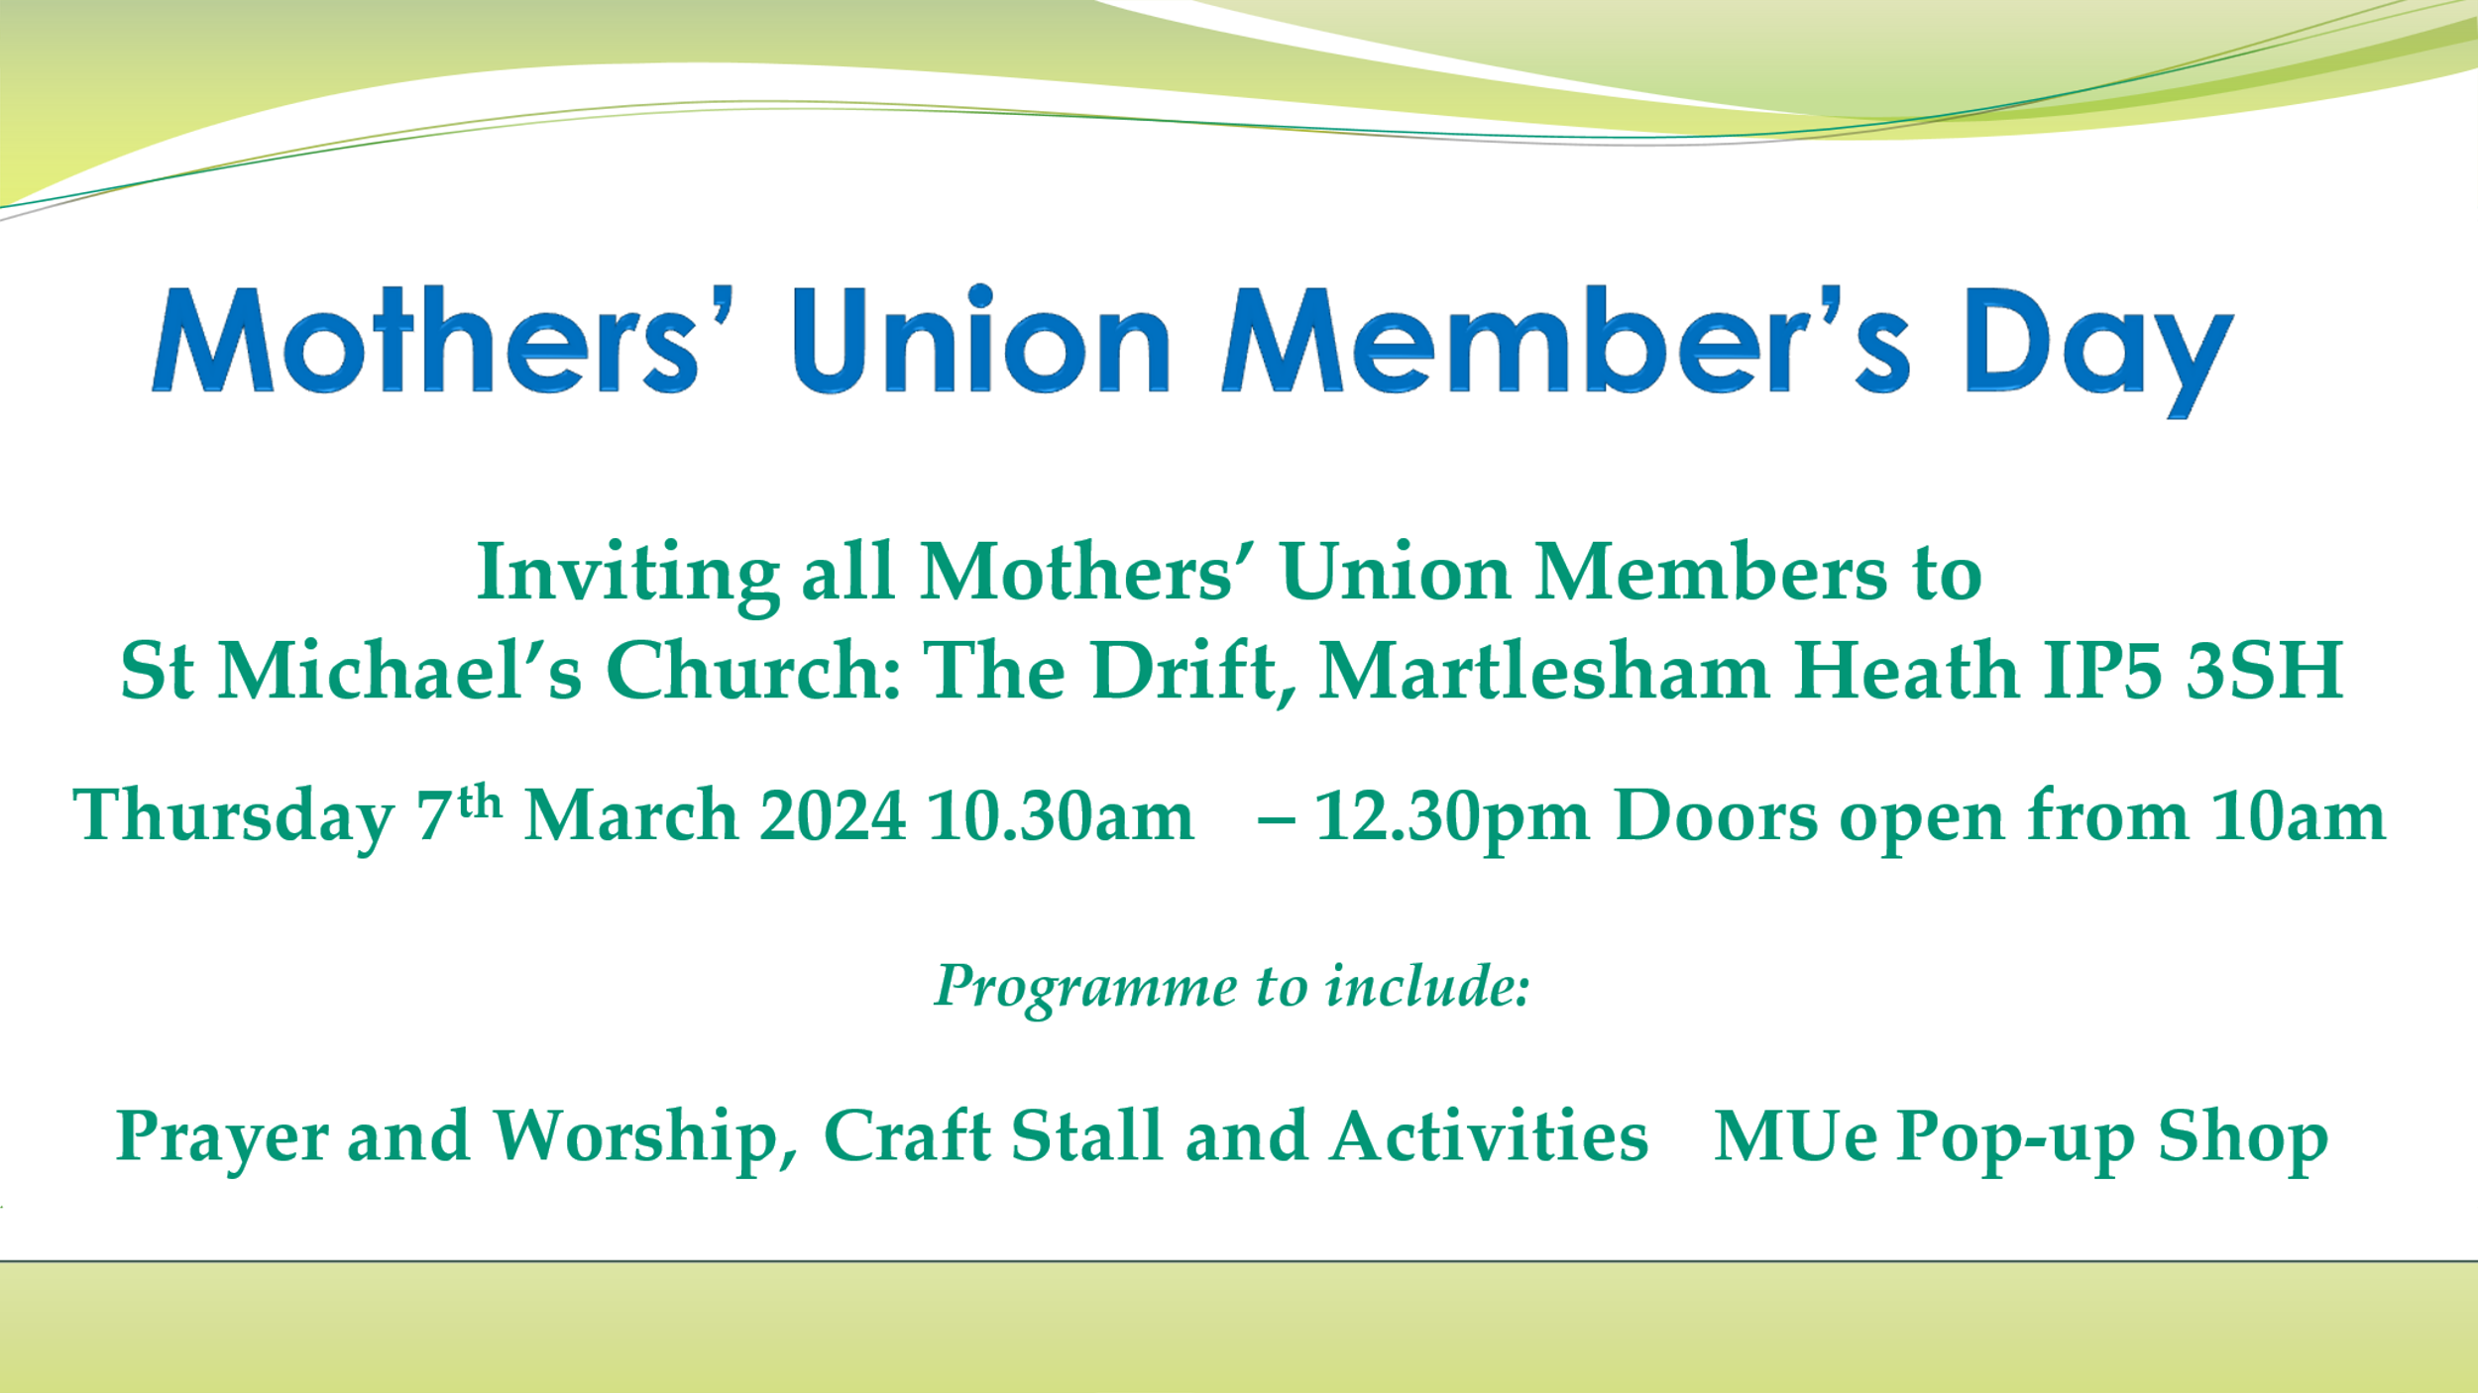

Save this date!
This event is for all of our Mothers’ Union members and will be in the following format. It will start with tea, coffee and the usual excellent Mothers’ Union cakes. This will be followed by a time of praise and worship and then craft activities. This will include the opportunity to collect fabric and wool as well as patterns and to see a wide range of craft projects. Other activities will also be available for members to engage with.
At the end of the formal part of the day there will be the option to stay for lunch at the Douglas Bader pub which is immediately next to St Michael’s church Martlesham. A table will be reserved for Mothers’ Union members. If you want to stay for lunch, contact Beryl Mee to book your place, secretarysuffolkmu@gmail.com

Council Meeting: This was the first time Mothers’ Union had used Coddenham Centre as a venue and everyone seemed very pleased with its space and facilities. The ample car parking and quiet roads made it a pleasant place to travel to. On 30th November those attending were treated to a wonderful landscape of white frost on the fields and trees but fortunately, not on the roads.
School Uniform Vouchers: In 2023 the Cost-of Living crisis has created a real challenge for parents. This has included the increased cost of school uniforms along with all the other household bills. Parents are required by law to ensure that their children who are of compulsory school age must be registered at school and attend regularly. School uniforms are compulsory clothing.
Mothers’ Union in the Diocese of St Edmundsbury and Ipswich has a Parenting Fund, which has historically been used solely to finance parenting programmes. The trustees have now extended the use of the Parenting Fund to enable parents to apply for vouchers to cover the cost of school uniforms (including school shoes) for their children. If you know of a family who needs this support, please contact Val Jeffries at afiamusuffolk@gmail.com. Val has kindly undertaken to oversee the issue of School Uniform vouchers and will provide the necessary grant application form for School Uniforms.
Nomination papers are out for the role of General Trustee. Do you know someone who:
- Is committed to, and enthusiastic about the Mothers’ Union
- Able to devote the necessary time and effort to trustee meetings
- Has good, independent judgement
- An ability to think creatively
- A willingness to speak their mind
Then please ask them if you can nominate them for the role of General Trustee. Nomination papers are available from Beryl Mee ( secretarysuffolkmu56@gmail.com). These must be returned by January 31st 2024.
The BIG GIVE GIFT FOR LIFE APPEAL
You made double the difference and gave a Gift for Life!
In some of the world’s poorest communities, the future is now brighter, thanks to you. The positive response to our ‘Big Give Gift for Life’ appeal has been overwhelming. Your support has enabled more communities, people and families to invest in their future with resilience, strength and hope. Although we reached our online Big Give target, it is not too late to donate to our appeal and continue to make a difference.

A Christmas Tree Blessing
Holy Creator of trees,
Bless with your abundant grace this our Christmas tree as a symbol of joy.
May its evergreen branches be a sign of your never fading promises.
May its colourful lights and ornaments call us to decorate with love our home and our world.
May the gifts that surround this tree be symbols of the that we have received from the Tree of Christ’s Cross.
Holy Christmas tree within our home,
May Joy and Peace come and nest in your branches and in our hearts.

Offering a Christmas Blessing
Sometimes our most common prayers are the mini-Christmas blessings we offer when we extend our greetings to friends and family. The simple Christmas blessing of “Merry Christmas” is the most common way to share a prayerful sentiment with someone.

