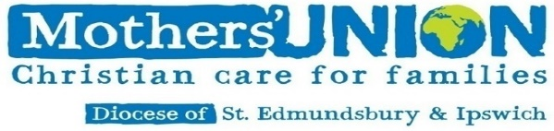

15th December 2020, No. 11

[www.musuffolk.org.uk](http://www.musuffolk.org.uk)

Charity No. 24972



Dear MU members, wherever you are!

This comes to bring Christmas greetings from the Trustees and Officers of the St Edmundsbury and Ipswich

Mothers’ Union, and to pray that, in spite of everything that’s happening around us, you will have a truly

blessed and meaningful Christmas. We have much for which to rejoice and give thanks – and indeed for

many of our members, for once they will be first in the queue…! Be encouraged - take heart – ❤️ !

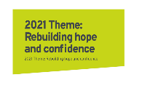

Next year’s MU theme is all about “Re-building hope and confidence”, and as an organisation I can say we really do believe that God will be doing great things in the coming year. Sheran Harper, our Worldwide President, has sent a letter of greeting to all Indoor Members and she, together with Bev Jullien, our CEO, have outlined their vision for the future – and it’s all very exciting! Find out

the latest news/information on the websites: ([www.mothersunion.org](http://www.mothersunion.org)) and ([www.musuffolk.org](http://www.musuffolk.org)).

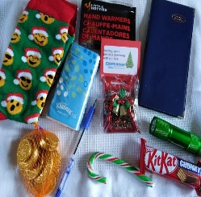Branches and Areas have been working really hard too – sending out Christmas “treat boxes” to their members, giving imaginative gifts to those less fortunate, fund-raising for the Urgent Appeal and the Big Give matched funding, and much more. Branches have been learning how to Zoom, some reminiscing about Christmas past (complete with nibbles, fancy jumpers and party headgear). Getting to grips with all the modern technology has been quite a challenge for many of us, and as Trustees we have very much appreciated the effort made to tackle these new ways of working – on a recent MU zoom call one member spent the entire session upside-down on the screen! Thanks so much for persevering…!

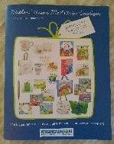

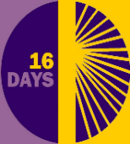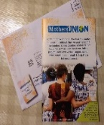Branches have also been supporting MUe and sending out cards, delivering the Prayer Diaries, magazines and newsletters, and encouraging one another through “bubbles”, visits, ‘phone calls and other activities such as campaigning for the “No more 1 in 3” initiative, raising awareness of the 16 Days of Activism against Gender Based Violence, writing articles for parish magazines, newsletters and reflections for our website …. Others have been involved in the food banks and volunteering, taking Bags of Love around parish and care homes, serving in their local churches, supporting clergy, and our prayer warriors, underpinning everything we do. There is just so much more going on behind the scenes, and each contribution is much appreciated. Mothers’ Union across the diocese is certainly being noticed….

But there has also been much sadness too this year, and we remember with affection those who are no longer with us (do remember our *Inspiring Individuals* page on our website), and we continue to pray for those of our number who are struggling with their physical and mental health – and, as we question where God is in all that’s going on, we remember especially those whose faith is fragile, and ask that they might know the peace of God in their hearts and be given the strength to cope at this time.

But in spite of everything, together we have nearly made it to the end of 2020. On Thursday 17th December at 7.30 pm the Mothers’ Union MSH **“Nine Lessons & Carols”** (an ***“evening of Christmas tradition and celebration”***) will be broadcast on the Mothers’ Union Facebook page and on the YouTube channel (and you will be able to play catchup), and on Monday, 21st December – the longest day of the year - at 5.00 pm we have ourown St Eds&Ips ***Blue Christmas Service***, organised by Jeanette (our Faith and Policy Trustee) with members (socially distanced of course) from around our diocese.

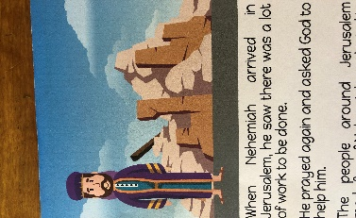In the New Year there will be our video ***launch of the 2021 MU theme*** based on the prayer life of Nehemiah rebuilding the walls of Jerusalem – an all-age occasion for a time of fellowship with like-minded members. This too will be available on Facebook + YouTube so that together we can reflect on the work of Mothers’ Union here and overseas, deepen our Christian faith and commitment, and affirm our identity by enjoying a different kind of shared experience. There’s just so much going on...!

So this comes with our love, and prayers, with encouragement and joy, as we rejoice in the birth of a small Baby born in Bethlehem 2000 years ago… . Take care and keep safe, until we meet again face-to-face.

**Branch/Deanery News**

**EAST BERGHOLT: Just a few words and a HUGE thank you to Christine Jacob**

Christine Jacob is standing down after ten years as Branch Leader of East Bergholt. Whenever there is a Mothers’ Union occasion – in different and various places around the county - Chris can be found at the MUe stall where members could go and buy items. I last met Christine a few weeks ago, at the opposite end of the county, representing her members by lighting a candle for the Blue Christmas Service. Always present at coffee mornings, Councils Meetings, and everywhere that MU goes, Chris is familiar figure. On the 6th December at the Sunday morning service at East Bergholt, there was a special service at which she was given a lovely flower arrangement as a token gesture and mark of appreciation for all she has done for the Branch. Well done Christine and thank you!

**FRESSINGFIELD**

During September thirty Mothers’ Union members from Fressingfield Branch met in small groups of six in 5 different member’s gardens. Each group shared in an act of worship and then enjoyed each others’ company over a cup of tea and cake.  We have really missed our regular monthly meetings although we have kept in touch and up to date through newsletters, emails and phone calls but it was lovely to see at least some members face to face. (AV)

**NORTH SUFFOLK AREA**

In October the North Suffolk Area once again ran the I-Chameleon pop-up shop in Halesworth. In spite of disappointing weather and Covid restrictions, which limited the number of people able to enter the shop at one time, the week was still very worthwhile. Thanks to the generosity of members from the north, and beyond, the shelves were well stocked with a large variety of items and MUe cards were also on sale. Together with some private and eBay sales over £1200 was raised plus £238 for the cards!! £300 has been sent to both the Overseas and Britain & Ireland funds. Further money will be used to support ‘Open the Book’ teams in the North Suffolk Area and provide guests at the Ipswich Night-shelter and tenants in Hope into Action housing with a pair of Christmas socks filled with both useful and fun items. (AV)

**IPWSWICH AREA**

Christmas gifts were bought and given to the Mums and Children at Peppercorn Lodge in Ipswich (SG)

**WOMEN’S REFUGE**

This Christmas Mothers’ Union has bought Christmas Gift Vouchers for the Women’s Refuge at Ipswich and Bury St Edmunds, and also men’s and lady’s pyjamas and underwear for the Ipswich Night Shelter – the gifts have been very much appreciated by all the recipient. (SG)

Thank you to all our Mothers’ Union members, and their friends and families who have given so generously of their time, money and effort during this last year – whether it be to the Urgent Appeal, the Big Give with matched funding, baking, cooking, shopping, delivering, volunteering, serving, praying or whatever – even being just you – we are certainly having an impact on the diocese!

Thank you for everything….. and have a wonderful festive season. This comes with our love