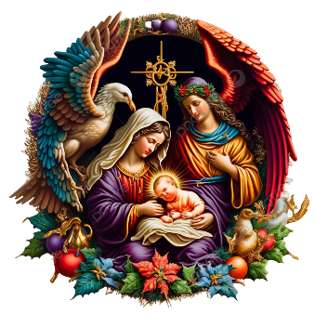

December 2024
Number 59
Charity No. 249728
Transformation Now!
Dear MU Members and friends,
Advent has arrived! – a prayer for you from ‘The Prayers We Breathe’ red book: ‘God of hope and joy, open our hearts in welcome, that your Son Jesus Christ at his coming may find in us a dwelling prepared for himself, who lives and reigns with you and the Holy Spirit, one God now and forever, Amen ’(From New Zealand Prayer Book, John 1 v 1-18)

This was going to be a final thank you letter from me to say how much I have appreciated all the love, support, prayers and encouragement over the last six years as the Diocesan President and to thank you from the bottom of my heart for all that you have given me. I have so enjoyed my time (well, most of it!) meeting folk, visiting branches, attending functions and all the other happy occasions (but not so good at all the admin, IT, meetings, legalities and the rest) but I have had a truly wonderful team to work with who have filled in all the gaps. Their wisdom, knowledge, skills, experiences, attitudes and prayers have so much blessed our MU here in St Eds and Ips – truly a “body with all its parts working together”. Most of all I have loved learning from you, and sharing my story when visiting branches, and I know I have consequently grown deeper in my faith. It has been a real privilege to serve, and my love and prayers go with the new team as they take the work of MU forward. Exciting times lie ahead…. Thank you all for everything you’ve given me….

It was the last Council Meeting of the triennium at Shepherds Drive Baptist Church on 4th November, and included our updates, an archive display, thanks and gifts. Christine Ward and Val Jeffreys were acknowledged for their commitment and dedication to MU and in appreciation were made Life Vice Presidents and awarded certificates with our grateful thanks. The new team for the next triennium (2025-2027) was announced by Jeanette - please remember each of them in your prayers: New Trustee Board - Diocesan President – Jeanette Appleton; General Trustees: Clare Thomas, Ruth Dennigan, Rev Alan Forsdike (and one trustee vacancy); Diocesan Chaplain – Rev. Catherine Forsdike; Diocesan Finance Officer - Amanda Langan supported by Diocesan Book-keeper - Rob Shackleton; Diocesan Secretary/Correspondence – Vacant; Diocesan Minutes Secretary - Ruth Dennigan. Community of Interest (COI) Leads and Diocesan Officers - Diocesan Members Rep - Sarah Nicholson; Development COI Lead – Vacant; AFIA Rep - Vacant; Prison - Vacant (Christmas Cards for HMP Highpoint/Hollesley Bay contact - Sue Norrington); Craft COI Lead - Cathie McGregor; Communication COI Lead - Vacant; Faith COI Lead -Vacant; Worldwide Contact - Anji Dawkins; Indoor Members Rep - Margaret Morrison; Membership Secretary & MUe manager - Clare Thomas; Policy COI Lead - Cathie McGregor; 90th Birthday Contact - Margaret Rollins; Modern Day Slavery Contact - Christine Ward. Please pray for those whom God is still calling, asking that they will have the courage to respond to the vacancies, and especially the Secretary/Correspondence post and Communications Lead. When God calls, He also promises to equip and bless.

Giving and Receiving – it’s Christmas!
By now you will all have received your 2025 Prayer Diary and Christmas Appeal information. Do send in your (and your family and friends and neighbours) donations, before the 10th December, to MSH, so that your gift can be doubled. We are in the middle of 16 Days of Activism (25th November - 10th December) – have you sorted out what you have/will be doing for the Global Day? – as an individual with your prayers, as a branch, an MU fellowship group or your church?

“Meet” our new Worldwide President in the new Prayer Diary which, by now, you should all have received….
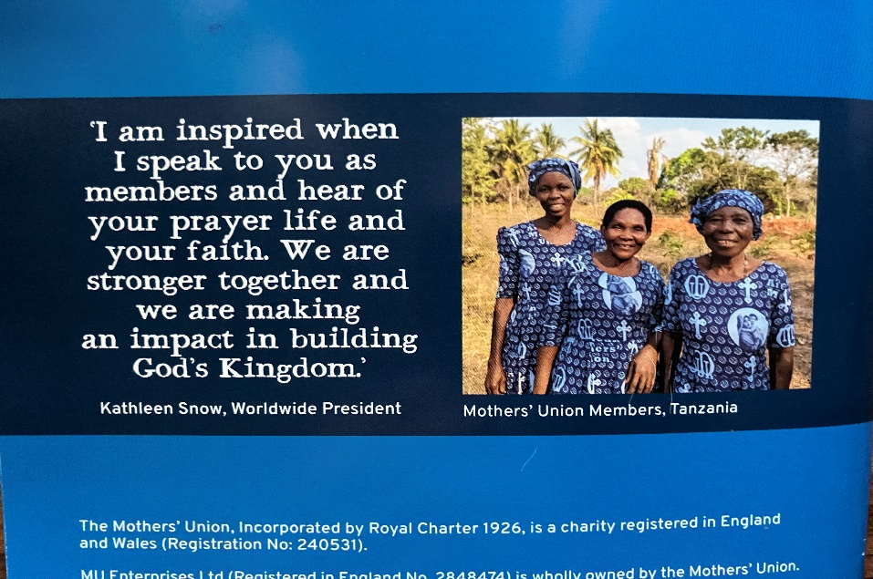

From Kathleen Snow, next Worldwide President, taken from the back cover of the new 2025 Prayer Diary

Money – Outgoing: £7,500 to Mary Sumner House. Incoming, £566 from the Ipswich Coffee morning with the MUe stall raising £547.36 (best ever result!) and bringing £54.73 back to our diocese from the TRG grant. Well done everyone!

Hospitality: Very much enjoyed all your invitations to branch Christmas fairs, parties, meals, get-togethers - like Hoxne’s Church Christmas Faye (with Cathie on “Cakes” making a good post-operative recovery), Fressingfield, Needham Market, the Enrolment at St Mary Stoke and Advent Tea in Yoxmere Benefice. It’s been really sad to hear of the passing of the Rev Margaret Bonsall. Knowing she was dying of cancer, she planned her own beautiful service of a celebration of her life, held on the 11th November at noon, and attended by many including Beryl and Sandra who, on our behalf, represented Ipswich Area and the Diocese. Maureen was a loyal friend and member of MU at St Botolph’s Church, Whitton, Ipswich. She took our Healing Service at St Botolph’s church soon after the pandemic and also joined us at Castle Hill Ascension Church for our Reimagining Workshop earlier in the triennium. Maureen will be sadly missed by her many MU friends and family. May she rest in peace and rise in glory.

Sharing our thoughts and prayers for those unwell (and maybe perhaps a card from MU?) - Rosemary Farrow, (address in Beryl’s email), Rosemary Wood at Seckford Care, Mary Addington at Rendlesham and others whom we know….

Catch up with news from Sandra about the gifts given to the Women’s Refuge at the Lighthouse, or perhaps read about Amanda’s “handful of rice” ,,,, “A few weeks ago I felt a need to ask our Top Up Shop coordinator at St Matthews whether there was any foodstuff item that she needed more of and she came back to me to say, “ Rice”. She said she can never have enough rice. I asked her what type and she said the cheaper the better so Dik and I now add 2 bags of white, easy cook, rice to our grocery order each week (we carried on with home deliveries post covid). It costs us 52p per bag and I now take it to church each Sunday. I just put it in with that week’s top up shop stock. A quiet way of helping, with a very small cost to Dik and I, but it can help to feed a family in difficult circumstances. I send God’s love quietly with each bag - how powerful is that?!” (Thank you, Amanda)

Upcoming dates for your diary: Thy Kingdom Come Prayer Plan – 29th May - 8th June, and another Annual Gathering planned for 2025 – brilliant feedback – for Saturday, 27th September, again at The King’s Centre in Oxford.

New ways of working …… Prison work is gathering pace following the Prison Week service at the Cathedral. Contact Wendy Norris for more details and a form if your church (PCC) would be willing to become a “Welcoming Church” and commit to praying for prisoners on release. The Governor at Hollesley Bay asked me if we could make 1,000 Christmas cards like we do for HighPoint prison) and then added “What can my prisoners do for the MU?” (would love to hear your thoughts and suggestions….). Save all your Christmas cards and pass them on to Sue Norrington!

Flourishing Families: Flourishing Families seeks to provide positive peer support for parents through offering a five week guided support group. We know that at times parenting can feel challenging and lonely and that often parents are balancing keeping the family going with pressures of work and life events, such as bereavement or job loss, and this makes things feel even harder. Flourishing Families provides a safe space to enable parents and carers to share experiences, knowledge and reflection on their family relationships and to have space to consider and build their sense of wellbeing. Families will be enabled to learn, to protect their physical and mental health, and to make good decisions whilst maintaining strong relationships with their children and family members. We believe that safe, non-violent and supportive parenting is key to healthy child development. Our hope is that families will thrive, meeting their needs through strong and respectful relationships and with children growing up in safe and nurturing environments. This manual is aimed at volunteer facilitators to guide facilitators providing the information and tools needed for each session. The manual draws on the experience of Mothers’ Union’s work with parents and carers as well as academic theory and practice. Next year will see a greater emphasis on family relationships, grandparents, and MU’s potential influence.

Further afield: St Margaret’s Church, Ipswich, UK and St. Paul’s Church, Ipswich, Australia. Diocesan member Shirley Girt has uncovered information about some 17th Century medallions of St. Mark and St. Luke which were donated to St. Paul’s by St. Michael’s. This was a ‘Thank you’ for the food gifts organised by St. Paul’s and sent to St. Margaret’s during World War 2. Parish Council minutes from 1958 record the journey of the medallions to Australia. Mothers’ Union members collected some of the £39 that was needed to install them. By 1959, Parish Council minutes record that the medallions were in place with a plaque indicating that they were presented to mark a link between the two churches. (Thank you Shirley, for finding all this out with the help of your MU friends in Australia, via Sue

New Royal Patron: Today was going to be the day for announcing our new Royal Patron, but this is postponed due to staffing difficulties at MSH (we have no social media staff, our Director of Membership (Steph) is on long term sick leave, and our Director of Finance (Richard) is on paternity leave – his wife gave birth to no. 5, a daughter, on Saturday). Do continue to pray for the MSH team, for Kathleen our new WWP, the new trustees boards, officers, community of interest leads and our worldwide membership, and especially for all the challenges they face in setting up the new database, potential sale of MSH, staffing issues, etc. And of course, all the joys and blessings too.

Together – as I have so often said, “we praise God, rejoice and give thanks” for all that He has done, is doing and will do in the future, and we have confidence in knowing that God is working His purposes out – for us as individuals, in our churches and communities, and as members of the worldwide Mothers’ Union.
With all my love at this wonderful season of Christmas, as ever, Linda

