



**Transformation Now!**



w

ww.musuffolk.org.uk



Charity No. 249726



August 2023 No 43

**St Mary’s Woodbridge raises £264.03 for the Summer of Hope Appeal**

We have been collecting small coins in various ways to go to the Summer of Hope Appeal. These began with a small tube of smarties at Christmas which we were asked to eat and then fill the tube with coins; we have also used small jars – a MU initiative.

In June we held a cream tea to raise money also for the Sumer of Hope; cream teas are always popular and enjoyable. Our total for this Appeal was £264.03

At our wave of Prayer service in July we had a collection and sent £61.20 for Overseas

Sadly, we have lost two members this year but were able to attend the funerals and donate in their memory; one lot of money coming to MU. Anne Wright.

**10% of our MU membership in this diocese are made up of Diocesan members**.

This rise is in part due to the fact that the new Fellowship groups are made up of diocesan members. Diocesan membership also suits people where there is no branch or Fellowship group nearby. Diocesan Members rep Sue Norrington sends out monthly mailings so that diocesan members are kept up to date and Sue ensures that they receive their copies of “Connected” and the Prayer Diary from Mary Sumner House. Sue also organises the collection of their subscriptions for our Diocesan treasurer.

Diocesan members are welcome to attend any council meetings or branch meetings across the diocese. If you are interested in learning more about this form of membership, please contact Sue Norrington tel: 01728 660280 email: [farthings@btinternet.com](mailto:farthings@btinternet.com)

Sue will be stepping down from this role at the end of the triennium; she would like to work with her replacement for a few months so that she can hand over the role smoothly. If you feel called to this role, please contact Sue at the above phone number/email

**Indoor members rep:** Monica Twaits would like to step down from the role as Indoor members rep. Monica has faithfully kept in touch with around 50 MU Indoor Members with regular correspondence. This is a role that does not involve travel or attending any meetings. Is this a role you feel called to? If so, please contact Monica, as she would like to have a period of handover to ensure the smooth running of this invaluable role. We thank Monica for her dedication in this role and wish her every blessing.

**Mary Sumner Day Service- St Mary Stoke Ipswich.**

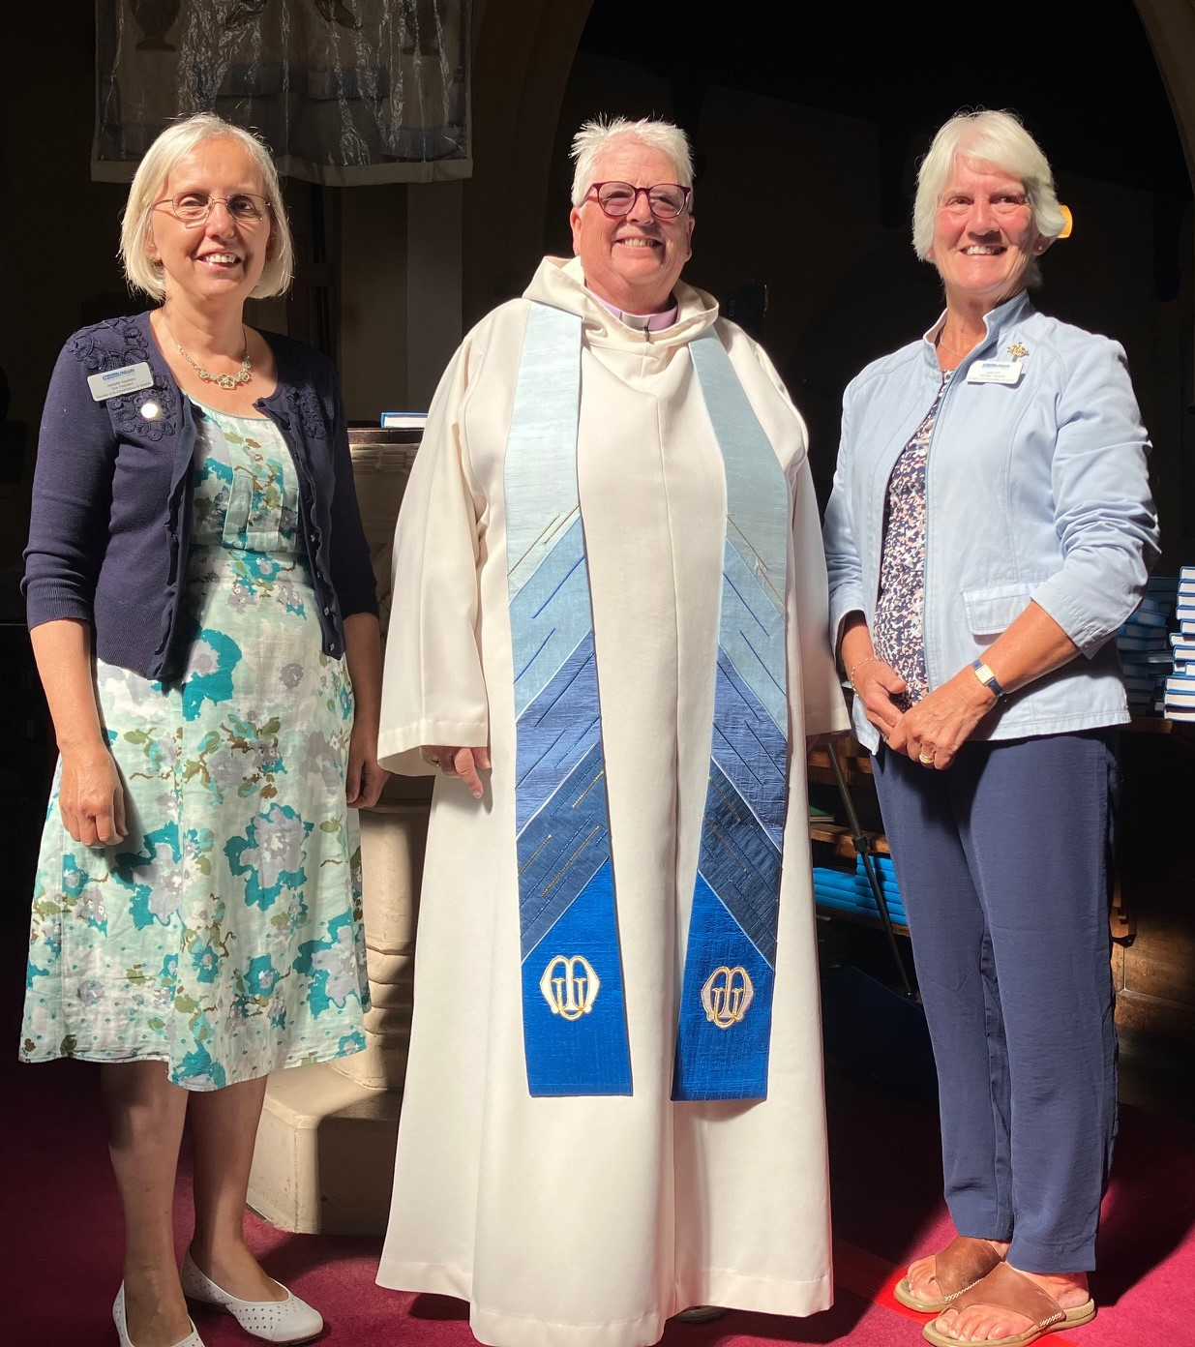

Rev Catherine Forsdike led the service, which was well attended. There were also excellent refreshments served afterwards. Thank you to Brenda and her wonderful team. An occasion full of faith, fun and fellowship. Afterwards Linda Ginn announced that Jeanette Appleton will be our Diocesan President for the next triennium, starting in January 2025. Jeanette is our Vice President. She has been a member of the Mothers’ Union for many years and has served in nearly every department possible from being a branch member through leadership roles and working alongside those at Mary Sumner House. Jeanette brings with her a wealth of experience from other dioceses, and has a huge network of friends and acquaintances within the organisation. For me, the most important factor is her genuine faith and trust in the Lord, her prayerfulness and her sense of vision and enthusiasm. She is going to make a tremendous contribution to MU in our Diocese, and I commend her to you. Do pray for Jeanette (and Richard) as she shadows during 2024 and begins the process of putting together the team who will take Mothers’ Union in our diocese into the next triennium. Congratulation Jeanette!

**Annual Gathering York September 22nd:**

Still time to book your place, there are two groups going from our diocese that you could join; for more details contact; Jeanette Appleton tel: t:0776841842 email:[Jeanette.Appleton@mothersunion.org](mailto:Jeanette.Appleton@mothersunion.org)

**Donations to Ipswich hospital:**

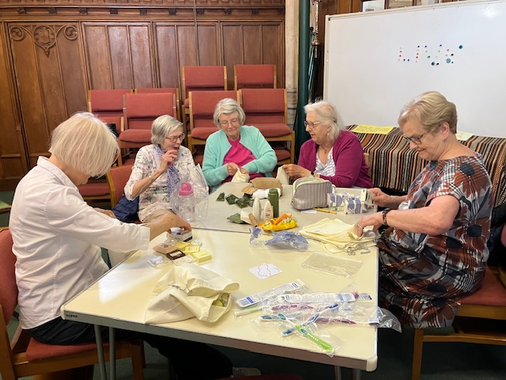

**l** East Bergholt and Brantham branch made up emergency wash bags at their July meeting as part of their response to the call for Hope into Action, the theme of this year’s Summer of Hope Appeal. Taking advantage of the fact that the 16th July was on a Sunday their Wave of Prayer service was incorporated into-the morning service at St Mary’s East Bergholt enabling the whole congregation to participate.

**I Chameleon Pop Up Shop in Halesworth -12th -18th October 2023**

This major fundraising event needs your support. They are looking good quality china, glass, household items, pictures, fabrics, jewellery, scarves, bric-a-brac etc. If you have any items like this, that you would like to donate, please contact Anna Vessey 01379 588389. Also don’t forget to put this date in October in your diaries and come and support this Pop-Up Shop in person and why not bring a friend with you

**The MU subscription for 2024 is to be £27.00**

An email from Mary Sumner House (MSH) was circulated recently highlighting how the £23.50, which is the part of 2024 MU subscriptions that will go to the worldwide work at MSH, is spent. Here in St Edmundsbury and Ipswich there will be just a 50p increase to the part of the subscriptions that cover the costs of running all the diocesan aspects of our charity.

Subscriptions to the Mothers Union in other dioceses range from £30 – 33. If you were a member of the WI your 2023 subscription was £46. The reason why the subscription in our diocese is so much lower than other dioceses, is in part due to the fact we do not have any paid staff such as diocesan secretary or treasurer. Our diocese uses email where possible and zoom meetings to keep the costs of postage, travel and room hire to a minimum.

**Do you use the Daily Hope prayer line?**

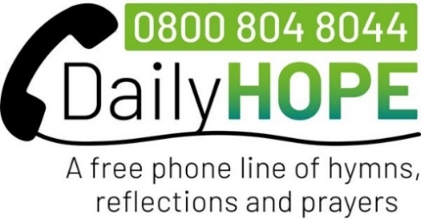

Archbishop Justin Welby answers your call with a short message followed by a choice of options:

Press 0 for main menu

Press 1 for hymns we love

Press 2 to hear hymn line

Press 3 spring reflections

Press 4 chair exercises.

Press 5 Church of England Service

Press 6 traditional Morning and Evening Prayers

Press 7 pray for Ukraine

Press 8 write to daily hope or make a donation

Press * to hear a message from Archbishop Justin Welby

Press # to sleep well with daily hope

Have you used the Daily Hope

free phone line? Here is a guide

of the choice of options.

Remember this is a free phone

line.