Transformation Now!

www.musuffolk.org

Charity No. 249726

April 2024 No 51

Do you know our next Diocesan Treasurer?

First, we need to pray that the right person will come forward to take up the role of Mothers’ Union Diocesan Treasurer. Second, we need to think of someone in our family, circle of friends or church community who we could ask to be this diocesan treasurer. They do not have to be a member of the Mothers’ Union, but they must be good with figures. Our finances are very healthy and thanks to Amanda, all organized and ready to pass on. All the information is on our website www.musuffolk.org

If not a Treasurer, then maybe you know our next Diocesan Secretary?

Beryl is standing down at the end of this year and would like to hand over to her successor as soon as possible to ensure a smooth transition. Please stop and then think prayerfully if you know of someone who could fill this role. They do not have to be a member of the Mothers’ Union. Details are on our www.musuffolk.org website.

Mothers’ Union Annual General Meeting: April 23rd at 10am
The Coddenham Centre, Mary Day Close, Coddenham, IP6 9SR
This is an important meeting for all MU members so we can reflect on our activities and achievements in our diocese during 2023. Please do come and join us on Tuesday 23rd April.
There is a large car park next to the Coddenham centre for sole use of hall-users and with level access to the hall. It is close to the A14, A140 and A1120, just east of Needham Market which should hopefully make travel to the venue as easy as possible.
Mothers’ Union Spring Council Meeting: April 23rd at 11am; The Coddenham Centre
Following the 45-minute AGM there will be time for refreshments and also to catch up with other members before the Spring Council meeting. One topic on the agenda is to include a new form of membership, that of ‘Friend of Mothers’ Union’. A Friend of Mothers’ Union will not be required to be baptized, which currently excludes some people who are keen to support Mothers’ Union. This form of membership is currently available from Mary Sumner House and has been adopted by number of dioceses. Trustees look forward to hearing the views of all members on this subject.
Lady Day service.
Those Mothers’ Union members who attended the Lady Day service in Lavenham on March 22nd enjoyed a time of praise, prayer and fellowship, once they had circumnavigated the various roadworks and diversions round the village. After the service there were more informal gatherings as members had lunch at pubs and cafes before returning home.

Canterbury Provincial Gathering: Saturday 22nd June 2024
The King’s Centre, Thames Hall, Osney Mead, Oxford, OX2 0ES

Doors open 10am and the event closes at 5pm
Cost: £20 per person and available at www.ticketsource.co.uk/mothers-union

This will be a wonderful opportunity to meet members from across the province, share information about what we are doing in our local dioceses, enjoy fellowship and worship together. There will be ample time during the day for fellowship and fun. The event is open to all members and you are welcome to bring friends. It will be a wonderful way for everyone to learn about Mothers’ Union.

Thank You
Mary Sumner House report that the 2023 Christmas Appeal, which focused on supporting our savings and skills work in Tanzania, raised £110,000; this included the match-funding we receive through the ‘Big Give’. This is a small increase on the previous year. We are extremely grateful to all members and supporters for helping us to achieve this target.
A date for your diary
Thy Kingdom Come: 9th – 19th May. Prayer is essential in the invitation of others to join us on our MU journey. Once again, MU will join in the prayer initiative, ‘Thy Kingdom Come’. We will pray from Ascension Day to Pentecost, 9th -19th May for five people in our network to come to know the Love of God and invite one of these five to a Mothers’ Union event. This is our MU link: https://www.mothersunion.org/ThyKingdomCome for more information - resources will follow.
Branch news
Kesgrave Mothers’ Union is having a coffee morning on April 23rd between 10am and 12pm at the Fred Upton Hall. Access is via Ropes Drive. The cost is £3 and includes refreshments. There will be a book stall and a raffle.
East Bergholt and Brantham branch have achieved a Bronze ‘RISE UP’ Against Domestic Abuse Award, for their work promoting awareness of domestic abuse. As well as posting the ‘RISE UP’ posters in many locations in their community, members donated ‘moving in bags’ for the Ipswich women’s refuge and created a prayer tree for both churches. Most recently they staged a ‘Souls of our Shoes’ display in both churches, which resulted in some profound and moving feedback from both parishioner and visitors to the churches.
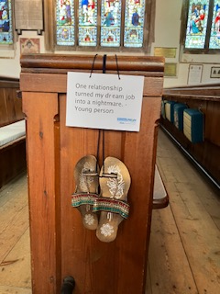
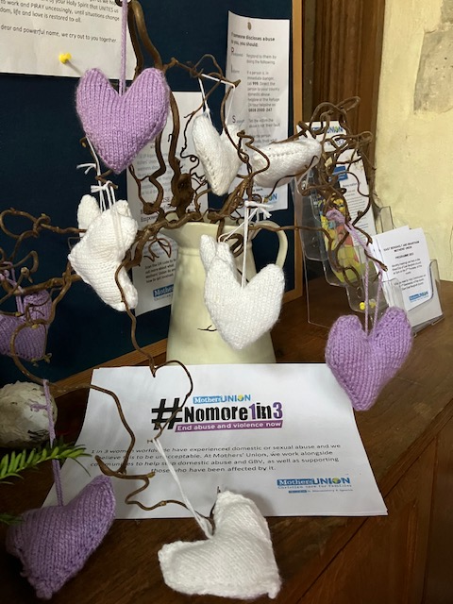
Prayers

This month we pray for all clergy and ministers in Hartismere, Hoxne and Saxmundham deanery. We hold King Charles and the Princess of Wales in our prayers in their ongoing treatment for cancer. We also pray for all our members who are undergoing surgery, chemotherapy or radiotherapy for cancer.

A prayer from our Mothers’ Union Book of Comfort by Sue Norrington:

Lord of compassion, to you we commend all who are ill and in need of help.
You brought healing to the sick and vulnerable in your earthly life.
You promised to hear our prayers, you are a present help in times of trouble.
Come now we pray to all who are in pain and distress, who are uncertain and fearful.
That they may know your peace and healing touch.
Enfold them in your love for the sake of Jesus Christ our Lord. Amen

