Holy Communion Service
on the feast of the Annunciation of our Lord to the Blessed Virgin Mary
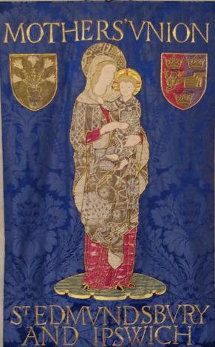

Friday 22nd March 2024 at 11.00am
at St Peter & St Paul
Church St, Lavenham, Suffolk England, CO10 9SA
Led by Rev. Canon Simon Pitcher,
Assisted by Rev.Catherine Forsdike
Chaplain of St Edmundsbury and Ipswich Mothers’ Union

There will be dispensation for those having food before communion.

The service will be livestreamed for those unable to attend in person. To request the link please email secretarysuffolkmu56@gmail.com
MUe stall available
Tea/Coffee and Biscuits after the Service

