HANDBAGS FOR SALE ON BEHALF OF MOTHERS UNION AND ALL AT £25 each
The items below were given for the I Chameleon sale but we felt that they were worth more than we could have sold them for in the shop. All the bags are in excellent condition

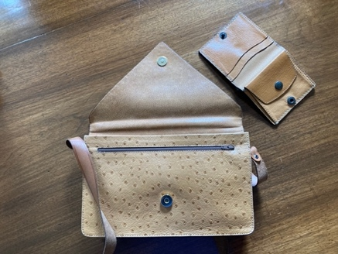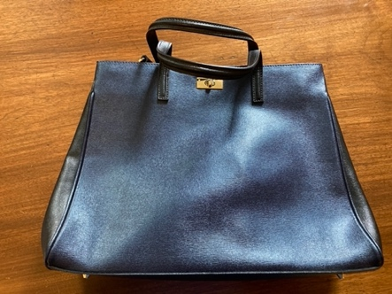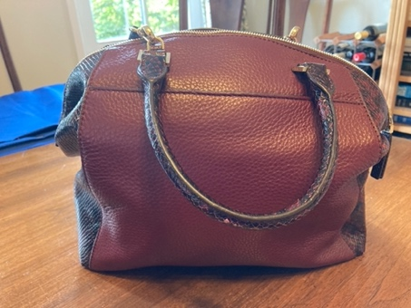
3
2
1

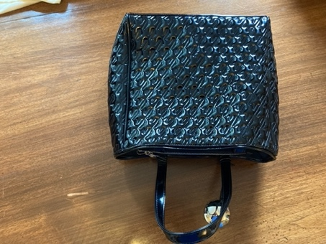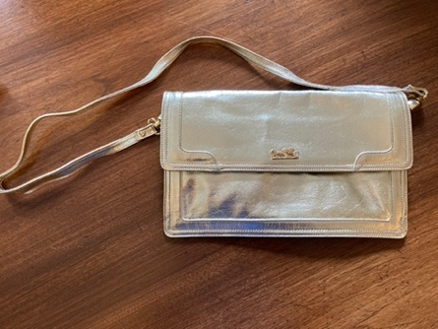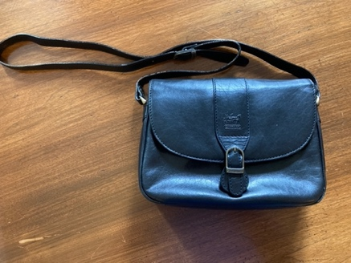
6
5
4

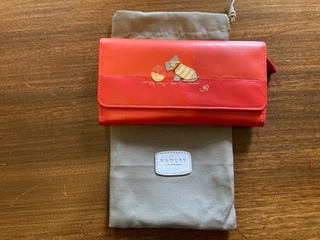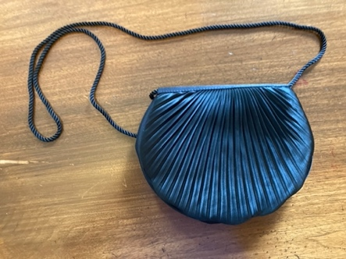
1 – Texier shoulder bag and purse
2 -Russell and Bromley handbag
3 – Michael Kors handbag
4 – Jaeger black patent handbag
5 – Lussy gold evening bag
6 – ‘Carriage’ leather crossbody bag
7 – Radley purse
8 – Black evening shoulder bag

8
7

MOSAIC ARTWORK FOR SALE ON BEHALF OF MOTHERS UNION – ALL £25 each
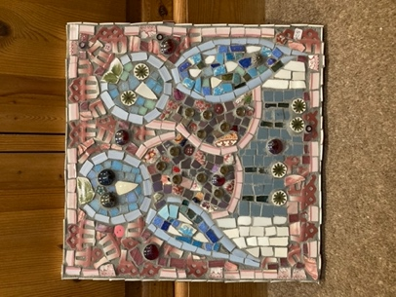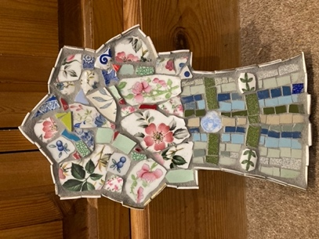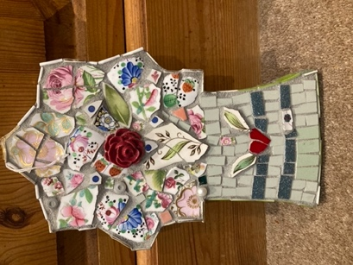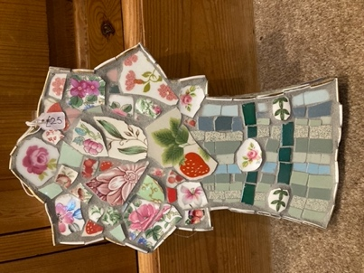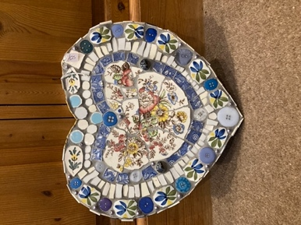
30 cm wide
All 26 cm tall
31 cm square
If you are interested please phone:-
Sue Norrington – 01728 660280 or
Anna Vessey – 01379 588389

