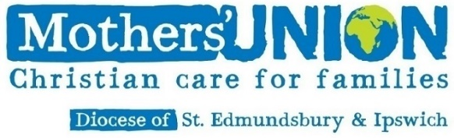
WAVE OF PRAYER SERVICE 2021
Our Diocesan Links: Jalingo, Nigeria, Byumba, Rwanda, Lake Malawi, Malawi, Lucknow North India
Jalingo Nigeria.
MU started in Nigeria in 1908. current members are at least 60,000. It’s very active in creating opportunities for women and girls. Its outreach activities include hospital visitation, health clinics, support for widows and orphans, day care centres/ nursery schools, marriage
preparation, prison ministry, vocational training. parenting programmes
Byumba, Rwanda
This is situated in central Africa, where Rwanda is a safe refuge for refugees. MU started in 1966, now 24,000 members with projects such as health awareness programmes, parenting groups, savings and credit help, marriage preparation, Sunday school. addressing gender-based violence and vocational training. Mothers’ Union leaders are Consolata, Pascale, and Angelique.

Lake Malawi MU
There are 13000 members in this Diocese.Tthe country is among the least developed in the world despite that the country is called the warm heart of Africa. MU members help with the challenges they all face and have st up savings and credit groups, agriculture and permaculture programmes, orphan care, health awareness, malaria prevention and work with St Agnes Guild for young girls.
Lucknow Northern India
India has high levels of poverty, in this second highest most populous world state. MU reaches out to those most in need, often women and girls, with vocational skills, training marriage preparation, health awareness programmes and campaigning against gender-based violence.

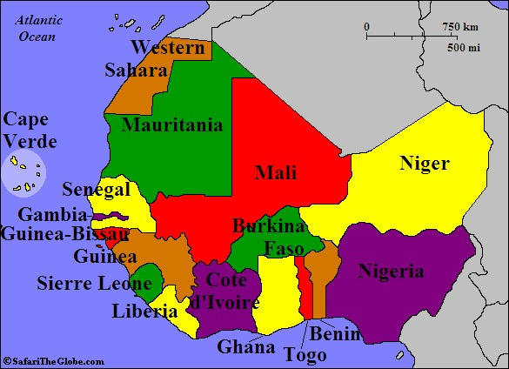
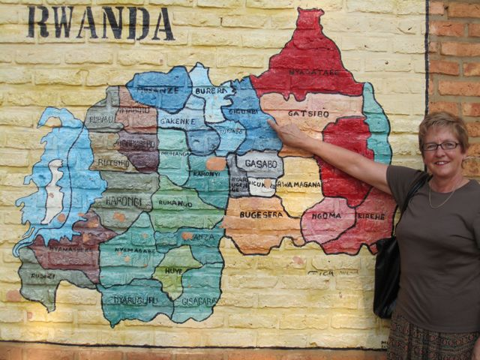
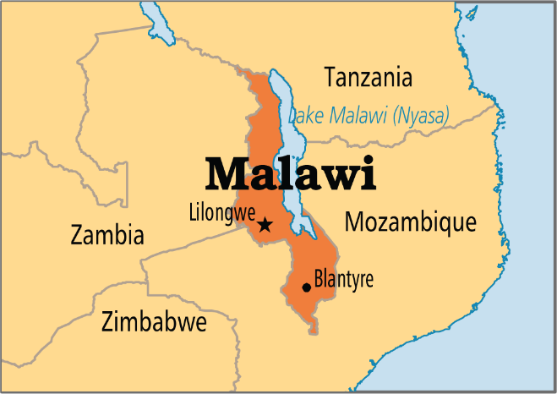
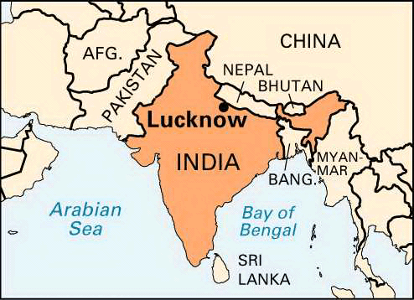
WAVE OF PRAYER SERVICE 2021 July 16th – 18th

WELCOME

Lord we welcome you. We thank you that you are in our midst. We give special thanks that after so many months on being unable to attend Mothers’ Union services we can praise you for this time together to pray for the people and work of the Mothers' Union, And in particular, our own link dioceses.

With thankfulness and love we take our place in the family of the Mothers' Union worldwide. Open our eyes to the significance of relationship with members worldwide; with those known to us or not. With support and love we reach out to our sisters and brothers across the world.

Strengthen our commitment to them with whom we share vision and values; wherever we may live. In unity and love we link hands with our worldwide family of God. Unite us in worship; build us in service, as together we seek to share your love. In Jesus' name.
Amen

Let us pause for a moment of quiet whilst we bring to mind our thoughts and deeds for which we ask forgiveness.

A prayer of confession.

All: Merciful Lord, who died that we may be accepted into the family of God, Forgive us the times when our love for each other is strained,
When the bonds between us are loose.
Forgive us when we choose to ignore the joys of shared relationship and focus on weakness and strife.
Help us to change our selfish ways that we may love God and his children with all our hearts.
Amen.

Absolution may be given by a Minister if present, otherwise the following prayer can be used by the person leading the service.

May our heavenly Father open wide his arms in loving forgiveness and grace. May we know the joy of restored relationship with God and his people.
Amen

All Blessed are you, Lord our God,
Giver of life, Father, Son and Holy Spirit.
You call us out of darkness into your marvellous light.
Take us as we are and make us into what you would have us be.
Blessed are you for ever and ever. Amen

HYMN

READING

[A talk, address or thought for the day could be added here. This might be followed by a period of reflection on what has been heard - music could be
played if silence is not wanted.]

Having heard and shared the word of God we pray

All we need, good Lord, is yourself;
Not words about you, but your very presence.
In the Silence
In the Stillness.
Come, Lord, Come.

Lord, you give us courage to trust you,
Energy to work for you,
Persistence to hold on
And be yours for ever. Amen

INTERCESSIONS
A time to remember those with whom we are linked through the
diocese, the deanery and our individual branches.

Our Diocesan Links: Lake Malawi, Malawi, Jalingo, Nigeria, Byumba, Rwanda, Lucknow North India

Lord, we bring you our praise for the fellowship and prayer support that we have known through the wave of prayer, for our links with the worldwide Mothers’ Union; and for our own links with Lake Malawi, Malawi, Jalingo, Nigeria, Byumba, Rwanda, Lucknow North India

We pray for the relationships that we may build with them in the coming years, and ask for patience and a sense of hope when lack of news has driven us to do the only thing we can – to hold them in your love and keep them in our prayers. Bind us together in mutual love and support as we uphold one another in prayer.

Loving Lord, help us to fully appreciate the blessings of being united in the family of God. Let us be ever ready to intercede for each other For God's assistance and protection. May God encourage us in heart and unite us in love.

Dear Lord, we know that some of the people we are linked with suffer from the lack of food and medicines that could help them and their families have a fuller and more comfortable life.

Although we rejoice in the beauty of your world and thank you for the rich harvest it produces - we remember those who do not have enough, the thousands who are dying from hunger and disease each day. We pray especially for the people of Lucknow, who along with the rest of India have suffered to much due to the Covid19 virus.

We pray for those who have more than they require and ask that we learn
to share your bounty, the world's harvest, more fairly.
Teach us to value people more than things and teach us we pray to seek your will here on earth as servants of Jesus Christ our Lord.
Amen

Loving God, we thank you for all we share in common with your people near and far, our lives interwoven, inter-related, interdependent, intertwined. Help us, we pray, to recognize more fully what that means, to appreciate the responsibilities it brings, and to seize the opportunities it offers. Lord of all join us together in love for the sake of Jesus Christ our Lord. Amen

Nearer to home, dear Lord, we bring before you the Mothers’ Union here in St Edmundsbury and Ipswich Diocese, its leadership and members; we pray for the Mothers’ Union nationally and for its future in this country. We thank you for the privilege of belonging to a movement which promotes marriage and family life, and pray that these values may be revitalized in our own homes, in our churches, in our country, and throughout the world. Lord of love and power
Hear our prayer.

The Lord's Prayer

Our Father in heaven, hallowed be your Name,
your kingdom come, your will be done, on earth as in heaven.
Give us today our daily bread.
Forgive us our sins as we forgive those who sin against us.
Save us from the time of trial and deliver us from evil.
For the kingdom, the power and the glory are yours,
now and for ever. Amen

THE MOTHERS' UNION PRAYER
Loving Lord, we thank you for your love so freely given to us all. We pray for families around the world. Bless the work of the Mothers' Union as we seek to share your love through the encouragement, strengthening and support of marriage and family life. Empowered by your Spirit, may we be united in prayer and worship, And, in love and service, reach out as your hands across the world. In Jesus' name. Amen

MARY SUMNER'S PERSONAL PRAYER
All this day, O Lord, Let me touch as many lives as possible for thee; and every life I touch, do thou by thy spirit quicken, whether through the word I speak, the prayer I breathe, or the life I live. Amen

HYMN

The final blessing may be given by a minister if present or this prayer may be said by all:

Father and Mother God,
enfold us with your gracious presence
so that our praying and living become one.
Jesus, Son of God, as living witnesses,
help us to speak with confidence
and in ways which make sense to people who do not know you.

Leader:
Holy Spirit of God, as your obedient people,
enable us to see your activity in the world
and inspire us to join with you in that work. Amen

All: Let us go out in joy and in peace, to love and to serve the Lord!
In the Name of Christ! Alleluia! Amen.

Notes for Wave of Prayer service 2021

Readings and Hymns: Please feel free to choose your favourite readings and hymns for this service. After all these months of not being able to sing in church, sing as loudly as you like and have all the verses of the hymns you have chosen.

You can add the words of the readings and hymns in the appropriate places on this service sheet.

If you need help with this please contact: Jeanette Appleton
email jeanetteappleton@hotmail.com Tel: 07768418942

