Global Day Get Involved – Join our Online Global Protest
As many of you know, we had asked our members to join together on 5th December in your local town centre or cathedral grounds to hold a visual, peaceful protest to draw attention to our campaign, followed or preceded by a tea and coffee morning “Tea for no more 1 in 3” where we would have also suggested that homemade products could have been on sale to raise funds.
However, times have changed and we realise that for many dioceses this will just not be possible and our members safety and security is our priority. Therefore, like much of our work this year we are going to take this protest online!
We need you all to do the following, if possible:
- Print out our sign here https://www.mothersunion.org/sites/default/files/resources/public/No%20More%201%20in%203%20Placard.docx – or use this to create you own if you wish! Make sure it is clear it is Mothers’ Union and it includes the hashtags - #NoMore1in3 and #1in3NotMe
- Ideally if you have 3 people in your household gather them together to get involved – all ages are welcomed and encouraged. If there isn’t 3 of you – don’t worry please still take your photo and join us.
- We suggest that you all wear a plain black top or a MU T-shirt for this.
- 1 person in the 3 (or one person if there are 1 or 2 of you) paint a cross over your lips – we have found the best way to do this is simply with a red lipstick but you can use plasters or tape or an alternative.
- Take a photo of the three of you (or however many there are) holding up the sign
- If you want to, you can also film yourself holding up the sign and saying: “No more 1 in 3”
  - This can just be filmed on your phone – landscape is best!
- Send your photo and / or video to communications@mothersunion.org by 7th November – please note by sending us your photo / video, you are consenting to us using it across our social media channels, press releases and on our Mothers’ Union website
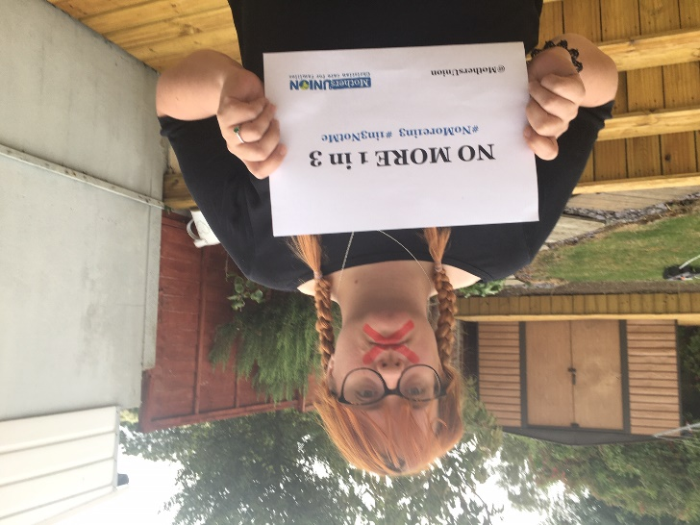
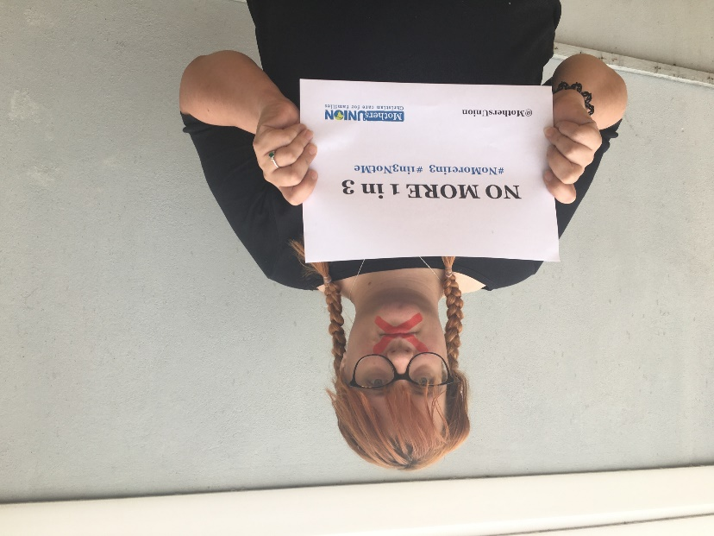
The images and videos will be woven together to form a protest video that we will launch on the 5th December – we want to make sure we have as many members getting involved as possible so please do take some time in your day to get involved!

