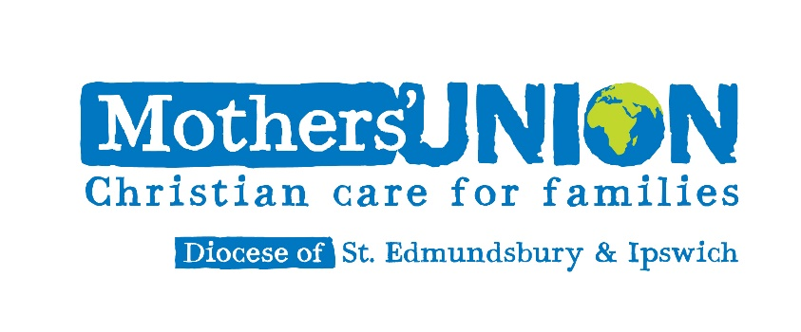

Banner Service
with Holy Communion and Commissioning
on the feast of the Annunciation of our Lord
to the Blessed Virgin Mary
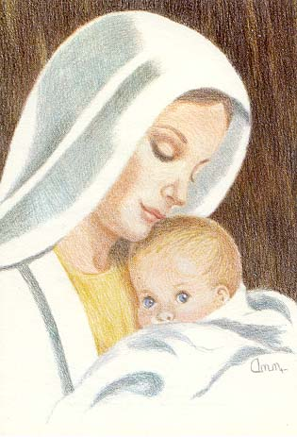
Thursday, 12 April 2018 at 11 am
at St Andrew’s Church, Rushmere St Andrew,
Ipswich IP5 1DH
Address: Mrs Lynne Tembey
World-Wide President of Mothers’ Union

Bring and Share Lunch after the Service

Banner Service
with Holy Communion and Commissioning
on the feast of the Annunciation of our Lord
to the Blessed Virgin Mary
Thursday, 12 April 2018 at 11 am
at St Andrew’s Church, Rushmere St Andrew,
Ipswich IP5 1DH
Address: Mrs Lynne Tembey
World-Wide President of Mothers’ Union

Bring and Share Lunch after the Service

